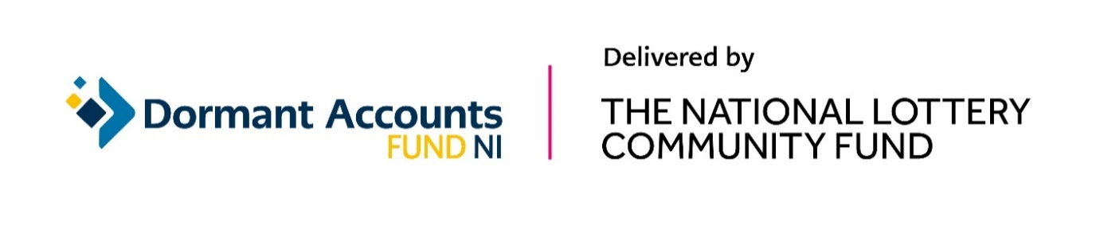
Dormant Accounts Fund NI

Grant Announcement

Date: 18 January 2022
Number of grants: 15
Total Awarded: £1,313,790

Table 1: Grants awarded across all Northern Ireland
Organisation | Location | Project summary | Amount awarded
Cara-Friend | Across Northern Ireland | Cara-Friend is using a £99,400 grant to implement a new business model to improve their sustainability. Over three years the project will establish their new LGBTQI+ Inclusive Business Charter, which will train and guide companies to eradicate workplace discrimination and support LGBTQI+ employees at work. The Charter will promote their work, develop new collaborations, diversify income streams, and engage more volunteers to take part in fundraising activities. The project will also focus on the education sector to promote an LGBTQI+ Inclusive Schools’ Charter. | £99,400
Northern Ireland Hospice | Across Northern  Ireland | NI Hospice is using a £99,151 grant to redesign their website and run training which will build their capacity and increase their income generation. Over one year the project will make improvements to their website and digital systems, run digital skills training for staff and volunteers so they can utilise the new systems and build capacity across the organisation, and run sales training for fundraising staff. | £99,151
PeacePlayers International - Northern Ireland | Across Northern Ireland | PeacePlayers International NI is using a £99,941 grant to build capacity through restructuring of the organisation and development of a long-term income strategy. Over three years the project will develop a central hub in Belfast with regional hubs in each council area in Northern Ireland. Staff will refocus their resources to be able to work more strategically including financial planning, training and development, programme planning, data collection and evaluation, policy reviews, and income generation. | £99,941
Special Educational Needs Advice Centre | Across Northern Ireland | Special Educational Needs Advice Centre (SENAC) is using an £80,070 grant to improve the sustainability of their services and develop a succession plan for staff. Over three years the project will increase resources that focus on partnership working and corporate fundraising to generate more income which will increase their financial sustainability. The project will also improve their IT systems to improve the efficiency of their processes and organise regular strategic review days and training for volunteers and trustees. | £80,070
Sustainable Northern Ireland | Across Northern Ireland | Sustainable NI is using a £99,815 grant to make improvements to the running of the organisation to make it more efficient and sustainable, and to raise their profile as climate action and environmental sustainability becomes more essential. Over two years the project will develop a stronger income model, carry out a brand review and develop a marketing campaign, develop and digitise the group’s sustainability tracker, and run training for the existing board. | £99,815

Table 2: Grants awarded in Ards and North Down
Organisation | Location | Project summary | Amount awarded
Camphill Community Glencraig | Ards and North Down | Camphill Community Glencraig in Holywood is using a £100,000 grant to improve staff capacity and upgrade their HR processes and systems to improve efficiency. Over two years the project will move their systems online and streamline their processes which will improve productivity and reduce costs. The project will also provide resources for senior staff to focus more time on building sustainability. | £100,000

Table 3: Grants awarded in Armagh City, Banbridge and Craigavon.
Organisation | Location | Project summary | Amount awarded
Brownlow House CIC | Armagh City, Banbridge and Craigavon | Brownlow House CIC in Lurgan is using a £100,000 grant to improve their finances and become more self-sufficient. Over two years the project will recruit and train more board members to build their capacity, develop a staff succession plan, form a steering group that includes local community members, develop strategic plans, and generate new income streams. | £100,000

Table 4: Grants awarded in Belfast
Organisation | Location | Project summary | Amount awarded
Belfast Archive Project | Belfast | The Belfast Archive Project is using a £15,450 grant to become more sustainable for the future. Over one year the project will run training for its board and volunteers to increase their skill set around business development and governance, diversify its volunteer base, develop a marketing strategy, increase their online presence, and make improvements to their ecommerce system to generate more income. | £15,450
Belfast Library and Society for Promoting Knowledge | Belfast | Belfast Library and Society for Promoting Knowledge is using a £100,000 grant to build a new digital platform for Linen Hall Library to improve their financial sustainability. Over two years the project will create a new website with an integrated digital library of their collections which will create opportunities to generate income. The project will also run digital skills training for staff. | £100,000
Springfield Charitable Association Limited | Belfast | Springfield Charitable Association Limited in west Belfast is using a £99,833 grant to promote and develop their social enterprise activities which will improve their sustainability. Over three years the project will improve their income generation by renting out space in their new building which includes a hydrotherapy pool, conference facilities, and office space. They will also develop their social enterprise model. | £99,833
The Black Box Trust | Belfast | The Black Box Trust in Belfast is using a £99,942 grant to make improvements to the organisation to become more sustainable. Over two years the project will develop a succession plan, build staff capacity, deliver an improved fundraising strategy, develop new revenue streams and partnerships, strengthen their board, improve their systems and structures and implement a marketing plan. | £99,942

Table 5: Grants awarded in Derry City and Strabane
Organisation | Location | Project summary | Amount awarded
Strabane Community Project | Derry City and Strabane | Strabane Community Project is using an £80,616 grant to strengthen financial management and governance to ensure future sustainability. Over three years the project will redevelop their financial and operational management procedures and processes to become more effective, develop a strategic plan for the future running of the organisation and deliver training to staff. | £80,616

Table 6: Grants awarded in Mid Ulster
Organisation | Location | Project summary | Amount awarded
Bardic Educational Arts & Media Limited | Mid Ulster | Bardic Education Arts and Media Ltd (BEAM Creative Network) in Donaghmore is using an £86,816 grant to build their leadership capacity to make them more financially resilient. Over three years the project will make improvements to their operating model, develop the digital skills of the board and staff, develop a new strategic plan, update their processes and policies, restructure financial income streams and transform their website. | £86,816
Niamh Louise Foundation | Mid Ulster | Niamh Louise Foundation in Dungannon is using an £86,256 grant to implement their strategic plan to future proof the organisation and become more financially resilient. Over two years the project will take on creative planning, a governance review, capacity building training for staff and committee, and develop collaborations across various funding sectors. | £86,256

Table 7: Grants awarded in Newry, Mourne and Down
Organisation | Location | Project summary | Amount awarded
Sticky Fingers Arts | Newry, Mourne and Down | Sticky Fingers Arts in Newry is using a £66,500 grant to expand the use of their Imaginarium centre to create a sustainable income stream and strengthen their organisation. Over one year the project will create more flexible spaces for workshops, events and programming to attract new clients and groups who can rent out the space. This will help the venue to become a creative community hub and generate income. | £66,500

