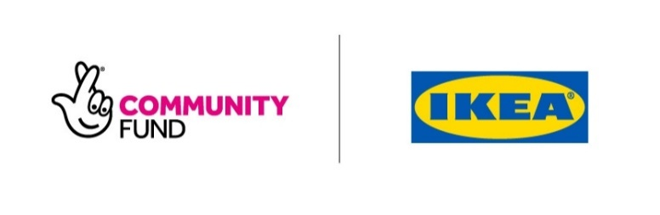
IKEA UK and The National Lottery Community Fund

Places Called Home grant announcement

Date: Thursday 14 October 2021
Number of grants: 18
Total Awarded: £74,706

Table 1: Grants awarded in Ards and North Down
Organisation | Location | Project summary | Amount awarded
Ladybird Children's Services | Ards and North Down | Ladybird Children’s services is using a £4,900 grant to build a parent support room within their Community Family Centre. This will create a ‘home from home’ environment for parents to come together for support, meet other parents, or to access services such as counselling. | £4,900
St Comgall’s Parish Youth Centre | Ards and North Down | St Comgall’s Parish Youth Centre is using a £1,300 grant to redecorate and refurbish their youth club area to create a welcoming and calming space for young people to build relationships with their peers and explore their creativity. | £1,300

Table 2: Grants awarded in Armagh City, Banbridge and Craigavon.
Organisation | Location | Project summary | Amount awarded
Blackwater Community Barge Limited | Armagh City, Banbridge and Craigavon | Blackwater Community Barge is using a £1,886 grant to support newcomers to the country to make connections in the local area, through going out on a wheely boat on the river together and sampling foods from different cultures. | £1,886

Table 3: Grants awarded in Belfast
Organisation | Location | Project summary | Amount awarded
Beechmount Residents Collective | Belfast | Beechmount Residents Collective is using a £5,000 grant to transform an area of waste land into a space for the local community to come together for activities and where children can play safely. | £5,000

Table 4: Grants awarded in Causeway Coast and Glens
Organisation | Location | Project summary | Amount awarded
The Glens Community Association | Causeway Coast and Glens | The Glens Community Association is using a £5,000 grant to create a new equipment storage shed to provide more space in their building for activities to take place. This shed will be built with the help of retired volunteers and younger volunteers in an intergenerational project that shares skills and experience. | £5,000

Table 5: Grants awarded in Derry City and Strabane
Organisation | Location | Project summary | Amount awarded
Creggan Country Park Enterprises Ltd | Derry City and Strabane | Creggan Country Park Enterprises is using a £5,000 grant to revive the former fishing shop at Creggan Country Park and transform it into a new community hub. This will provide a space for the local community to seek support, take part in activities and access a community fridge/freezer to help address food poverty and reduce food waste. | £5,000
Youthlife Limited | Derry City and Strabane | Youthlife is using a £5,000 grant to refurbish a space in their building which will be used for group therapies and activities for children and young people who have experienced bereavement. The space will be created by the group’s new Youth Advisory board as a team-building activity. | £5,000

Table 6: Grants awarded in Fermanagh and Omagh
Organisation | Location | Project summary | Amount awarded
Kinawley Gaelic Football Club | Fermanagh and Omagh | Kinawley Gaelic football Club is using a £3,570 grant to renovate the Ladies Toilets and the Disabled Toilets in their clubhouse. This will make a more comfortable and inviting space for the women members and people with disabilities who take part in activities there. | £3,570

Table 7: Grants awarded in Lisburn and Castlereagh
Organisation | Location | Project summary | Amount awarded
Kindergarden Cooks CIC | Lisburn and Castlereagh | Kindergarden Cooks is using a £2,28 grant to buy a polytunnel and equipment to develop their work with the local community to teach them how to grow their own plants and food and eat healthily. | £2,280

Table 8: Grants awarded in Mid and East Antrim
Organisation | Location | Project summary | Amount awarded
Northern Ireland Blind Golf Association | Mid and East Antrim | Northern Ireland Blind Golf Association is using a £5,000 grant to set up an art group to increase social opportunities for blind and partially sighted people living in the wider Ballymena area and show that art can be enjoyed by all abilities. | £5,000
The Mae Murray Foundation | Mid and East Antrim | The Mae Murray Foundation is using a £5,000 grant to buy an all-terrain wheelchair to give families with a disabled family member, the opportunity to get active together in outdoor environments from which they are usually excluded. | £5,000

Table 9: Grants awarded in Mid Ulster
Organisation | Location | Project summary | Amount awarded
Cro Na Cille | Mid Ulster | Cro Na Cille is using a £4,955 grant to refurbish their kitchen to make it a better facility for community events. This new facility will create a shared hub that can be used by other groups within the community. | £4,955
Institute of Irish Leadership | Mid Ulster | The Institute of Irish Leadership is using a £5,000 grant to pay for a staff member to set up and run a Community Café in their centre. The café will bring people together for social activities, classes, events and will improve community spirit. | £5,000
Mid Ulster Victims' Empowerment | Mid Ulster | Mid Ulster Victims' Empowerment is using a £4,950 grant to run a new Chatterbox Club to reduce loneliness and isolation and improve wellbeing for local older people and men and women who have been affected by the Troubles. | £4,950
South and East Tyrone Welfare Support | Mid Ulster | South and East Tyrone Welfare Support is using a £3,000 grant to run a carers support group. The project will provide activities to learn new skills and connect with other carers and give them regular time away from their caring responsibilities. | £3,000
Stewartstown & District Environmental Outreach | Mid Ulster | Stewartstown & District Environmental Outreach is using a £5,000 grant to build a sheltered seating area in their community garden which will be built by members from their Men’s Shed. This will provide a relaxing meeting place for local residents and act as a memorial for people in the local area who died from COVID-19. | £5,000

Table 10: Grants awarded in Newry, Mourne and Down
Organisation | Location | Project summary | Amount awarded
Kilkeel Parish Bridge Association Limited | Newry, Mourne and Down | JIMS Youth Centre at Kilkeel Parish Bridge Association is using a £2,915 grant to create an accessible community garden, developed by local families to build connections, teach children and young people gardening skills, and inspire families to consider sustainable lifestyle choices. | £2,915
Moneydarragh Community Hub Limited | Newry, Mourne and Down | Moneydarragh Community Hub is using a £4,950 grant to create an accessible community garden and provide safe access and walkways for disabled and older users. The project will run gardening activities will allow people and families to connect and improve the environment. | £4,950

