THE NATIONAL LOTTERY COMMUNITY FUND
UK FUNDING COMMITTEE
Tuesday 19th September 2023
9:00 – 12:00 Teams

MEMBERS:
Paul Sweeney (Chair)  Kate Still  John Mothersole | Northern Ireland Committee Chair  Scotland Committee Chair  England Committee Chair
IN ATTENDANCE:
David Knott  Stuart Fisher  Liz Watchorn  Mel Eaglesfield  Verity Prime  Ellen Dunlevy  Michael Bates  Kiran Bhopal  Lucy Taylor | Chief Executive  Finance Director  Senior Portfolio Manager  Deputy Director, Funding Strategy  Funding Strategy, Communications, and Impact Director  Senior Portfolio Manager  Senior Head of Finance  Finance Business Partner  Governance Officer (Minutes)
APOLOGIES:
Simone Lowthe-Thomas | Wales Committee Chair
- CHAIR'S WELCOME
  - The Chair welcomed all to the meeting.

- APOLOGIES FOR ABSENCE
  - Simone Lowthe-Thomas sent apologies, and Kate Still had sent her apologies during the beginning of the meeting. As the meeting was not quorate, it was agreed that any decisions would need to be ratified with absent Committee members over correspondence.

- DECLARATIONS OF INTEREST
  - There were no further declarations of interest.

- MINUTES OF THE PREVIOUS MEETING
  - Paul Sweeney and John Mothersole approved the minutes as an accurate record. Due to a lack of quorum, the final approval of the minutes would be decided over correspondence.
- ACTIONS ARISING
  - The Committee took the action log as read.
- FINANCIAL UPDATE
Kate Still joined the meeting.

  - Michael Bates provided an overview of the current financial status, including details on income and forecasts.
  - The Committee queried the back end loading of commitments later in the year, creating some risk to the forecast outturn for the year. They advised that while the matter should be noted today, there were other options available if the target became unachievable and suggested considering potential mitigation strategies sooner rather than later.
  - Mel Eaglesfield advised on the team’s efforts to smooth out the profile by launching an open programme. Mel expressed confidence in the pipeline's development and mentioned that based on the current model, awards should be made from Q1 in 2024/25, creating a steadier rhythm. However, she acknowledged the risks associated with the final quarter and anticipated smoother years ahead.

- THE UK FUND UPDATE
  - Ellen Dunlevy presented the UK Fund Update which offered insights into the progress of the UK Fund since its launch in July.
  - The Committee expressed satisfaction with the update, and commended the positive impact this Fund would have. They noted that the commitment to allocate £15 million in FY 23/2024 was regarded as a positive development. They further elaborated that this allocation coincided favourably with the strategy launch and hinted at the potential role of a panel in the UKFC transition, suggesting that such a panel would face significant responsibilities.

- CLIMATE ACTION FUND UPDATE
  - Liz Watchorn provided an extensive overview of the Climate Action Fund (CAF), encompassing highlights, future plans, current initiatives, and the current pipeline.
  - The Committee discussed the update at length and highlighted the pivotal role of differentiation across portfolios in the future development of CAF. Members advised revisiting this aspect, particularly in the context of the Fund's strategic pillars, highlighting the importance of clarifying the unique value proposition of CAF. Liz advised that there had been ongoing discussions about differentiation within the CAF panel and the need for a more strategic response.
  - Members queried the developmental projects and grant holders’ expectations. Liz advised that this was being worked on and that clear parameters would be set for projects. Liz advised that there would be a presence of a new learning and development partner to assist grant recipients in enhancing their sustainability.

- GROWING GREAT IDEAS UPDATE
  - Liz delivered a comprehensive update on the Growing Great Ideas initiative, sparking an insightful and productive discussion among Committee members. The Committee supported the proposed approach towards the next stage of the initiative.
- 2024/25 GRANTS BUDGET
  - Mel presented the 2024/25 budget and provided an explanation regarding the budget scaling and related considerations.
  - Overall, the Committee acknowledged and noted the paper. Regarding the unallocated budget, it was noted that there was some ambiguity surrounding it, but there was a consensus to align it with the commemorative aspects of the 30th birthday celebration and further alignment with the missions of the strategy.
- NORTHERN IRELAND BUDGET REALLOCATION
  - Ellen proposed to the Committee to approve a transfer of £1m from UK Portfolio budget for 23/24 to the Northern Ireland portfolio. Kate Still and John Mothersole confirmed their approval. Being the Chair of the Northern Ireland Committee, Paul Sweeney had a conflict of interest and did not partake in the vote.
  - Due to the lack of quorum, it was agreed that the decision would be decided over correspondence with absent Committee member Simone Lowthe-Thomas. Subsequently, Simone promptly communicated her approval for the budget reallocation.

- EDEN PROJECT
Funding Decisions are confidential and can be found in Annex A.

- UK PORTFOLIO UPDATE
  - Mel presented key highlights from the update and took questions from the Committee. Members noted that the report provided a comprehensive overview of the UK portfolio and expressed satisfaction with the content.
Verity Prime left the meeting.
- UKFC TRANSITION
  - The Committee discussed the paper on the UKFC transition. The paper proposed that the Chair of the Board would continue to lead the UK committee to maintain a UK-wide perspective. However, there was openness to reconsider the composition of the Committee beyond the Chairs of Country Committees and to incorporate external expertise. The primary goal of the paper was to suggest recommendations for changes in membership to present to the Board at the September Board meeting.
  - Members discussed the paper at length and advised that the UK portfolio ought to add value rather than becoming a separate entity. Members advised that the Board should be offered a range of options, rather than presenting a single proposal. In conclusion, it was agreed that the CEO would rework the paper to present a variety of options to the Board for their deliberation.
ACTION: The CEO
WITH THERE BEING NO OTHER BUSINESS THE MEETING ENDED AT 12:00.
MINUTES AGREED DATE: 21/11/2023
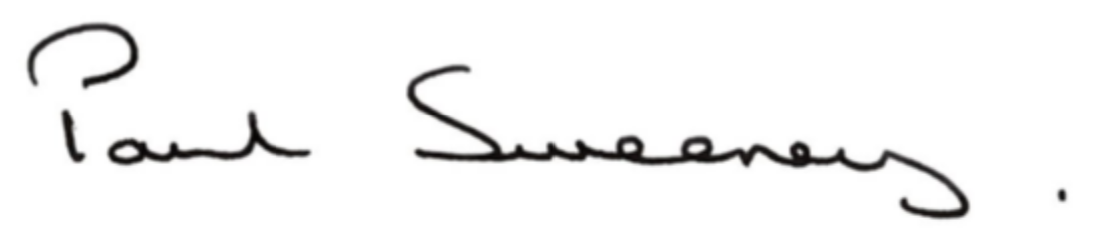

PAUL SWEENEY
UK FUNDING COMMITTEE CHAIR

