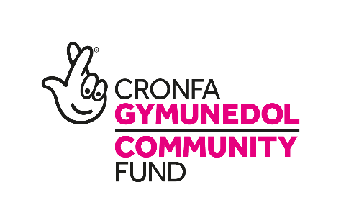
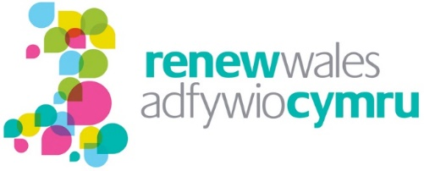
Renew Wales Evaluation

June 2020
Wavehill: social and economic research

- Wales office: 21 Alban Square, Aberaeron, Ceredigion, SA46 0DB (registered office)
- West England office: 2-4 Park Street, Bristol, BS1 5HS
- North of England office: Milburn House, Dean Street, Newcastle, NE1 1LF
- London office: 52 Cecile Park, Crouch End, London, N8 9AS

Contact details:

Tel: 01545 571711
Email: wavehill@wavehill.com

More information:

www.wavehill.com
https://twitter.com/wavehilltweets

© Wavehill: social and economic research

This report is subject to copyright. The authors of the report (Wavehill: social and economic research) should be acknowledged in any reference that is made to its contents.

Report authors:
Tom Marshall
Endaf Griffiths
Paula Gallagher
Eddie Knight

Any questions in relation to this report should be directed in the first instance to Tom Marshall (tom.marshall@wavehill.com)

Date of document: 20.07.2020
Version: FINAL

Client contact:
Dr. Kate Hamilton | katehamilton@renewwales.org.uk

Acknowledgements

We would like to thank the many individuals who gave their time to assist in the evaluation, including the supported groups, coordinators, peer mentors and host organisations that agreed to participate in visits and interviews. We would also like to thank those within Wavehill that provided assistance to the evaluation, including Sarah Usher, Tony Jones and Darren Forder, all of whom were important in the writing of this report. This evaluation would not have been possible without all of their contributions.

List of abbreviations

CARE | Cwm Arian Renewable Energy
CEA | Cost Efficiency Analysis
CHP | Combined heat and power
COVID-19 | Corona Virus Disease 2019
CO2 | Carbon Dioxide
CVC | County Voluntary Council
DTA Wales | The Development Trusts Association Wales
EV | Electric Vehicle
EU | European Union
FTE | Full Time Equivalent
LEADER | Liaison entre actions de développement de l'économie rurale
LED | Light-emitting Diode
PAVO | Powys Association of Voluntary Organisations
PSB | Public Service Board
SMART | Specific, Measurable, Achievable, Realistic and Timebound
WCVA | Wales Council for Voluntary Action
WFGA | Well-being of Future Generations (Wales) Act 2015

Contents
Contents i
Table of figures ii
Executive summary i
1 Introduction 11
1.1 The Renew Wales programme 11
1.2 Summary of the previous evaluation 13
1.3 The objectives of the 2018-2020 evaluation 16
2 Methodology 18
2.1 Survey of supported groups 18
2.2 Workshops with supported groups 19
2.3 Interviews with host organisations 19
2.4 Interviews with the central team 19
2.5 Additional research methods 20
3 Effectiveness of programme delivery mechanisms 21
4. Support provided and actions resulting from this support 26
5. Outcomes 32
5.1 Impact on awareness, knowledge and understanding of climate change 33
5.2 Impact on ability to take action 38
5.3 Community groups’ and other third sector organisations’ connectedness with each other and with others outside the programme 42
6. Renew Wales’ contribution to relevant policy and practice 49
7. Conclusions and recommendations 54
7.1 Effectiveness of programme delivery mechanisms 54
7.2 Actions resulting from support provided 55
7.3 Renew Wales’ impact on communities’ knowledge, skills and ability to be more resilient on climate change 56
7.4 Building connectedness within the sector 57
7.5 Renew Wales’ contribution to relevant policy and practice 59
7.6 Using learning from the evaluation to inform the future strategic direction of Renew Wales 60
8. Annex One: Case studies of supported groups 62
8.1 Abergynolwyn Community EV 62
8.2 Cemmaes Jubilee Hall 68
8.3 Cwm Arian community owned wind turbine 72
8.4 Emmaus South Wales 77
8.5 Gilfach Goch Community Gardens 81
8.6 Mayhill Washing Lake and Community Food Garden 87
8.7 Sketty Eco-Church Project 92
8.8 Theatr na nÓg 96
8.9 Ysgol Pen Barras 102

Executive summary

This executive summary briefly outlines the findings of the final evaluation report of Wavehill’s independent evaluation of the Renew Wales programme. Wavehill was commissioned by Development Trusts Association Wales (DTA Wales) to carry out an evaluation of the programme between September 2018 and May 2020, running alongside programme delivery.

The Renew Wales programme

Renew Wales is a peer-to-peer mentoring programme, which aims to “help communities in Wales reduce their carbon footprint, adapt to the impacts of climate change and live more sustainably”. Established in 2012 by a consortium of third sector organisations, Renew Wales supports community groups tackle the causes and impacts of climate change by providing advice, training, mentoring and technical support services delivered by experienced community practitioners. The programme is funded through the National Lottery Community Fund.

Renew Wales is primarily delivered as a ‘peer-to-peer’ support programme, through a network of local coordinators and peer mentors hosted in third sector organisations. Both coordinators and peer mentors are experienced community practitioners that have already taken action in their communities. In addition to peer-to-peer support delivered in the community, Renew Wales also supports regional and national events, providing a forum for community groups and stakeholders to meet, network, and discuss their ideas and projects.

At programme level, Renew Wales is hosted by DTA Wales where it is managed by a small Central Team (currently employing 2.4 FTE staff), and overseen by a Steering Group representing the consortium of third sector organisations that identified the need for this type of support and established the programme.

The objectives of the evaluation

Drawing on the Renew Wales programme objectives and recognising that Renew Wales has already been evaluated, the following central research questions were identified for the 2018-2020 evaluation, which primarily focused on the impact that Renew Wales is having on supported groups, specifically:

What impact is Renew Wales having on:

- Communities’ knowledge, skills and abilities to be more resilient to climate change?
- Community groups’ and other 3rd sector organisations’ connectedness with each other and with others outside the programme, with a view to supporting and inspiring each other to take action going forward?
- Contributing to relevant policy and practice, drawing on lessons learned through Renew Wales?

In addition to the central research questions, additional research questions have been pursued during the course of this evaluation, specifically:

- To what extent do communities have more knowledge, skills and ability to be more resilient to climate change and what has contributed to this?
- To what extent are the community groups, organisations and practitioners involved in Renew Wales (better) connected to each other and other relevant community groups, organisations and practitioners so that they can support and inspire one another and their communities to take action on climate change, now and in the future?
- What is being done to share learning and insight from Renew Wales with relevant policy and practitioner audiences, and to what extent does this appear to have impact?
- To what extent has the programme contributed to the objectives of the Well-being of Future Generations Act (WFGA)?

During this evaluation, we have also attempted to understand the additionality of outcomes – i.e. to answer how much of a difference Renew Wales makes.

Methodology

To answer these evaluation questions outlined above, a mixed-methods evaluation approach was adopted, which drew on the following research methods:

- A telephone survey of supported groups which received 57 responses
- 10 in-depth impact workshops with groups that have received support from Renew Wales
- In-depth telephone interviews with 10 host organisations
- In-depth interviews with the Renew Wales core team carried out in June 2019
- A literature review carried out in September 2018 which aimed to identify equivalent programmes operating in Wales or elsewhere and appropriate research tools to evaluate Renew Wales
- Observational visits to the Renew Wales Festival and coordinators’ meeting in July 2019

Summary of evaluation findings

The overall findings of the evaluation are positive. The evidence available to the evaluation team indicates that the programme is having an impact on community groups’ knowledge and awareness of climate change, increasing their ability to take action on climate change and improving connections between community groups and third sector organisations. Reflecting the fact that Renew Wales is a relatively small part of groups’ journeys, it is difficult to identify how much impact can be attributed to Renew Wales. The evidence suggests that there is additionality for supported groups insofar as Renew Wales makes things happen more quickly and more effectively, but it must be accepted that some – and for certain groups - many of these outcomes would have happened without the involvement of Renew Wales.

As with the previous programme evaluation, feedback from stakeholders has been largely positive, as it has been from the majority of groups participating in the survey. At the same time, there are areas of programme delivery that the Renew Wales steering group and central team might wish to review for the future.

In particular, the evidence suggests that the programme appears to have been more successful supporting groups to complete specific projects than it has been at supporting genuinely peer-to-peer sharing between community groups that want to achieve similar things and overcome similar challenges across Wales.

Effectiveness of programme delivery mechanisms
The evaluation received positive feedback about the way the programme is being delivered although host organisations raised some questions about whether the process and design of the programme is as effective as it might be.

Groups surveyed during the evaluation were generally positive about the programme and the way that support is provided. In particular, they praised coordinators and peer mentors for the passion and expertise that they bring to the problems that groups are struggling with, echoing themes that have emerged in previous evaluations of Renew Wales.

A key strength of Renew Wales is that there is no ‘one-size-fits all’ way of providing support to the groups it supports. The approach is centred on the specific needs of the groups and as a result, the programme has been able to support community groups with different interests in climate change and different support needs. It has provided support to community groups in advanced stages of developing community owned renewable projects with advanced support around issues such as forecast budgets while at the same time supporting projects providing basic climate change awareness education to primary school children.

Management processes and procedures have been generally effective in supporting the objectives of the evaluation. However, some host organisations raised questions around the effectiveness of the how coordinator and Peer Mentor roles are functioning, with some suggesting that there was no practical need for two different roles, and a small number of host organisations raised concerns around the amount of paperwork required for what is ultimately a relatively small intervention.

The added value of Renew Wales for host organisations
There is a lack of consensus about what the added value of the model is for the host organisations. For some, building stronger personal and organisational networks within the third sector are the most important motivation for participation, while other host organisations are driven to participate because there is close alignment between their organisational objectives and those of Renew Wales. For some other organisations, the main motivation for participation in the programme is primarily financial.

There are also very different levels of integration between host organisations’ core activities and Renew Wales. Within some host organisations, it does not appear that senior staff know much about Renew Wales, with responsibility for the programme lying with the individual staff involved in delivering it. This appears to correlate to some instances where organisations delivering Renew Wales activities at arms’ length, with the programme effectively delivered by staff who work with the organisation on a consultancy basis rather than by ‘core staff’ within the organisation.

The extent to which Renew Wales provides peer-to-peer mentoring
While the variety of ways of working with community groups is a key strength of the programme, there are questions around whether the support provided meets the definition of ‘mentoring’. During the evaluation, it was noted that the Mentor support provided can be subdivided into two types:

- Support with planning and developing ideas
- Support relating to a specific technical problem

Particularly where Mentors’ activities have focused on specific technical problems, it is not clear that the relationship between Mentors and supported groups can accurately be described as a mentor-mentee relationship. In many instances, the support provided appears to address a short-term issue that is holding back the community group. The relationships with supported groups often seem to be defined by these problems rather than providing holistic, wrap-around mentoring, and might be better described as consultancy, helping groups to complete a project rather than building a longer term relationship with supported groups.

This is not necessarily a negative finding because – as will be outlined in the following section - groups are receiving useful input from Mentors, but there is a question around the extent to which the programme is leading to long-term relationships between communities and mentors.

Actions resulting from support provided
The evaluation has found that on the whole, the support provided by Renew Wales is resulting in groups taking action on climate change. More than 90 per cent of the groups surveyed during this evaluation reported that they have taken action following the support received.

Assessing ‘additionality’ is a key part of any evaluation. Additionality is about making things happen. The definition is broader, however, also including the extent to which an activity tales place on a larger scale, earlier or within a specific designated area or target group as a result of the intervention (in this case, Renew Wales). The evidence collected for this evaluation suggests that Renew Wales is making things happen more quickly and more effectively as a result of Renew Wales support, even if they may have eventually happened anyway. It is, therefore, reasonable to conclude that there is additionality resulting from the programme.

Supporting groups to plan and develop ideas is seen as a key strength of the programme. Many groups mentioned that Renew Wales had better helped them to plan their actions, and for many groups, it has provided them with a greater appreciation of the options open to them. For some groups this has led to increased confidence in the course of action they are taking, while for others this has led to groups deciding that their proposed course of action is the wrong one and taking different actions instead.

In addition to this, Renew Wales has provided specific technical support that ‘plugs gaps’ in the skillset and expertise of group. This includes both groups that already have significant capacity to take action on climate change, such as community groups in advanced stages of launching community owned renewables projects looking for additional technical expertise, as well as groups with very limited capacity engaging with Renew Wales in order to receive an energy audit of their premises or support with planning a community garden from an experienced horticulturalist.

Across groups that have received technical support and advice and those that have received support on a more conceptual level, the main added value of the programme is that it increases the awareness of options available to groups, as well as increasing groups’ confidence that they can take meaningful action.

Despite the effectiveness of the support provided through Renew Wales, there are, however, barriers that continue to prevent some groups taking action. Groups that have not taken action, or have completed only some of what they set out to achieve, most frequently reported the availability of funding to support community groups to take action is the most significant barrier they face. Other factors cited included the group’s capacity, with volunteers not always having sufficient time to bring ideas to fruition, and the challenges of interacting with public bodies, which are not always geared up to empower and support community groups to take action on climate change and sustainability.

Renew Wales’ impact on communities’ knowledge, skills and ability to be more resilient on climate change
The data collected during this evaluation indicates that Renew Wales has contributed to increasing community groups’ knowledge and awareness of climate change. Of the groups engaged by the telephone survey, 88 per cent reported that Renew Wales has had an impact on their knowledge and awareness of climate change. In some cases, groups reported that the support has resulted in better awareness of the issue area, while for most groups it has resulted in increased awareness of specific areas of climate change. When asked to explain what about the support had made a difference, the practical aspects of the support and advice were most commonly cited as the reason for the change.

Building connectedness within the sector
This evaluation has found evidence that Renew Wales has led to increased connectedness, both for supported groups and host organisations delivering Renew Wales activities. The increased connectedness observed, however, is quite shallow, often involving only the Mentors and coordinators or one or two other groups and there is therefore, potentially an opportunity to build deeper and more sustained connections between groups working to achieve similar things across Wales that is not currently being taken.

Particularly where mentor support might be better described as ‘consultancy’, relationships between supported groups and mentors have often tailed off after the support has been provided, and with groups reporting that they are not in regular contact with these mentors. While it should be noted that groups report feeling able to ‘pick up the phone’ to their mentors should the need arise, there is limited evidence of long-lasting (mentor – mentee) relationships being formed.

Similarly, although groups report becoming more knowledgeable about climate change and more able to take action on it, there is little evidence that many groups are then passing on the skills and experience of taking action on climate change that they have developed. Encouraging groups to do more of this would increase the long-term benefit of the initial investment made by funding the programme. It appears that groups are often working on similar problems in parallel, without necessarily coming into contact with one another. Networking events were identified as important for building these connections, but for some these were seen as inaccessible, and currently there is no evidence that these events are leading to longer-lasting collaborations.

Recommendation One: The Renew Wales Steering Group and Central eam may wish to consider exploring whether technology could be better used to bring groups into contact with one another and share resources. This is particularly important in the context of COVID-19, which mean that Wales-wide gatherings might not be feasible in the near future.

The programme does not currently appear to be encouraging skill share across community groups as widely as it might, and work is being duplicated in certain areas as a result. This is particularly true among the educational projects supported by the programme, where resources and ideas for engaging young people with climate change are not being shared as widely as they might be. Reflecting on this, and the fact that the relationship between groups and those delivering support does not always appear to be mentoring, the steering group and central team may wish to consider whether more should be done to foster genuinely peer-to-peer relationships between supported groups.

Recommendation Two: The Renew Wales Steering Group and Central Team may wish to consider how strongly the programme should be driven by the peer-to-peer model.

While the kind of technical support that groups are receiving is helping them to complete projects, some groups receive support from Renew Wales without being put in contact with a single group in a similar position. While the evaluation acknowledges that there are other forms of support available through the programme, including events etc., for many groups they are not core parts of the ‘Renew experience’.

If it is identified that the peer-to-peer model should be core to Renew, the steering group and central team may wish to place greater emphasis on its peer-to-peer aspect. Developing or promoting existing forms of support in addition to mentoring, which aim to foster more genuinely peer-to-peer relationships between community groups (i.e. putting community groups in contact with groups attempting to achieve similar things, allowing groups that have already taken action to share what they have learned with groups yet to do so) may lead to more long term capacity for these community groups to take action on climate change.

Another way of achieving this would be to link groups with a peer mentor (i.e. someone within a community group that has previously received support from Renew Wales), with the aim of providing long-term support from a group that has taken action in a similar way before, as well as expert mentors, who are able to assist with particular technical problems such as energy audits.

In addition to reviewing mentoring relationships, the steering group and central may wish to look at the way that groups are brought together to work collaboratively on similar problems.
Developing ‘communities of practice’ or ‘action learning sets’, where groups share the learning experience – as well as peer-to-peer advice and resources – may be another way of achieving more genuinely peer-to-peer learning, and ensure that stronger connections are formed between groups working on similar problems.

This could potentially be done thematically at a national level, linking groups who have similar interests and working on similar projects, as well as creating stronger regional networks, linking together groups from the same area.

Recommendation Three: The Renew Wales Steering Group and Central Team should consider exploring ways of developing stronger long-term working relationships between communities working on similar projects.

This could be done thematically at a national level, bringing together projects working on similar things, such as:

- Community growing
- Engaging young people with climate change
- Energy efficient buildings
- Community owned renewables

This would potentially ensure greater skill share between groups that have received support from Renew, and longer-term supportive relationships between groups working to achieve similar objectives. One way of doing this would be to introduce Action Learning Sets for groups working on particular problems.

Strengthening regional networks could make events more accessible on a local level and encourage groups to meet others in their area.

Renew Wales’ contribution to relevant policy and practice
This evaluation has found that extensive external engagement activities have been carried out. These have included presenting and attending at external events, including with Welsh Government and WCVA, as well as video and written case studies, and contributing to other networks in Wales and across the UK. While these appear to be proportional to the size and objectives of the programme, it has not been possible to evidence whether – and the extent to which – these activities have had an impact on relevant policy and practice although engagement with the relevant policy officials will clearly be beneficial.

In light of this, there is a case to ask whether outcome four is a realistic outcome for a project the size of Renew Wales. The Renew Wales Central Team and Steering Group should review whether influencing policy and practice is feasible for a programme of the size of Renew Wales to achieve. If it is identified that this is appropriate, outcome measures should be re-written to ensure that they are SMART (Specific, Measurable, Achievable, Realistic and Timebound), including a clear understanding of what policy and practice is anticipated to be influenced and how.

Recommendation Four: The Renew Wales Central Team and Steering Group should review programme outcomes to ensure that they are SMART. While this is most applicable to outcome four, it is potentially an issue across the project outcomes.

The Well-being of Future Generations Act (WFGA) is a key piece of legislation in Wales requiring the public bodies listed in the Act to think more about the long-term, work better with people and communities and each other, look to prevent problems and take a more joined-up approach. A secondary objective for the evaluation has been to explore the contribution of Renew Wales to the objectives of the WFGA. The finding is that activities supported by Renew Wales contribute towards the national wellbeing goals established by WFGA act and the national wellbeing indicators required by the Act.

However, the key context of the WFGA is the public bodies named in the act and the sustainable development principle that public bodies must work to improve the economic, social, environmental and cultural well-being of Wales. The programme has a potentially valuable role to play in supporting public sector organisations to realise the objectives of the Act and demonstrate the potential role that community groups can play. Public bodies now have an obligation to include communities in their planning, but very little knowledge or experience of how practically to achieve this. Renew Wales could add value to what public bodies are doing in this area by involving communities in sustainable development, with the benefit for Renew Wales being an increase the visibility and reach of the programme. This would not be delivering on the objectives of WFGA for the public bodies, so much as showing public bodies the value of community-led action on climate change. Achieving this would, however, require a step-change in the way that the programme is pitched, requiring more in-depth and more extensive engagement with public bodies in Wales.

Recommendation Five: If the Renew Wales Steering Group and Central Team wish to align programme activities with the WFGA, it would benefit from more high-level engagement with public bodies listed in the act. Engaging with these bodies may provide opportunities for learning from Renew Wales to inform the way that public bodies deliver on the objectives of WFGA in conjunction with communities.

Future strategic direction of Renew Wales
Since the start of the evaluation, the context in which Renew Wales is operating has changed considerably. COVID-19 is likely to affect the delivery of projects for the foreseeable future as well as the availability of funding and the priorities of funders in commissioning projects. While the terms of reference of this evaluation did not include the context presented by COVID-19, they clearly influence the way that any recommendations will be taken up, and programme delivery will already have had to take into account the reality of delivering support to community groups amid social distancing guidelines.

Beyond simply the impact of COVID-19 on the project, it could be argued that this evaluation has not produced effective evidence to inform the future direction of the programme. At times, there has been a greater than ideal distance between the evaluation and the strategic decisions facing the programme. Ideally, strategic stakeholders within the programme, such as the Renew Wales Steering Group would have been involved in setting the Terms of Reference for the evaluation, and actively involved in shaping the way that evaluation findings are turned into strategic nudges for the future direction of the programme.

Recommendation Six: To ensure that future evaluation activities effectively inform future programme direction, Renew Wales may wish to identify and convene an Evaluation Steering Group or Expert Advisory Group. This could potentially include members of the Renew Wales Steering Group and other stakeholders capable of advising on the strategic challenges facing Renew Wales and the way that evaluation activities can inform them.

The aim of the group would be to identify the big questions affecting the future strategic direction of Renew Wales and identify appropriate evaluation questions to inform these issues.

Introduction
This is the final evaluation report of an independent evaluation of the Renew Wales programme, produced by Wavehill, an independent social and economic research company. This evaluation has been carried out between September 2018 and May 2020, running alongside programme delivery.

Section summary
- Renew Wales is a peer-to-peer mentoring programme hosted by DTA Wales, which aims to “help communities in Wales reduce their carbon footprint, adapt to the impacts of climate change and live more sustainably”.
- As a ‘peer-to-peer’ programme, Renew Wales is delivered by coordinators and peer mentors hosted by third sector organisations across Wales. coordinators are responsible for recruiting groups to the programme and developing action plans for them, while peer mentors are responsible for providing support to help groups progress on the action plan.
- This evaluation was commissioned in 2018, building on two previous evaluations of the Renew Wales programme, one of which was also carried out by Wavehill and the other by Trilein Ltd. The previous evaluation found that Renew Wales was a successful programme, because of the support that is received, but also because of ‘the model’ by which the programme is delivered.
- The primary objectives of this evaluation have been to understand the difference that the programme makes to supported groups. In particular, it has focused on the programme’s impact on their knowledge and awareness of climate change, their ability to take action and their connectedness with other community groups and third sector organisations.
- Secondary objectives of the evaluation have been to identify Renew Wales’ contribution to relevant policy and practice and understand the programme’s contribution to the objectives of the Well-being of Future Generations Act (WFGA).

The Renew Wales programme
Renew Wales is a peer-to-peer mentoring programme, which aims to “help communities in Wales reduce their carbon footprint, adapt to the impacts of climate change and live more sustainably”. Established in 2012 by a consortium of third sector organisations, Renew Wales supports community groups tackle the causes and impacts of climate change by providing advice, training, mentoring and technical support services delivered by experienced community practitioners. The programme is funded through the National Lottery Community Fund.

A key aspect of Renew is that it is a ‘peer-to-peer’ programme, with support delivered by individuals who have already delivered similar projects and actions within their own communities. Renew Wales works through a network of Local coordinators, hosted in third sector organisations, who sign up community groups for the programme and identify their needs. Once these needs have been identified, an action plan is drawn up, and groups are assigned a Peer Mentor. Peer mentors are experienced community practitioners that have already taken action in their communities. Peer mentors work with the community groups to take action in the areas identified in the action plan.

In addition to peer-to-peer support delivered in the community, Renew Wales also supports regional and national events, providing a forum for community groups and stakeholders to meet, network, and discuss their ideas and projects.

Importantly, Renew Wales is delivered using a model which, as well as delivering support to community groups, is designed to directly benefit those organisations involved in its delivery and, hence, the third sector in Wales more generally. The key to this is that the Central Team, coordinators and Mentors are hosted by third sector organisations throughout Wales. Income generated through coordinating the programme and mentoring community groups supports host organisations’ wider activities and ensures that host organisations’ is passed on to other community groups.

At programme level, Renew Wales is hosted by the Development Trusts Association Wales (DTA Wales). It is managed by a small Central Team (currently employing 2.4 FTE staff), and overseen by a Steering Group representing the consortium of third sector organisations that identified the need for this type of support and established the programme.

1.1.1 Programme KPIs
Renew Wales has the following KPIs for the period 2018-2020, related to anticipated outcomes resulting from programme:

- Outcome One: More communities have better knowledge, skills and abilities to build more resilient communities by tackling the causes and adapting to the impacts of climate change
- Outcome Two: Legacy: a network of experienced and knowledgeable community groups, organisations and practitioners who can support and inspire one another and their communities to take action on climate change, now and in the future
- Outcome Three: Initiatives supported by Renew Wales are taken to a larger scale and support the ambitions of the Well-being of Future Generations Act
- Outcome Four: Learning from the programme informs climate change and sustainable development policy, and the Renew approach is built upon

Summary of the previous evaluation
This evaluation report builds on the findings of a previous evaluation, carried out by Wavehill between 2015 and 2018. Objectives for this evaluation were:

- Understanding the model: Renew Wales has a different way of working from that of many projects and programmes. The evaluation considered what the added value of the Renew Wales approach is, and how it compares to that of other projects and programmes
- Understanding the outcomes: The evaluation was tasked with collecting quantitative and qualitative data that will allow the impact of Renew Wales to be assessed

In relation to these two questions, the findings of the previous evaluation were positive. Feedback from stakeholders was almost exclusively positive, as it was from the majority of groups participating in the survey. It was found that Renew Wales is a highly regarded programme, not only because of the support it provides, but also because of the ‘model’ through which Renew Wales is delivered.

The evaluation found that there is added value from Renew Wales insofar as the delivery of the service is embedded into the local community/area, since both coordinators and Mentors must be hosted by a local third sector organisation. This generates additionality in several ways:

- Renew Wales’ support is integrated into the other support delivered to communities in each area (although not necessarily in the same way due to the range of host organisations and the variance in what they do). The potential for duplication is therefore less and supported groups can be directed towards other, complementary or more appropriate support; and
- Renew Wales directly supports the host organisations of the coordinators, Mentors and Central Team by contracting with them for the delivery of services, thereby helping to diversify their income streams and, in some instances, directly setting up and/or sustaining those organisations. It also provides training and development support to the staff of those organisations (i.e. coordinators and mentors), which will be beneficial to the other roles that they have within the organisation.

However, the evaluation also found that:

- As with any contractor-based model, programme managers have limited influence over ‘staff’ engaged to deliver Renew Wales services, as they spend only a proportion of their time delivering Renew
- Training and development costs for staff will be relatively high due to the numbers involved; and
- The approach is relatively administratively heavy for the Central Team due to the number of organisations and individuals involved

Recommendation 1: Potential actions that could further enhance the model being used to implement Renew Wales should be explored. These could include:

- Enhancing the support provided to host organisations with a view to increasing the (non-financial) benefit that they gain from being part of the ‘Renew Wales network’. Options could include: (i) the provision of ‘pro-bono’ support from within the network, (ii) collective purchasing of products/services, (iii) developing the Renew Wales brand into a ‘quality assurance’ mark useful when tendering for services, etc.
- Identifying or developing additional programmes or projects that could be delivered via the same network (increasing the income to groups, reducing training costs [and other economies of scale], etc.).
- The provision of organisation-wide training support.

Positive outcomes resulting from the support delivered through Renew Wales were also identified. The principal outcome identified is that Renew Wales improves and enables projects and community groups to progress and deliver their services/activities to the benefit of the local community. Whilst the outcomes of those activities cannot be attributed directly to Renew Wales, the support provided is supporting (and often enhancing) their delivery.

The evaluation found that the key reasons for the success of the support provided to groups were:

Maintaining these key ‘characteristics’ (or ‘critical success factors’) of the support provided as the programme progresses was identified as crucial.

Recommendation 2: The provision of ‘knowledge and expertise’ has been identified as a critical success factor for Renew Wales and, therefore, needs to be maintained and developed. The pool of experts available via Renew Wales should be mapped and assessed on an ongoing basis to ensure that it reflects the ongoing and developing needs of community groups (i.e. ensuring that the correct knowledge and expertise can be provided). If necessary (e.g. if gaps in the expertise available are identified), the potential to develop and increase the expertise of Mentors via the provision of training and development support should be considered. The potential to have a pool of funding that can be used to pay for additional expertise, to supplement that available from within the Renew Wales network, should also be considered.

Coordinators were identified as having a critical role to play in the successful implementation of the programme. From a programme management perspective, understanding this is critical. It was identified that coordinators need to maintain (or develop) a range of different skills. For example, alongside knowledge and understanding of climate change and potential actions to mitigate its impact, the coordinator also needs to be an excellent communicator, able to work effectively (and quickly) with community groups as well as other stakeholders. They also need to be able to effectively promote the programme within their local area.

Recommendation 3: Recruitment of new coordinators should consider the wide range of skills and expertise that the role requires, including communication, promotion and marketing skills as well as knowledge and experience of climate change issues and actions. Where appropriate, training and professional development support should be provided to develop the necessary range of skills and experiences.

This recommendation is linked to Recommendation 1, which proposes the development of additional support for host organisations — training (perhaps not only for the individual who is the coordinator) could be one of those ‘non-financial’ benefits.

It was also suggested that some national issues could be explored or tackled centrally to avoid the potential for duplication at a local level.

Recommendation 4: The potential for the development of more ‘national’ projects should be considered. This would not necessarily mean an expansion of the Central Team or their role; it could, for example, be that individual coordinators or Mentors from within the Renew Wales network are given ‘national’ roles when projects are developed, or opportunities arise which match their areas of expertise. The potential to ‘scale up’ ideas and actions developed at a local level should also be explored on an ongoing basis.

It was suggested that the website could be enhanced substantially and that this could potentially expand the number and range of groups that Renew Wales is able to engage and support online. Such support could also effectively complement the face-to-face support provided by Mentors and coordinators, which it should not be replacing.

Recommendation 5: Options to further develop the online presence of Renew Wales should be explored. These should include the potential to set up and host online discussion forums for accessing advice from Renew Wales Mentors, online networking forums for community groups, video tutorials, video case studies, and so on.

The evaluation found that the steering group provide valued support to the programme, particularly to the Central Team. However, the need to ‘refresh’ the group was apparent.

Recommendation 6: Options for refreshing the membership of the Steering Group, potentially on an ongoing basis, should be explored. Options could include an annual general meeting of a more formally constituted Renew Wales as an organisation to elect members to the Steering Group or rotating a proportion of the membership of the group between the host organisations on an annual basis alongside ‘core’ members of the Steering Group.

The objectives of the 2018-2020 evaluation
In establishing the parameters of the current evaluation, there was a desire not to duplicate the work carried out in the previous evaluation. To this end, it was decided not to focus on ‘the model’ by which Renew Wales is delivered, but to understand how it works in practice and focus primarily on outcomes and impact resulting from the programme.

Drawing on the Renew Wales programme objectives outlined above in section 1.1.1, the following central research questions were identified.

What impact is Renew Wales having on:

- Communities’ knowledge, skills and abilities to be more resilient to climate change?
- Community groups’ and other 3rd sector organisations’ connectedness with each other and with others outside the programme, with a view to supporting and inspiring each other to take action going forward?
- Contributing to relevant policy and practice, drawing on lessons learned through Renew Wales?

In addition to the central research questions, additional research questions have been pursued during the course of this evaluation:

- To what extent do communities have more knowledge, skills and ability to be more resilient to climate change and what has contributed to this?
- To what extent are the community groups, organisations and practitioners involved in Renew Wales (better) connected to each other and other relevant community groups, organisations and practitioners so that they can support and inspire one another and their communities to take action on climate change, now and in the future?
- What is being done to share learning and insight from Renew Wales with relevant policy and practitioner audiences, and to what extent does this appear to have impact?
- To what extent has the programme contributed to the objectives of the Well-being of Future Generations Act (WFGA)?

The evaluation has also sought to understand these questions in relation to three inter-related factors that are central to robust programme evaluation:

- The additionality of the intervention. Additionality is “the extent to which activity takes place at all, on a larger scale, earlier or within a specific designated area or target group as a result of the intervention”.
- The deadweight within outcomes. Deadweight is “a measure of the amount of outcome that would have happened even if the activity had not taken place”.
- The extent to which the programme has contributed to observed outcomes. Sometimes described as attribution, to understand the impact of a programme it is necessary to ask “to what extent are observed results due to programme activities rather than other factors?”

Methodology
To answer these evaluation questions, a mixed-methods evaluation approach was adopted.

Section summary
- This evaluation has taken a mixed methods approach to provide an evidence base to answer the research questions outlined in the previous chapter.
- The evaluation team carried out a telephone survey of supported groups in February and March 2020, which received 57 responses. The results of another telephone survey carried out with 89 groups in summer 2018 was also used to inform the report. This was available in English and Welsh.
- Between January 2019 and May 2020, the evaluation team carried out 10 workshops with supported groups to further probe the impact of the programme on those in receipt of support. Six of these were carried out face-to-face, while a further four were carried out remotely via Microsoft teams due to social distancing measures imposed due to COVID-19. Nine workshops were carried out in English and one in Welsh.
- Ten host organisations were interviewed during January and February 2020.
- Three interviews were carried out with the Renew Wales central team in June 2019.
- A literature review of relevant similar programmes and measurement tools used in other evaluations was carried out in September 2018.
- An observational visit to the Renew Wales Festival and coordinators’ meeting was carried out in July 2019
- Additional methods, including a Cost-Efficiency Analysis (CEA) and interviews with strategic stakeholders were explored, but were not completed during the evaluation.

The main primary research methods used during this evaluation include the following:

Survey of supported groups
A telephone survey of community groups was carried out in February and March 2020, which received 57 responses. Supported groups were asked a series of questions focusing on the group’s journey, and the role of Renew Wales in supporting this journey. The interviews focused particularly on Renew’s role in:

- improving groups’ understanding of climate change
- improving groups’ ability to take action on climate change
- improving groups’ connectedness with other community groups and organisations across Wales and beyond

In addition to the survey of supported groups carried out in 2020, an analysis of telephone interviews with 89 supported groups carried out in summer 2018 was also used to inform the evaluation.

This survey was carried out by telephone interviews, which were available bilingually.

Workshops with supported groups
In addition to the survey of supported groups, in-depth workshops were carried out with 10 groups that have received support through Renew Wales. These workshops explored similar themes to those explored in the telephone survey, providing greater qualitative depth around groups’ journeys and the role that Renew Wales has played in them.

The first six of these were carried out as workshops accompanying site visits between January and December 2019. However, due to social distancing measures introduced as a result of the COVID-19 pandemic, the final four workshops were delivered remotely using Microsoft Teams. Nine of these workshops were carried out through the medium of English, and one was carried out in Welsh.

These workshops have resulted in case studies of supported groups, included in Annex One of this report.

Interviews with host organisations
Stakeholder interviews were carried out with 10 host organisations during January and February 2020. In all instances, interviews were attempted with senior management within host organisations. However, in roughly 50 per cent of cases, interviews were carried out with the staff involved in delivering Renew Wales, as senior management reported that they did not know enough about the programme to contribute usefully to the evaluation.

These interviews were available bilingually, although all interviewees chose to carry out the interview in English. In addition to the data collected by Wavehill, data collected during interviews with host organisations was also analysed as part of the evaluation.

Interviews with the central team
Three interviews with the Renew Wales core team were carried out in June 2019. These interviews focused on the effectiveness of programme delivery mechanisms for delivering programme objectives, as well as how effectively changes to programme delivery had been made since the end of the previous evaluation.

Additional research methods
In addition to the main research methods that have informed this evaluation report outlined above, additional research methods contributing to this evaluation included the following:

- A literature review carried out in September 2018 with the following aims
  - To identify equivalent programmes operating in Wales or elsewhere
  - To identify appropriate research tools to evaluate Renew Wales
- Observational visits to the Renew Wales Festival and coordinators’ meeting in July 2019
- A cost-efficiency analysis (CEA) to explore how cost-efficient the delivery of the programme and potential alternative approaches. However, after an initial assessment of the feasibility of a CEA for Renew Wales, it was decided not to pursue this line of enquiry any further
- Policy and practitioner interviews with individuals capable of commenting on how effectively learning and insight from Renew Wales had been shared with relevant policy and practitioner audiences, and the impact of this. A selection of individuals – within Welsh Government, Natural Resources Wales and the Future Generations Commissioner’s Office - were approached by the evaluation with the aim of carrying out interviews to try to understand whether - and in what ways - Renew Wales has influenced relevant policy and practice. However, none of the stakeholders approached to participate in these interviews felt that they could effectively comment on Renew Wales’ influence in this area

Effectiveness of programme delivery mechanisms
In order to understand the outcomes resulting from the programme, and how successfully programme delivery mechanisms have supported them, this section draws on programme monitoring data accurate to the end of March 2020, interviews with representatives of host organisations and interviews with the Renew Wales core team.

Section summary
- The programme has been successful in reaching and recruiting community groups across Wales.
- Both individuals involved in the delivery of Renew Wales and groups in receipt of support from the programme are positive about the model’s effectiveness for supporting community groups taking action on climate change. As per the previous evaluation, the role of the coordinator was identified as crucial to programme delivery.
- Although broadly supportive of the delivery model, some host organisations raised questions around the effectiveness of having separate coordinator and Peer Mentor roles, and a small number of host organisations raised concerns around difficulties with paperwork.
- There is added value of delivering Renew Wales for host organisations, but this does not appear to be substantial. Interviews carried out with host organisations suggested that the main benefit of hosting Renew Wales coordinators and/or peer mentors is financial. Organisations reported becoming better networked and connected as a result of the programme as well as Renew Wales providing development opportunities for staff members.
- There is no evidence that this connectedness is leading to significant additional activities, although host organisations report that Renew Wales is allowing host organisations to support more community development activities with a climate change or environmental focus.

Programme reach
Monitoring data was provided for 149 projects that have been supported through Renew Wales and this data was subsequently analysed to understand any patterns or trends.

With regard to the geographical spread of projects supported by the programme, the number of groups supported in each region is generally proportional to the population of each region. However, Mid Wales is slightly overrepresented within the programme, accounting for 20 per cent of Renew Wales projects (30/149) but only 7 per cent of the overall Welsh population. Conversely, South West Wales, and the two North Wales regions are slightly underrepresented against population.

Breaking this out by each Local Authority, both Powys and Ceredigion are over-represented (12 per cent groups vs 4 per cent population, and 8 per cent groups vs 2 per cent population respectively). The highest number of groups are based in Rhondda Cynon Taf (20/149, 13 per cent) and Swansea is slightly under-represented comprising 8 per cent of the population but only 3 per cent of the groups (5/149).

        - Supported Groups and Local Population by Welsh Region

N Groups: 149, N Population: 3,138,631

Although Renew Wales has been working with some groups supported during previous programme phases, the majority of groups supported in this period are new to Renew (141/149, 95 per cent) and tend not to be newly constituted groups (113/149, 78 per cent). Just under half (66/144, 46 per cent) have been identified as groups that are new to climate change. This suggests Renew Wales has had some success in reaching groups that do not have climate change at the forefront of their activities.

At the same time, however, data collected in the survey of supported groups suggests that groups recruited by the programme do at least have some familiarity with the issue, and are looking to take steps to act – although acting on climate change is not always motivation for participation. Some host organisations reported that they had struggled to engage groups that may not be typical to the sector, although this varies considerably between host organisations and across the engagement strategies they employ.

“[We] find it hard to get into a proper conversation with those that don't have the environment at the forefront of their work.” - Host Organisation Interview

The nature of the groups engaged by the programme is very diverse with the most popular being community centres (21/149, 14 per cent). Fifteen of the 21 community centres were based in South East Wales. Unsurprisingly, the target audience of these groups was predominantly their local community (68/148, 44 per cent) or facility users (23/148, 16 per cent).

        - Focus of groups who engaged with Renew Wales (coded)

N=149

Most groups (112/149, 75 per cent) supported in this programme phase have only worked with one Mentor although a small number of groups have worked with more than one. On average, groups have received 2.25 days of Mentor support and 44 per cent of groups received between 3 and 5 days. Twenty-three per cent of participants (33/144) have received no mentoring support, although it should be recognised that as these figures have been analysed during programme delivery, it does not mean that these groups will exit the programme without receiving mentoring support.

Appropriateness of the delivery model
During the evaluation, there has been positive feedback about the way the programme is being delivered. Host Organisations interviewed during the evaluation reported that Renew Wales is a good model, although some questions were raised about the process and design of the programme. Likewise, supported groups are positive about the way that support is being provided.

As with the previous evaluation, it was identified that coordinators are essential to the effective delivery of the programme.

“[How well Renew Wales works] really depends on the individual coordinator set up. For those who are more reliant on the income, those are the ones who pick up projects and really drive things forward. Others with more workload, we don’t really hear from them. Some others have incorporated it within their day jobs and these tend to be the best.” - Central team interview

Despite this broad positive feedback, some specific issues were flagged during the evaluation. Two host organisations interviewed suggested that there were potential structural issues with dividing the roles of coordinators and Mentors within the delivery of Renew. These host organisations suggested that the role of coordinator hindered activity and that it would make more sense for peer mentors to contact groups directly. One of them commented that it was sometimes difficult for the coordinator to monitor the Mentor’s performance where the Mentor was providing advice beyond the coordinator’s expertise.

“Coordinators don't manage to get round to passing things on to organisations as they are not dynamic enough. Makes little sense for the mentors not to contact direct.” - Host organisation interview

Another interviewee questioned whether the pool of mentors available to the programme were the most suitable people to be giving advice or whether professional consultants with more experience in the area would be best placed to help communities that are looking to take action. This, however, does not appear to be a view that is widely shared.

Feedback about administration and paperwork was mixed, with some host organisations reporting that it is more onerous than they were used to whilst others said it was much better with invoices being paid promptly and reports delivered in a timely manner. One host organisation reported that over time, the monitoring associated with the programme has become more rigorous and that this had led to a slight loss in delivery flexibility.

“The reality for coordinators who are just dipping in and out is that [programme processes] can be a barrier, daunting and a bit confusing. But I’m not sure what other methods there are that we could use. A bit overwhelming for coordinators potentially if they’re not in regular contact with us but works for us as a central team.” - Central team interview

Added value for host organisations

As part of the stakeholder interviews with host organisations, organisations were asked about their motivations for being involved in Renew Wales. Most organisations interviewed identified the financial benefits of delivering the programme as the primary motive for getting involved, however organisations also expressed more altruistic motivations for getting involved, with themes of ‘giving back’ and ‘furthering the development of the third sector in their area’ prominent.

Three organisations identified the opportunities to network with other organisations in similar situations as a motivation for participating, and a further three reported that Renew Wales positions meant that they were in a good position to be able to link organisations together and one wanted to use the project as a development opportunity for their volunteer. Three organisations felt it added value to their existing delivery/principles.

“The reason we’re involved is twofold - one area is as a coordinator, I have good connections already from my background. It's easy for me to refer people between organisations... Apart from being 'do-gooders', this is the way the future should be – peer-to-peer, supporting the third sector and 'sharing the love'. Better than going to consultants that are more commercial and may take the money and run.” - Host organisation interview

In terms of how their involvement adds value to the delivery model, host organisations reported that they believe the strength of their (the host organisation’s) networks plays a key role to play in how well the project works on the ground. It was also reported that an important part of the way that Renew works is to link organisations up across Wales rather than creating small pockets of networks, in particular parts of Wales, although there was some disagreement about how well this works in practice.

Few host organisations interviewed commented directly on how successfully Renew has been embedded in host organisations, but where reference was made it seems that staff members in a number of organisations are working independently of the host organisation and some were doing their Renew work in their own time:

“No as [the staff member involved] did a lot of it in her own time, some of it was out of office hours due to the organisations we were working with.” - Host organisation interview

In other cases, it appears that coordinators and Mentors are being engaged on a consultancy basis by some host organisations. In practice, this means that while there are financial benefits for these host organisations, the learning and networking outcomes that might be expected are likely not being achieved.

Support provided and actions resulting from this support
This section explores the support groups have received and the actions that this support has enabled community groups to take. It also seeks to a final section exploring how effectively programme delivery mechanisms have supported the programme’s objectives.

Section summary
- As would be anticipated, mentoring support was the most commonly cited support received by groups. Mentor support is specific to the needs of the group but the support provided can be subdivided into two types: support with planning and developing ideas; support relating to specific technical problems.
- Although described as mentoring within programme literature, it is not clear how much of the activity supported by the programme can be described as mentoring.
- More than 90 per cent of groups interviewed during the survey of supported groups reported having completed some actions as a result of the support they have received from Renew Wales. For most groups, action is a work in progress, requiring more support and activity in the future.
- Across groups that have completed some or no actions, barriers were identified preventing more action. The main barriers included the availability of funding to support taking action and the capacity (particularly time) of groups.

Support provided
Supported groups were asked to describe the support they received from the programme. Figure 4.1, below, provides a coded summary of these responses.

        - Type of support received through Renew Wales (coded)

N=57
As would be anticipated, mentoring support was commonly cited. Mentor support was specific to the needs of the group but the support provided can be subdivided into two types:

- Support with planning and developing ideas;
- Support relating to specific technical problems.

The former category included support in terms of acting as a sounding board to share and refine ideas, something cited by many groups as a key benefit of the mentoring received.

“The mentor acted as a sounding board for our ideas and signposted us to different organisations we could approach.” - Supported group survey

Other supported groups reported that mentors had helped to advise on growth plans, how to set up and run community gardens, running workshops to carry out a consultation to engage other community members and identify and support applications for funding. Although less common, some were groups supported with developing an environmental policy and some were supported with developing their governance and/or legal structure.

Other activities described are more practical, including supporting groups in receipt of support to find premises, support with finances and – particularly – to carry out energy audits of premises.

While activities in the former category appear to align closely with definitions of mentoring, activities in the latter category often appear to be closer to consulting than mentoring. As will be demonstrated later in this report, these interventions do not typically lead to long-term relationships being formed between Mentors and community groups.

In terms of the thematic focus of Renew Wales support, this was again diverse but the most common topic was energy efficiency (42/149, 28 per cent). Most engagements were focused on mitigation (79/146, 54 per cent) as opposed to adaption (14/146, 10 per cent) although 32 per cent of plans covered both areas (46/146).

        - Focus of Renew engagement (coded)

N=149
Source= Monitoring data

Actions resulting from the support provided
The figure below shows supported groups’ description of actions resulting after support was received from Renew Wales. It shows the most common action described by supported groups includes taking measures to improve the energy efficiency of premises. Typically, this has included switching to more energy efficient LED light bulbs, making changes to heating systems (such as installing thermostatic radiator valves and upgrading boilers), and in some cases the installation of solar panels. Community growing projects was the second most frequently reported action.

        - Actions taken as a result of Renew Wales support (coded)

N=57

Groups were also asked about whether they had achieved all that they planned to, following the support received from Renew Wales.

        - Following the support received, how much of what was planned was achieved?

N=57

As the figure above shows, 80 per cent of groups surveyed completed at least part of what they planned to do, and 11 per cent completed something different than was planned. This is positive, as it shows the value of coordinator and Mentor input in supporting groups’ planning and demonstrates that the input and expertise from Renew Mentors and coordinators is having an effect on the types of actions undertaken by organisations- without this support, actions may not have been not as appropriate or effective as hoped.

Of the groups that indicated that no actions had been completed, the most common reason for this was inability to secure funding (three of five groups surveyed). One group reported awaiting the results of their energy survey required them to be successful with a grant application and another group believed that the recommendations they had received from the mentor they worked with were too costly as it would involve making structural changes to the roof and the village hall was leased and required authorisation from the landlord.

        - Reasons for incomplete actions (coded)

N=57

Analysis of responses stating that only part of what was planned was carried out reveals that the most common reason for this was difficulties securing funding. Fifteen of the 28 groups that identified they hadn’t been able to complete all of what they intended to identified funding as the reason. Often the recommendations made in energy audits involve financial investment and for many community groups, this means accessing grants and other sources of funding.

“We have struggled to find funding to pay for the batteries and the cost is too much for us to buy them without support.” - Supported group survey

“We are based in a portacabin and so we couldn’t make some of the improvements listed by the report as they were too expensive and we couldn’t find funding to make those changes to the heating system.” - Supported group survey

“The findings of the heating engineer show we need a complete overhaul but in order to do this we require additional funding.” - Supported group survey
Despite this, there were many examples of groups that had been supported by Renew Wales to make successful funding bids. Often this was through support in pulling together the relevant information that strengthened the bid and having evidence from a feasibility study or an energy audit. There were a number of examples where successful bids had been made with the support of Renew Wales when previous bids had been turned down.

“The information collected by the mentor has been essential to this project going forward. They had the expertise to develop the funding bid and collect information for the feasibility study.” - Supported group survey

“[Mentor’s] knowledge of the way the funding bid works and what is required to apply & obtain funding [was very important].” - Supported group survey

Another commonly cited reason (8/28) for not completing all planned actions was that groups are still in the process of putting them in place. The actions completed as part of Renew Wales were often part for a larger, longer term project which required more time and additional funding bids.

“This is the start, we will be looking for additional funding to build on what has been achieved.” - Supported group survey

Outcomes
This chapter presents the findings of the evaluation based on the evidence collected through the methods outlined in the previous chapter. It is structured around the central evaluation questions, with sections on the programme’s impact on:

      - Communities’ knowledge, skills and abilities to be more resilient to climate change
      - Community groups’ and other third sector organisations’ connectedness with each other and with others outside the programme

Section summary
- The data collected during the course of this evaluation indicates that Renew Wales has contributed to improving community groups’ knowledge and awareness of climate change. In some cases, this has been broad awareness of the issue area, while for other groups this has related to specific areas of climate change and sustainability. When asked to explain what had made a difference, practical support and advice was the most commonly cited of improved knowledge and understanding of climate change.
- The practical advice received, tailored to groups’ own context, was important and contributed to the support impacting on their ability to take action. Typically, responses mentioned the information that they received, either through an audit, presentation or workshop, as helping them understand what steps could be taken.
- This section finds that Renew Wales has led to increased connectedness within the sector, both for supported groups and host organisations delivering Renew Wales activities. However, this increased connectedness is quite shallow, often involving only the Mentors and coordinators or one or two other groups.
- There is, however, perhaps a missed opportunity to build deeper and more engaged communities of practice, which would provide longer-term relationships between community groups exploring the same issues. This could potentially be supported by thematic working groups, which would be formalised as action learning sets, stronger regional networks or simply an online repository of resources and guidance. The extent to which this is relevant, however, depends on how committed the steering group and central team are to the programme being a peer-to-peer project.

Impact on awareness, knowledge and understanding of climate change
As part of the supported groups survey, community groups were asked to rate the impact of Renew Wales support on their awareness, knowledge and understanding of climate change.

        - Impact of support on groups’ awareness, knowledge and understanding of climate change

N=57

As the figure above shows, groups are generally positive about the impact of the support on their awareness, knowledge and understanding of climate change. However, it is notable that 12 per cent of responses indicated that Renew support had no impact in this area. While this could be perceived as negative, it is likely to reflect the fact that many groups in receipt of support through Renew Wales already have a good awareness and knowledge. Indeed, if those that indicated there had been no impact, all but one stated that this was because they were already well informed and for these groups, the impact of the Renew Wales support could be seen in other areas, mainly around the practical problems that they had engaged Renew Wales to assist with.

Respondents were asked to explain why they believe their awareness, knowledge and understanding of climate change has or hasn’t changed as a result of the support they have received. Answers showed that the Renew Wales support had an impact on both theoretical and practical knowledge. This showed that the support helped groups to develop not only their knowledge and understanding of climate change, but the practical steps that could be taken in order to help to reduce its impact. This is significant as having the theoretical understanding without the practical knowledge of how to address some of the issues may lead to groups having the motivation to change, but not the knowledge of how. Both are important to better equip communities are to take action on climate change.

        - Qualitative responses on groups awareness, knowledge and understanding (coded)

N=57

Theoretical knowledge and understanding
Almost one in three responses indicated that the groups theoretical understanding of climate change had improved as a result of Renew Wales. This was where responses indicated improved understanding but didn’t indicate a specific area (for example recycling or renewable energy).

“The workshops/presentations delivered by the mentor/coordinator explained what climate change was, how it was caused and different ways it could impact on us.” - Supported group survey

The analysis did reveal a number of specific areas where groups’ responses indicated improved theoretical knowledge or understanding. The most common was on renewable energy (16 per cent) but responses also indicated a better understanding of water wastage (12 per cent), as well as improved knowledge around biodiversity (7 per cent), including the benefits of community growing and the impact of reducing food miles.

Practical knowledge and understanding
Many responses referred to groups developing an understanding of the practical steps that could be taken in order to combat climate change. Some responses gave specific examples, and these were coded accordingly but other comments were more general.

The analysis identified that the most common area in which practical knowledge was gained was to do with lighting (14 per cent) and the impact of replacing old lightbulbs with more efficient LED lights. Other common themes highlighted included the practical knowledge that could be taken to improve heating efficiency (11 per cent), for example through replacing radiator valves with thermostatic ones and making heating more efficient by having better insulation.

Raising awareness
A number of responses referred to developing awareness of issues that they hadn’t previously known to affect climate change. The most common example of this was answers referring to food miles and water wastage. Whilst some of the themes highlighted on climate change, such as energy saving and renewable energy sauces, are fairly well-known and well publicised, awareness of food miles and water wastage appeared to have more of an impact on some group’s awareness.

“I already knew about climate change but didn't know what steps we could take to combat it e.g. changing light bulbs, having individual room heated instead of the whole building. I was also unaware how much water wastage contributed to CO2 emissions.” - Supported group survey

“We now know how important it is to cut food miles as it means less CO2 being put into the atmosphere and causing climate change. It is stupid that vegetables are flown in from around the world when we can grow our own locally. The food is also healthier as it doesn't use pesticides and artificial fertilisers.” - Supported group survey

Which aspects of the support made a difference
Groups were asked about the specific aspects of the support they received that made the difference in their awareness, understanding and knowledge of climate change in order to ascertain the type of support groups most valued as part of Renew Wales.

        - How support made a difference to groups awareness, knowledge and understanding (coded)

N=48

As shown in the figure above, groups particularly valued the practical and implementable advice that was offered as part of the programme. As previously mentioned, having the theoretical knowledge without practical knowledge of the steps that can be applied to the groups own specific context is likely to reduce the impact on behaviour change. Over half of groups referred to this as making the difference which demonstrates this point. An awareness of the constraints and realities of implementing the recommendations and ensuring that groups expectations are aligned with the likelihood of achieving goals is also an important aspect to consider. Had the advice been given been impractical, unimplementable and unachievable, the programme would not have had the same impact.

“The mentors gave us practical advice about what to grow and when and also what species we should encourage and how.” - Supported group survey

“[Mentor] took all of our ideas, offered us guidance and formulated a solid, cohesive action plan that we can refer to and set ourselves deadlines to get things done by, rather than just coming out with ad hoc ideas and not really achieving anything. [Mentor] was always available for help, support and advice and always gave us a rapid response time.” - Supported group survey

“We were floundering - Renew Wales gave us the mainframe and detail we needed to implement what we wanted to achieve.” - Supported group survey

Another valuable aspect of the support was the role of the mentor in providing technical advice in relation to the specific actions groups wanted to take. Almost half of groups (46 per cent) explicitly referenced this as making a difference. The advice given was both in the form of developing understanding of the benefits of changes and helping understanding the practicalities of how the changes could be implemented. As well as giving advice, some groups also referred to the fact that mentors played an important role in developing and exploring ideas, facilitating discussions and helping with the delivery of projects.

“The mentor had a lot of knowledge and experience running a Food Hub and was able to give us a plan of action with practical steps we needed to take to set up a Food Hub.” - Supported group survey

“We found it difficult to obtain good independent advice which Renew Wales has provided - they understood what has happened to us and given us the confidence that we can access sound independent advice.” - Supported group survey

“Knowing that I was doing the right things. I felt it was great having another pair of eyes on the project - I was so involved it was good to be able to step back and let someone else look over the project and offer advice where necessary and confirm I was doing the correct things.” - Supported group survey

Groups highlighted the fact that both mentors’ (35 per cent) and coordinators’ (17 per cent) knowledge on climate change was a valuable aspect of the support. This typically referred to the presentations or workshops that mentors/coordinators carried out and was important for providing groups with information on the causes of climate change, and the most effective measures to implement which would have the biggest impact.

“The talk by the mentor about climate change to the committee was very inspirational and the energy survey was very detailed and made lots of good suggestions.” - Supported group survey

“The Workshops delivered by the mentor made the biggest difference as it made sure everybody understood what climate change was, what caused it, the different impacts it could have and what actions people could take to combat it.” - Supported group survey

Thirteen per cent of groups mentioned the fact that Renew Wales support offered assistance and guidance with sourcing or applying for funding. This is an important aspect of the support as often the recommendations and changes groups aim to carry out can be expensive and require external funding to be attainable. Groups indicated that the advice was helpful for both identifying where to apply for funding as well as supporting with the actual funding bid, providing details of the key information to include in order to strengthen the bid and have the best chance of being successful.

“Support made it easier to understand what is required to successfully apply for the lottery grant - the first attempt at applying for the grant was unsuccessful.” - Supported group survey
“Applying for grants was a completely new thing to me so this support was invaluable. [Mentor] was also a great help with driving the project in respect of ensuring we had all the required information ahead of deadlines.” - Supported group survey

Impact on ability to take action

        - Scaled scores of groups ability to take action on climate change as a result of Renew Wales support

N=57

Figure 5.4 above illustrates groups’ perceptions of the impact the support had on their ability to take action on climate change on a scale of 1 (no impact at all) to 5 (substantial impact). The most common response was 4 (58 per cent) and almost three-quarters of groups (72 per cent) scored either a 4 or 5. The average score was 3.7.

        - Responses on the ability to take action as a result of Renew Wales support (coded)

N=55

When asked what elements of the Renew Wales support had enabled them to take action, the majority said that it was the advice and support from the mentors had been key (74 per cent, 39/53) and strongly linked to this was the provision of practical and implementable advice or solutions that community groups could use to improve their energy efficiency. It was interesting to note that 17 per cent (9/53) noted that an education into the effects of climate change and the impact of current processes on the environment had motivated them to make changes to their working practices. Although an important aspect of Renew Wales is facilitating connections, only 11 per cent (6/53) said that this was a key element that enabled them to take action.

        - Responses on elements of Renew Wales support that enabled them to take action (coded)

N=53

Consistent with findings from previous questions, groups believed that the practical advice, tailored to their own context, was important and contributed to the support impacting on their ability to take action. Typically, responses mentioned the information that they received, either through an audit, presentation or workshop, as helping them understand what steps could be taken. This was also coupled with the guidance and support in planning for the implementation of the steps which was also seen to be a valuable aspect of the support (51 per cent). This support often referred to helping develop spaces and growing plans for community gardens and advising/sourcing on equipment or products to help implement changes (for example boilers, light bulbs, types of insulation).

“The mentor explained how our current lighting and heating was very inefficient and used a lot more electricity and gas than modern bulbs and boilers which meant that more CO2 was produced to create the energy and that it was costing us more. They were able to break everything down into changes that we could apply for funding for e.g. they sourced the right modern efficient boiler for our type of building.” - Supported group survey

“We would have not installed solar panels without the support and advice of our Renew Wales mentor. They guided us through the whole process and made sure that we had a system that worked well for our building and operations.” - Supported group survey

Supporting groups with planning changes also came in the form of helping groups to refine their ideas, understand what was achievable and think about the actions that could be easily implemented that would have the biggest impact.

“Helping us to focus on the most important issues that will have the biggest impact.” - Supported group survey

“[Mentor] brought us the ability to start tackling some of the smaller issues almost immediately.” - Supported group survey

“Moved us from talking and thinking about it into giving us something tangible that we can work on and taking practical steps.” - Supported group survey

Almost a third of responses (32 per cent) indicated that the support had given them a better understanding of the benefits the actions would have, and this helped with their ability to take action. These responses commonly referred to the impact the action could have on reducing the amount of CO2 being emitted, creating more sustainable operations, reducing the amount of energy consumed, reducing the amount of money spent on energy and reducing water wastage.

“[Renew Wales] knew what type of solar panels would work best for our type of building to provide renewable energy. They highlighted the amount of energy being wasted heating our main hall and what difference de-stratification fans could make. This has reduced the amount of energy we use which reduces the amount of CO2 being produced and cuts our energy bills.” - Supported group survey

“[Renew Wales] also explained how the solar panels would help the environment by reducing the amount of electricity generated through fossil fuels and inspired us to think of other ways to help the environment.” - Supported group survey

Analysis revealed that the Renew Wales support allowed the groups to engage a wider audience than they had previously been able to. In some cases, this was a specific objective and the mentor supported the group to carry out public engagement exercises or consultation. But for others, this was more a case of leading by example.

“We have changed all of our light bulbs to LED as this saves energy. A lot of people in the community have also done this including myself. We have helped people in the community apply for funding to increase the amount of insulation in their homes.” - Supported group survey

There were different reasons given for the three responses that scored the impact on ability to take action one. One group referred to the fact that following two meetings with the coordinator, there was no follow up and no further action; another group referred to difficulty in securing funding for the changes; and the other group were already taking action on climate change by reducing the amount of waste going to landfill. This group mentioned that the support helped them by signposting to other community groups that could act as hosts for their operation.

Community groups’ and other third sector organisations’ connectedness with each other and with others outside the programme
Another objective for the evaluation was to explore the extent to which Renew Wales has improved community groups and third sector organisations’ connectedness with each other and with others outside the programme. This chapter draws on the supported groups survey and in-depth interviews carried out with host organisations. Ten host organisations took part in in-depth interviews with Wavehill researchers, and an additional ten transcripts of interviews carried out by the Renew Wales central team have also been analysed.

This section finds that Renew Wales has led to increased connectedness, both for supported groups and host organisations delivering Renew Wales activities. However, this increased connectedness is quite shallow, often involving only the Mentors and coordinators or one or two other groups.

There is, however, potentially a missed opportunity to build deeper and more engaged communities of practice, which would provide longer-term relationships between community groups exploring the same issues. This could potentially be supported by thematic working groups, which would be formalised as action learning sets, or simply an online repository of resources and guidance.

Improved connectedness for community groups
Being able to leverage connections to get things done is another important outcome of the connections fostered by Renew Wales. The Abergynolwyn Community EV project is an important example, as the group suggested that the mentoring was particularly impactful in terms of brokering relationships with other stakeholders in the area, including – crucially - the community centre where the vehicle is now hosted.

“If connections hadn’t been made by Renew Wales, I don’t think that we would have been able to get the charger installed.” - Case study workshop

When asked to what extent the support received has helped the groups make connections with other community groups, organisations and practitioners on a scale of 1-5, respondents gave an average score of 3.1.

        - Extent support helped make connections with other community groups, organisations and practitioners

N=57

It is notable that whilst 53 per cent of respondents gave a score of 4 or 5, almost a third (30 per cent, 17/57) gave the lowest score. Indeed, some community groups reported not making contact with a single additional community group through Renew Wales.

Networking events were cited as useful ways of meeting new connections, and this 30 per cent of groups that gave this the lowest rating are likely to be those that have not participated in these events. Some concerns were raised about how accessible events were, with several groups - and one host organisation - reporting that distance, particularly for more rural groups, had made some of the Renew Wales network events inaccessible.

“Renew can feel very distant. Groups have to travel a long way to participate in anything that connects them with the rest of Renew. Potentially there is scope for more local activities and events.” - Host organisation interview
Building greater capacity for online and digital engagement may be important, particularly in the context of COVID-19.

Recommendation One: The Renew Wales steering group and central team may wish to consider exploring whether technology could be better used to bring groups into contact with one another and share resources. This is particularly important in the context of COVID-19, which mean that Wales-wide gatherings might not be feasible in the near future.

        - Responses to the question ‘With whom/what did you make new connections?’ (coded)

N=38

Where connections have been made these have typically been with their peers; other community groups that have received support from Renew Wales. The nature of these connections included visiting examples of successful projects, the formation of partnerships, attending conferences and linking with groups who are in a similar position.

When asked how these connections were potentially useful to the community groups, the ability to share knowledge and experiences was the most common response (64 per cent, 25/39). A further 28 per cent (11/39) cited the provision of advice on practical solutions they could implement and 15 per cent (6/39) said it had allowed them to improve their community engagement and/or the community’s awareness of climate change issues.
        - Responses to the question ‘In what ways are these connections potentially useful to you?’ (coded)

N=38

Although connections have been made, there is a sense in which the connections are not as extensive (either in terms of numbers of connections made or in terms of duration) as they might be.

There is a question around how genuinely the support provided is peer-to-peer, and where the programme decides to prioritise outcomes needs to consider what outcome Renew is most interested in achieving. Is the outcome to increase the prevalence of peer-to-peer connections that enable groups to support each other (due to the outcomes that generates) or to achieve a positive outcome for the community group (in which case, shorter-term support from skilled individuals is probably more likely to generate outcomes or at least be quicker to generate outcomes).

Recommendation Two: The Renew Wales steering group and central team may wish to consider how strongly the programme should be driven by the peer-to-peer model.

While the kind of technical support that groups are receiving is helping them to complete projects, some groups receive support from Renew Wales without being put in contact with a single group in a similar position. While the evaluation acknowledges that there are other forms of support available through the programme, including events etc., for many groups they are not core parts of the ‘Renew experience’.

If it is identified that the peer-to-peer model should be core to Renew, the steering group and central team may wish to place greater emphasis on its peer-to-peer aspect. Developing or promoting existing forms of support in addition to mentoring, which aim to foster more genuinely peer-to-peer relationships between community groups (i.e. putting community groups in contact with groups attempting to achieve similar things, allowing groups that have already taken action to share what they have learned with groups yet to do so) may lead to more long term capacity for these community groups to take action on climate change.

Another way of achieving this would be to link groups with a peer mentor (i.e. someone within a community group that has previously received support from Renew Wales), with the aim of providing long-term support from a group that has taken action in a similar way before, as well as expert mentors, who are able to assist with particular technical problems such as energy audits.

Improved connectedness for host organisations
Overall, host organisations are positive about the extent to which the programme has improved their connectedness. However, it is worth noting that five of the 16 organisations who commented on networking said that they struggled to attend gatherings and networking events due to the time commitments involved in this.

Where organisations have been able to attend larger networking events such as conferences, they were largely positive about their experiences and reflected that it helped them to feel connected to the overall programme.

“Didn't even feel we were part of delivering the programme at first, wasn't until we held our conference that we realised we were part of a bigger thing.” - Host organisation interview

Networking was identified as a way of sharing knowledge, skills and good practice and suggestions were made by some participants about the potential to widen participation in the networks.

Two participants suggested that Renew Wales would potentially benefit from piggybacking off existing networks rather than seeking to establish a brand new one.

“Renew Wales needs to piggyback on other networks and go to where other groups already are.” - Host organisation interview
Only three interviewees made reference to bringing skills/awareness to the wider community. All felt that it was early days but that the project was making a contribution to people’s awareness. One project in particular had done a lot of work in this area:

“Yes, now able to go to the town council and talk to groups that are concerned about climate change, recognise now what each of our roles are and the need to pool resources and skills. Really brought together community groups, there were already many committed ones, but work in the summer programme means we're beginning to engage with other groups that haven’t' set themselves up with those that hadn't set up as climate change groups.” - Host organisation interview

During interviews with the central team it was suggested that Basecamp, the project management system used by Renew Wales, has been useful to bring coordinators and Mentors together to share ideas.

“What has been successful has been getting the coordinators working together via Basecamp. There’s been a huge increase in people talking to each other, giving support and advice. There’s a lot more networking, sharing of advice and support, etc. New paperwork, handholding coordinators through their first project has been quite successful. Getting everyone trained up as soon as possible seems to be going quite well.” - Central team interview

This view is reflected by the level of activity on Basecamp, although it should be noted that coordinator and mentor perspectives on the use of Basecamp and the value it adds to their work were not sought as part of the evaluation.

Developing communities of practice
The evidence collected during the evaluation suggests that many interventions have not led to long-lasting relationships being formed. Where a relationship with a Mentor is better described as consultancy than mentoring per se, these relationships have typically dropped off after the initial interaction supported by Renew Wales.

Likewise, it appears that many groups are dealing with similar problems in parallel, without necessarily coming into contact with one another. The programme is not currently maximising the extent to which skills are shared across community groups, and work is being duplicated in certain areas as a result. For example, there would be added value in encouraging sharing of resources across community growing projects taking place in different parts of Wales and the educational projects supported by the programme.

There may be value in exploring whether Renew Wales could develop stronger communities of practice for community groups interested in taking action on climate change. First developed in the writings of Jean Lave and Etienne Wenger, “a community of practice is a group of people who share a concern or a passion for something they do, and learn how to do it better as they interact regularly”. The key elements of a community of practice are:

- The domain: members are brought together by a learning need they share (whether this shared learning need is explicit or not and whether learning is the motivation for their coming together or a by-product of it)
- The community: their collective learning becomes a bond among them over time (experienced in various ways and thus not a source of homogeneity)
- The practice: their interactions produce resources that affect their practice (whether they engage in actual practice together or separately)

This could potentially include a thematic focus, bringing groups together working to achieve similar things, and a geographical focus, bringing groups together in the same area.

Recommendation Three: The Renew Wales steering group and central team should consider exploring ways of developing stronger long-term working relationships between communities working on similar projects.

This could be done thematically at a national level, bringing together projects working on similar things, such as:

- Community growing
- Engaging young people with climate change
- Energy efficient buildings
- Community owned renewables

This would potentially ensure greater skill share between groups that have received support from Renew, and longer-term supportive relationships between groups working to achieve similar objectives. One way of doing this would be to introduce Action Learning Sets for groups working on particular problems.

Renew Wales’ contribution to relevant policy and practice
This chapter explores Renew Wales’ contribution to relevant policy and practice, drawing on lessons learned during the delivery of the programme.

Section summary
- The evaluation has found that appropriate external engagement activities have been carried out. However, it is not possible to evidence whether – and the extent to which – these activities have had an impact on relevant policy and practice.
- These activities have included engagement with other programmes elsewhere in the UK, publishing online case studies and attending external events.
- One of the objectives for this evaluation has been to explore the contribution of Renew Wales to the objectives of the WFGA. The evaluation has found that Renew Wales does contribute towards the objectives of the Act and allows communities to become more involved in the way that long-term decisions are made about their communities. However, if this is a key objective for Renew Wales, there is more that could be done to ensure that community groups are working in partnership with public bodies to work towards the wellbeing goals of the WFGA.

As noted in the introduction to this report, one of the programme’s aims is to ensure that learning from the programme is shared with relevant external stakeholders, contributing to relevant policy and practice. This objective has been supported by external engagement activities.

Programme monitoring data indicates that external engagement activities carried out by the programme include supporting seven similar programmes in Wales and elsewhere across the UK, specifically:

- Localise West Midlands
- Energy Saving Trust Scotland
- Sustainable Communities Wales
- Transition Network
- The Zero Carbon Britain Hub at the Centre for Alternative Technology
- Communities Action Groups Oxfordshire
- Herefordshire Green Network

As well as producing 15 (written and available online) case studies and a number of think pieces, representatives of Renew Wales have been involved in 57 separate external events. These activities range from stalls at wider events such as the National Eisteddfod and the Royal Welsh Show, to participating in Welsh Government and Wales Council for Voluntary Action (WCVA) climate change events.

However, despite clear evidence that activity has taken place, it is not possible to ascertain whether these activities have had an impact on climate change and sustainable development policy, or whether the Renew approach has been built on. The Central Team and Steering Group should review whether these outcomes are feasible for a programme of the size of Renew Wales to achieve, and secondly to ensure that these outcomes are SMART (Specific, Measurable, Achievable, Realistic and Timebound). Outcome measures, including particularly but not limited to outcome four, should be re-written to ensure that they are SMART. In the case of outcome four, it would be important to develop a clearer understanding of what policy and practice Renew Wales anticipates influencing, and how the Central Team and Steering Group will know whether it is achieving this ambition.

Recommendation Four: The Renew Wales Central Team and Steering Group should review programme outcomes to ensure that they are SMART. While this is most applicable to outcome four, it is potentially an issue across the project outcomes.

Renew and the Well-being of Future Generations Act
This evaluation has found that Renew Wales does contribute towards the objectives of the WFGA and allows communities to become more involved in the way that long-term decisions are made about their communities. However, there is more that could be done to ensure that community groups are becoming more involved in the way that public bodies are working towards the wellbeing goals.

The WFGA came into force in 2016 and aims to improve the social, economic and cultural well-being of Wales by placing a duty on public bodies to think in a more sustainable and long-term way. It defines sustainable development as:

“…the process of improving the economic, social, environmental and cultural well-being of Wales by taking action, in accordance with the sustainable development principle, aimed at achieving the well-being goals.”

In practice, this means that when making their decisions, public bodies in Wales need to take into account the impact they could have on people living in Wales in the future. There are five things that public bodies need to consider in order to demonstrate they have applied the sustainable development principle:

- Long-term: The importance of balancing short-term needs with the need to safeguard the ability to also meet long-term needs.
- Prevention: How acting to prevent problems occurring or worsening may help public bodies meet their objectives.
- Integration: Considering how the public body’s well-being objectives may impact upon each of the well-being goals, on their other objectives, or on the objectives of other public bodies.
- Collaboration: Acting in collaboration with any other person (or different parts of the body itself) that could help the body meet its well-being objectives.
- Involvement: The importance of involving people with an interest in achieving the well-being goals and ensuring that those people reflect the diversity of the area which the body serves.

The Act applies to the following public bodies:

- Welsh Ministers
- Natural Resources Wales
- Local Authorities
- The Higher Education Funding Council for Wales
- Local Health Boards
- The Arts Council of Wales
- Public Health Wales NHS Trust
- Sports Council of Wales
- Velindre NHS Trust
- National Library of Wales
- National Park Authorities
- National Museum of Wales
- Fire and Rescue Authorities

The seven well-being goals

The public bodies included in the act are required to work towards seven well-being goals, specifically:

- A prosperous Wales: An innovative, productive and low carbon society which recognises the limits of the global environment and therefore uses resources efficiently and proportionately (including acting on climate change); and which develops a skilled and well-educated population in an economy which generates wealth and provides employment opportunities, allowing people to take advantage of the wealth generated through securing decent work.
- A resilient Wales: A nation which maintains and enhances a biodiverse natural environment with healthy functioning ecosystems that support social, economic and ecological resilience and the capacity to adapt to change (for example climate change).
- A healthier Wales: A society in which people’s physical and mental well-being is maximised and in which choices and behaviours that benefit future health are understood.
- A more equal Wales: A society that enables people to fulfil their potential no matter what their background or circumstances (including their socio-economic background and circumstances).
- A Wales of cohesive communities: Attractive, viable, safe and well-connected communities.
- A Wales of vibrant culture and thriving Welsh language: A society that promotes and protects culture, heritage and the Welsh language, and which encourages people to participate in the arts, and sports and recreation.
- A globally responsible Wales: A nation which, when doing anything to improve the economic, social, environmental and cultural well-being of Wales, takes account of whether doing such a thing may make a positive contribution to global well-being.

There is alignment between the outcomes that Renew Wales has achieved and some of these goals. For example, the outcomes resulting from activities supported by the programme contribute to the cohesion of communities, as well as allowing them to contributing to a “biodiverse natural environment with healthy functioning ecosystems that support social, economic and ecological resilience and the capacity to adapt to change (for example climate change)”. At the same time, it is not clear how well aligned Renew Wales activities are with local Public Service Boards’ (PSBs) well-being plans.

The five ways of working

Where Renew has contributed less, however, is in relation to the five ways of working. The five ways of working outline how public bodies should work towards these goals:

- Long-term: The importance of balancing short-term needs with the needs to safeguard the ability to also meet long-term needs.
- Integration: Considering how the public body’s well-being objectives may impact upon each of the well-being goals, on their objectives, or on the objectives of other public bodies.
- Involvement: The importance of involving people with an interest in achieving the well-being goals and ensuring that those people reflect the diversity of the area which the body serves.
- Collaboration: Acting in collaboration with any other person (or different parts of the body itself) that could help the body to meet its well-being objectives.
- Prevention: How acting to prevent problems occurring or getting worse may help public bodies meet their objectives.

There is clear potential for Renew Wales to contribute here. As a result of the WFGA, public bodies are now required to work with communities to deliver on long-term well-being goals. Renew Wales has demonstrated that it is capable of delivering projects in a collaborative way, working with communities to deliver collective for environmental resilience and sustainability. Both Renew Wales and public bodies have much to gain from exploring the potential for working together to deliver community-led activities that support public bodies to take action to be more sustainable. Engaging with public bodies should not be seen as delivering the WFGA for them but demonstrating the value of community-led action on climate change to them.

Recommendation Five: If the Renew Wales steering group and central team wish to align programme activities with the WFGA, it would benefit from more high-level engagement with public bodies listed in the act. Engaging with these bodies may provide opportunities for learning from Renew Wales to inform the way that public bodies deliver on the objectives of WFGA in conjunction with communities.

Conclusions and recommendations
This final chapter presents the conclusions of the evaluation alongside several recommendations for future programme delivery.

The overall findings of the evaluation are positive. The evidence available indicates that the programme is having an impact on community groups’ knowledge and awareness of climate change, increasing their ability to take action on climate change and improving connections between community groups and third sector organisations. However, it is difficult to identify how much of this impact can be attributed to Renew Wales. While there is additionality in terms of making things happen more quickly and more effectively, it must be accepted that some - and for certain groups many - of these outcomes would have happened anyway.

The programme appears to be more successful at supporting groups to complete specific projects than it has been at supporting genuinely peer-to-peer sharing between community groups that want to achieve similar things and overcome similar challenges across Wales.

As with the previous programme evaluation, feedback from stakeholders has been largely positive, as it has been from the majority of groups participating in the survey. At the same time, there are areas of programme delivery that the Renew Wales steering group and central team might wish to review for the future.

Effectiveness of programme delivery mechanisms
The evaluation has received positive feedback about the way the programme is being delivered. Host organisations interviewed during the evaluation reported that Renew Wales is a good model, although some questions were raised about the process and design of the programme. Likewise, supported groups are positive about the way that support is being provided. Supported groups surveyed praised coordinators and peer mentors for the passion and expertise that they bring to the programme, a theme that also emerged in previous evaluations of Renew Wales.

The programme has been successful in reaching and recruiting community groups across Wales. Both individuals involved in the delivery of Renew Wales and groups in receipt of support from the programme are positive about the model’s effectiveness for supporting community groups taking action on climate change.

At the same time, some host organisations raised questions around the effectiveness of how the coordinator and peer mentor roles are functioning, with some suggesting that there was no practical need for two different roles, and a small number of host organisations raised concerns around difficulties with paperwork.

There is also a lack of consensus about what the added value of the model is for the organisations delivering the programme. For some, networks and giving back to the sector is a key motivation, while others are driven by the programme’s alignment, and still others primarily see it as a financial relationship. There are also very different levels of integration between host organisations’ core activities and Renew Wales, with some organisations delivering Renew Wales activities at arms’ length, effectively delivered by staff who work with the organisation on a consultancy basis.

A key strength of Renew Wales is that there is no ‘one-size-fits all’ way of providing support to the groups supported by the programme, something which is reflected in the peer-to-peer delivery model. This means the programme has been able to support community groups with different interests in climate change and different support needs. It has provided support to community groups in advanced stages of developing community owned renewable projects with advanced support around issues such as forecast budgets while at the same time supporting projects providing basic climate change awareness education to primary school children.

However, while the variety of ways of working with community groups is a strength of the programme, there are questions around how well the support provided meets the definition of ‘mentoring’. It was noted that Mentor support provided can be subdivided into two types:

- Support with planning and developing ideas
- Support relating to specific technical problems

Particularly where technical support been the focus of Mentors’ activities, it is not clear that the relationship between Mentors and supported groups really is a mentor-mentee relationship. Relationships with supported groups often seem to be short-term, and might be better described as consultancy, helping groups to complete a project. This is not necessarily a problem as groups are receiving useful input from Mentors, but there is a question around the extent to which the programme is leading to long-term relationships between communities and mentors. Rather, in many instances, the support is addressing a short-term issue that is holding back the community group with the approach more akin to ‘task and finish’ rather than ‘mentoring’.

Actions resulting from support provided
The evaluation has found that on the whole, the support provided by Renew Wales is leading to groups taking action on climate change. In excess of 90 per cent of survey respondents reported that they have taken action following the support received. It is, however, difficult to ascertain the extent to which these outcomes would have happened anyway in the absence of Renew Wales.

The definition of ‘additionality’ is however broader than only making things happen, also including the extent to which an activity tales place on a larger scale, earlier or within a specific designated area or target group as a result of the intervention (in this case, Renew Wales). The evidence collected for this evaluation suggests that that things do happen quicker as a result of Renew Wales support, even if they may have eventually happened anyway, without the support. There is therefore additionality.

Supporting groups with planning and developing ideas is perceived as a key strength of the programme. Many groups mentioned the added value of the support they received through Renew Wales being that it helped them to plan their actions, For many groups, ‘mentoring’ has provided them with a greater appreciation of the options open to them. For some groups this has led to increased confidence in the course of action they are taking, while for others this has led to groups deciding that their proposed course of action is the wrong one.

In addition to this, Renew Wales support has provided specific technical support that ‘plugs gaps’ in the skillset and expertise that the group lack. This includes both groups that already have significant capacity to take action on climate change, such as community groups in advanced stages of launching community owned renewables projects as well as groups with significantly less capacity looking for an energy audit of premises or advice on setting up a community garden.

Across both of these ‘types of support’, the main added value of the programme is that it increases the awareness of options available to groups, as well as increasing groups’ confidence that they can take meaningful action.

Despite the effectiveness of the support provided through Renew Wales, there are, however, barriers that have prevented some groups taking action. Most prominent among the barriers is the availability of funding to support community groups to take action. Other factors such as group capacity and the challenges of interacting with public bodies were also cited.

Renew Wales’ impact on communities’ knowledge, skills and ability to be more resilient on climate change
The data collected during the course of this evaluation indicates that Renew Wales has contributed to increasing community groups’ knowledge and awareness of climate change. In some cases, this has been broad awareness of the issue area, while for other groups this has related to specific areas of climate change and sustainability.

When asked to explain what had made a difference, practical support and advice was the most commonly cited reason for improved knowledge and understanding of climate change.
The main impact that Renew seems to be having is that it is taking community groups with some interest in the issue of climate change and sustainability and making them more aware of the options available to them to take action.

Building connectedness within the sector
This evaluation has found evidence that Renew Wales has led to increased connectedness, both for supported groups and host organisations delivering Renew Wales activities. However, this increased connectedness is quite shallow, often involving only the mentors and coordinators or one or two other groups and there is therefore, potentially a missed opportunity to build deeper and more sustained connections between groups working to achieve similar things across Wales.

Particularly where mentor support might be better described as ‘consultancy’ than ‘mentoring’, relationships between supported groups and mentors have often tailed off after the support has been provided, and groups are not in regular contact with these mentors. While it should be noted that groups report feeling able to ‘pick up the phone’ to these mentors again should the need arise, there is limited evidence of long-lasting (mentor – mentee) relationships being formed.

Similarly, although groups report becoming more knowledgeable about climate change and more able to take action on it, there is little evidence that many groups are then passing on the skills and experience of taking action on climate change that they have developed. Encouraging groups to do this more would increase the long-term benefit of the initial investment made by funding the programme.

What is more, it appears that groups are often working on similar problems in parallel, without necessarily coming into contact with one another. Networking events were identified as important for building these connections, but for some these were seen as inaccessible.

Recommendation One: The Renew Wales steering group and central team may wish to consider exploring whether technology could be better used to bring groups into contact with one another and share resources. This is particularly important in the context of COVID-19, which mean that Wales-wide gatherings might not be feasible in the near future.

The programme does not currently appear to be maximising the extent to which skills are shared across community groups, and work is being duplicated in certain areas as a result. This is particularly true among the educational projects supported by the programme, where resources and ideas for engaging young people with climate change are not being shared as widely as they might be.

Recommendation Two: The Renew Wales Steering Group and Central Team may wish to consider how strongly the programme should be driven by the peer-to-peer model.

While the kind of technical support that groups are receiving is helping them to complete projects, some groups receive support from Renew Wales without being put in contact with a single group in a similar position. While the evaluation acknowledges that there are other forms of support available through the programme, including events etc., for many groups they are not core parts of the ‘Renew experience’.

If it is identified that the peer-to-peer model should be core to Renew, the steering group and central team may wish to place greater emphasis on its peer-to-peer aspect. Developing or promoting existing forms of support in addition to mentoring, which aim to foster more genuinely peer-to-peer relationships between community groups (i.e. putting community groups in contact with groups attempting to achieve similar things, allowing groups that have already taken action to share what they have learned with groups yet to do so) may lead to more long term capacity for these community groups to take action on climate change.

Another way of achieving this would be to link groups with a peer mentor (i.e. someone within a community group that has previously received support from Renew Wales), with the aim of providing long-term support from a group that has taken action in a similar way before, as well as expert mentors, who are able to assist with particular technical problems such as energy audits.

Developing communities of practice, where groups share the learning experience – as well as peer-to-peer advice and resources – may lead to more genuinely peer-to-peer learning and ensure that stronger connections are formed between groups working on similar problems. This could potentially be done thematically at a national level, as well as creating stronger regional networks.

Recommendation Three: The Renew Wales Steering Group and Central Team should consider exploring ways of developing stronger long-term working relationships between communities working on similar projects.

This could be done thematically at a national level, bringing together projects working on similar things, such as:

- Community growing
- Engaging young people with climate change
- Energy efficient buildings
- Community owned renewables

This would potentially ensure greater skill share between groups that have received support from Renew, and longer-term supportive relationships between groups working to achieve similar objectives. One way of doing this would be to introduce Action Learning Sets for groups working on particular problems.

Strengthening regional networks could make events more accessible on a local level and encourage groups to meet others in their area.

Renew Wales’ contribution to relevant policy and practice
This evaluation has found that appropriate external engagement activities have been carried out. These have included presenting and attending at external events, including with Welsh Government and WCVA, as well as video and written case studies, and contributing to other networks in Wales and across the UK. While these appear to be proportional to the size and objectives of the programme, it has not been possible to evidence whether – and the extent to which – these activities have had an impact on relevant policy and practice.

The Central Team and Steering Group should review whether these outcomes are feasible for a programme of the size of Renew Wales to achieve, and secondly to ensure that these outcomes are SMART (Specific, Measurable, Achievable, Realistic and Timebound).

Recommendation Four: The Renew Wales Central Team and Steering Group should review programme outcomes to ensure that they are SMART. While this is most applicable to outcome four, it is potentially an issue across the project outcomes.

A secondary objective for the evaluation has been to explore the contribution of Renew Wales to the objectives of the WFGA. This evaluation has found that activities supported by Renew Wales contribute towards the wellbeing goals and national well-being indicators required by the Act and allows communities to become more involved in the way that long-term decisions are made about their communities.

However, there is more that could be done to help community groups become more involved in the way that public bodies are working towards the well-being goals. To do so, there is no suggestion that Renew Wales should deliver the WFGA for public bodies, but rather that the programme could do more to demonstrate value of community-led action on climate change to these public bodies. This would potentially have great benefits for both Renew Wales (in terms of profile and reach of its activities) and public bodies (in terms of learning that could inform their ability to deliver on the aims of the act collaboratively, with communities). This would, however, require a step-change in the way that the programme is pitched, as it would require high-level buy in from public bodies in Wales, thus requiring a more comprehensive and strategic high-level engagement with public bodies.

Recommendation Five: If the Renew Wales Steering Group and Central Team wish to align programme activities with the WFGA, it would benefit from more high-level engagement with public bodies listed in the act. Engaging with these bodies may provide opportunities for learning from Renew Wales to inform the way that public bodies deliver on the objectives of WFGA in conjunction with communities.

Using learning from the evaluation to inform the future strategic direction of Renew Wales
Since the start of the evaluation, the context in which Renew Wales is operating has changed considerably. COVID-19 is likely to affect the delivery of projects for the foreseeable future as well as the availability of funding and the priorities of funders in commissioning projects. While the terms of reference of this evaluation did not include the context presented by COVID-19, they clearly influence the way that any recommendations will be taken up, and programme delivery will already have had to take into account the reality of delivering support to community groups amid social distancing guidelines.

Beyond simply the impact of COVID-19 on the project, it could be argued that this evaluation has not produced effective evidence to inform the future direction of the programme. At times, there has been a greater than ideal distance between the evaluation and the strategic decisions facing the programme. Ideally, programme stakeholders such as the Renew Wales Steering Group would have been involved in setting the terms of reference for the evaluation, and actively involved in shaping the way that evaluation findings are turned into strategic nudges for the future direction of the programme.

Recommendation Six: To ensure that future evaluation activities effectively inform future programme direction, Renew Wales may wish to identify and convene an Evaluation Steering Group or Expert Advisory Group to support them. This could potentially include members of the Renew Wales Steering Group and other stakeholders capable of advising on the strategic challenges facing Renew Wales and the way that evaluation activities can inform them.

The aim of the group would be to identify the big questions affecting the future strategic direction of Renew Wales and identify appropriate evaluation questions to inform these issues.

Annex One: Case studies of supported groups

Abergynolwyn Community EV
The Abergynolwyn Community Electric Vehicle Project is a trial electric car project run in Gwynedd. Managed at a county-wide level by Arloesi Gwynedd Wledig, in Abergynolwyn the project is run in conjunction with Egni Abergynolwyn Energy.

Figure 1: The Village of Abergynolwyn

Image: © Simon Robinson, 2008

Located at the foot of Cadair Idris in the wider Llanfihangel-y-Pennant community, the village of Abergynolwyn was founded in the 1860s to house workers from the nearby Bryn Eglwys quarry. With 339 residents as of the last census, the community does not have a lot of services located within it, and although the community does have a bus service to Tywyn in the West, and Dolgellau to the village’s North East, access to a car is almost essential for residents.

The journey
Established two years ago, Egni Abergynolwyn Energy was originally set up to investigate the possibility of developing combined heat and power (CHP) in the village. CHP was seen as a potential means of reducing the cost and carbon emissions associated of providing energy for the valley. Feasibility studies for the project were carried out, however, for a variety of reasons, these plans have yet to come to fruition.
Since the group was set up, it has been involved in a variety of other community projects in the valley. The EV project was initiated when the group was approached by the local Renew Wales coordinator, who signposted the group to funding that was available through Arloesi Gwynedd Wledig for an electric vehicle in the village. Arloesi Gwynedd Wledig is a LEADER-funded programme, supported by the Gwynedd Local Action Group that develops and implements projects in collaboration with the community under the following themes:

- Energy
- Outsourcing services
- Digital technology
- Adding value to resources
- Developing supply chains

The aim of the programme is “to identify and pilot innovative responses to the challenges facing Gwynedd. If they are successful, the aim is to share good practice throughout Gwynedd and beyond.”

The role of Renew and actions
It was suggested that if the group applied for the programme, Renew Wales could assist them by providing access to advice and support that would support their application to Arloesi Gwynedd Wledig to host the electric car scheme in Gwynedd. Following the initial meeting with the Renew Wales coordinator, Egni Abergynolwyn was provided with mentoring from a local mentor, experienced in developing funding applications, in addition to more specialist mentoring from a mentor hosted by Llanidloes Car Club.

Impacts
During the workshop, participants were asked to identify the role of Renew Wales support in Egni Abergynolwyn Energy’s journey. The support provided has enabled the group to successfully apply to host a community electric vehicle in Abergynolwyn for one year. This is a clear outcome of the support provided, although it is important to recognise that Renew did not play a direct role in achieving this, rather facilitating the application for the community vehicle. At the same time, it was suggested that the support from Renew Wales coordinators and Mentors was invaluable, providing the group with capacity and expertise to make the application that they would not otherwise have had.

Figure 2: Abergynolwyn Community EV

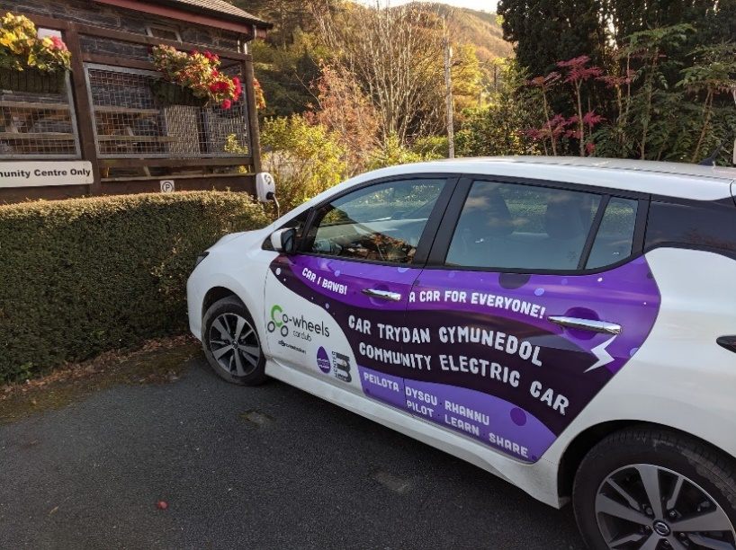

Although the vehicle has only recently been rolled out in Abergynolwyn, it has the potential to alleviate the need for second cars in town, and can be used to facilitate trips to medical appointments, improving access to services for Abergynolwyn’s residents. With a range of 168 miles, the car has the capacity to reach Denbigh, Chester and Aberystwyth, and is also being used for occasional long-distance trips. Volunteer drivers for the car enable it to be used as a community taxi. This social aspect of the provision demonstrates that there is clear potential for the service to have benefit for the community.

During the workshop, it was suggested that the mentoring was particularly impactful in terms of brokering relationships with other stakeholders in the area, including – crucially - the community centre where the vehicle is now hosted.

“If connections hadn’t been made by Renew Wales, I don’t think that we would have been able to get the charger installed.”

As demonstrated in figure 3 below, support provided through Renew Wales has helped Egni Abergynolwyn Energy to become better networked, working together with other organisations, including local government and other community groups. In particular, the support has helped to connect the group with UK-wide support organisations and car clubs elsewhere in Wales, none of which were not previously in contact with Egni Abergynolwyn Energy. In addition, Renew Wales mentoring has helped strengthen relationships between the group and the local community.

Figure 3: Egni Abergynolwyn Energy’s Networks

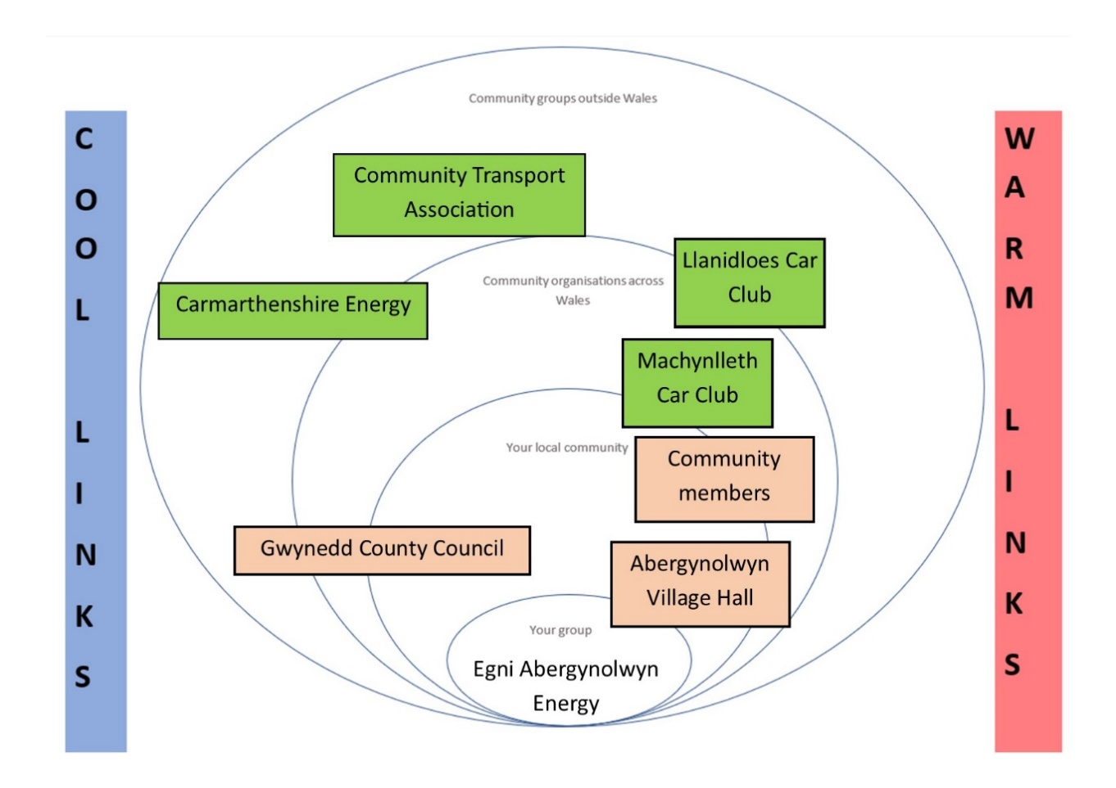

At the same time, attribution is difficult, as it is not possible to robustly or confidently identify how much of these changes- if any- was due to the support accessed through Renew and how much was brought about by other aspects of the project.

Participants were also asked about the impact of Renew Wales support on the group’s awareness of and ability to take action on climate change. It was suggested that given the group’s origins, the support received through Renew Wales hasn’t had a significant impact on awareness of climate change for members of the group, although supporting the installation of the community EV has had some impact on capacity. For the wider community, climate change is not an issue with a particularly high profile. The impact of the scheme, however, has been to raise the profile of the issue within the community. To this end, the impact of the support provided by Renew Wales has been represented by two arrows in figure 4 below, with on representing the impact on Egni Abergynolwyn Energy and the other representing the impact on the wider community.

Figure 4: Impact of Renew Wales support on awareness of and ability to take action on climate change

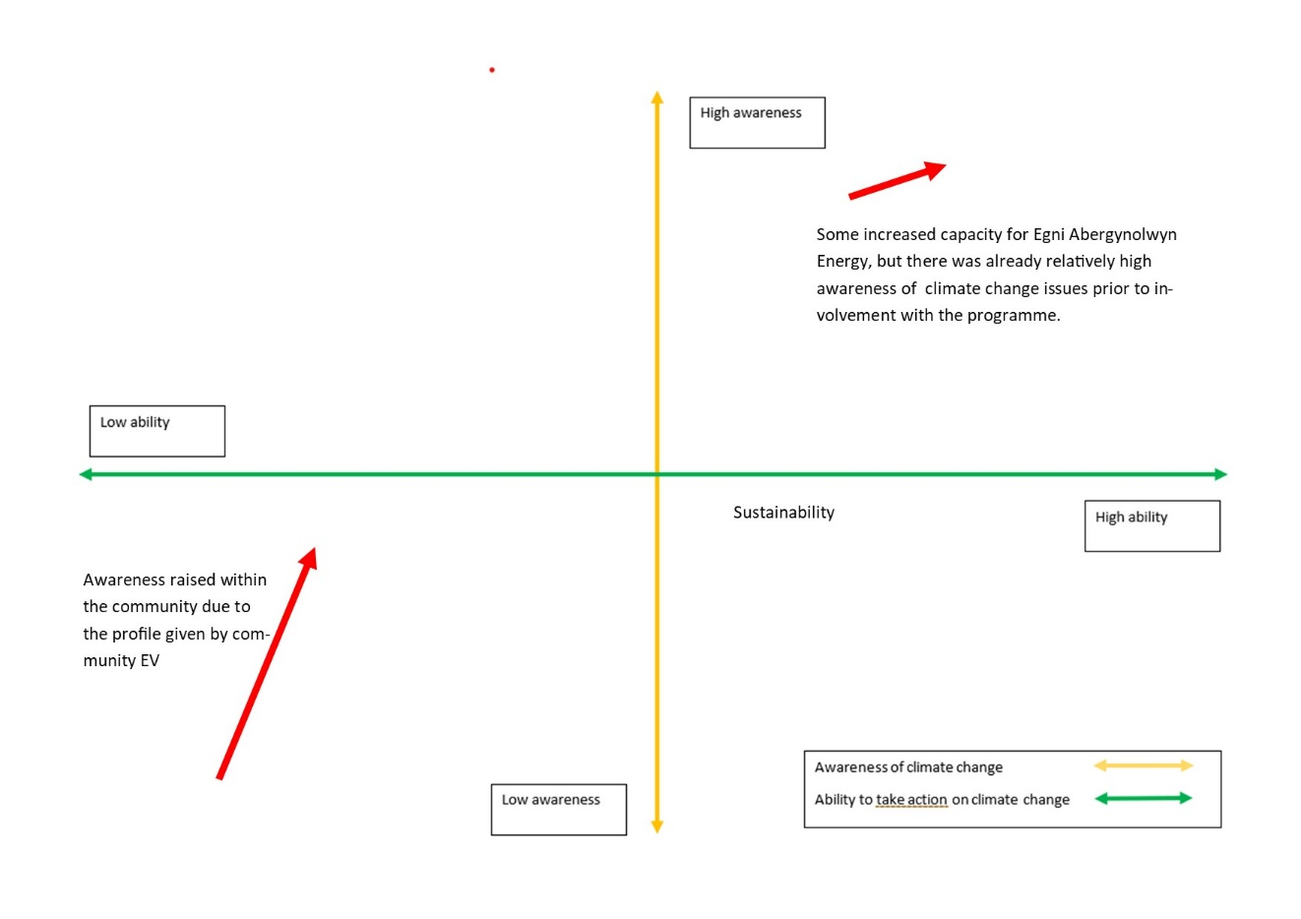

Again, it is important to recognise that these reflections represent the impacts of the project as a whole, and not just the impact of Renew Wales support, as it is difficult to disaggregate the precise impact of Renew Wales in this journey.

Future direction and the legacy of Renew Wales support
The workshop concluded by looking at Egni Abergynolwyn Energy’s future plans and the legacy of Renew Wales support for the group. The first objective for Egni Abergynolwyn Energy is to sustain and expand the community EV scheme. In order to do this, the group needs to secure support to continue to host a vehicle in the community, and to expand the project by gaining access to support for a community manager to carry out the administration and wider promotion of the scheme. If the organisations who have supported Egni Abergynolwyn Energy continue to support the group, the connections made through Renew Wales support have the potential to be instrumental for future initiatives as well.

Beyond the community EV project, there is also a desire to return to the initial focus of the group and explore the feasibility of a hydroelectric power scheme. Abergynolwyn was the first electrified village in Wales, achieved with power produced by a hydroelectric plant at the Bryn Eglwys quarry. The group’s long-term ambition is to restore these hydroelectric facilities, and a locally owned hydroelectric scheme could potentially lead to the community having access to lower cost, lower-carbon energy. However, there are a number of barriers the group faces in realising this scheme, including access to funding for the project, getting the right business support, overcoming local opposition from landowners, building community support for the project by keeping funding in Wales, and capacity for project development. While most of the connections made through Renew Wales are not relevant for these future plans, there is the potential for more community mentoring in the future.

Cemmaes Jubilee Hall
Cemmaes Jubilee Hall is a Church in Wales-owned property, previously belonging to the Harlech Estate. Built in 1893, the hall was originally a schoolroom for local children. The building became a church hall after 1912, when a larger school was built in the village. Located 8 miles north east of Machynlleth, the village is located in the Glantwymyn community of northern Powys.

Figure 1: Cemmaes Jubilee Hall

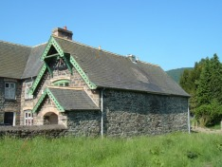

Alongside Ty Cemmaes, a shop come shared working space, and the local pub, the Jubilee Hall is one of only three public indoor spaces in the village. As a result, the hall is an important hub for its residents, at various times serving as:

- A location for community activities such as children’s activities, crafts, table tennis, whist drives, the home for writing courses run in partnership with Aberystwyth University
- The village polling station
- A venue for local people to host birthday parties and other functions

Cemmaes faces a challenge common to many rural communities in Wales. It is losing access to services, a situation exacerbated by government austerity, and has an ageing population, as young people move away from the village. There is no bus-service through the village, leaving people to walk along a main road to Cemmaes Road if they want to catch a bus to Machynlleth, Dolgellau or Newtown.

The journey

As the Church in Wales is financially unable to sustain the hall, a committee and a trust was set up in the community to help sustain and improve the Jubilee Hall as a resource for the community. Although the group has been able to obtain funding for renovations, including an extension, built in 2012, supported by the local County Voluntary Council (CVC), Powys Association of Voluntary Organisations (PAVO) and European funding streams, the hall has ongoing maintenance issues. A key challenge facing the group is to make the hall warm enough to use in the winter months. As an old building, the hall isn’t insulated to a particularly high standard, meaning heating costs are high and - at times - the hall isn’t suitable for more vulnerable groups, particularly the elderly, to use.

The role of Renew and actions
The group got involved with Renew Wales after being signposted to the programme through PAVO, when the group mentioned that they wanted help to make the building warmer. The committee was signposted to the local Renew Wales coordinator, from Ecodyfi, who engaged with the group, signed them up, and undertook an assessment of the group’s needs. After engaging the group, Ecodyfi carried out an energy audit.

The survey carried out by Ecodyfi identified several issues causing the difficulty in creating a warm indoor space: the lack of insulation, the high ceiling, a large window area, water infiltration, as well as an inappropriate heating system. It suggested appropriate means of addressing these issues and signposted the committee to possible sources of funding to take these actions.

Following the energy audit, Cemmaes Jubilee Hall was able to access £850 funding through the Dyfi Community Energy Fund to purchase blinds to reduce heat loss from the hall’s large windows.

Impacts
During the workshop, participants were asked to identify the role of Renew Wales support in the journey of Cemmaes Jubilee Hall. The main impact of the support was that an energy audit for the property was produced. This informed the group of the options available to them, and the strengths, weaknesses and viability of each of them.

In terms of practical action, Renew Wales support helped the group to access the Dyfi Community Energy fund, and the installation of blinds has gone some way towards making the hall warmer during the winter months. At present, however, while there remains a need to improve temperatures in the hall during the winter, further action has not been taken due to difficulties with obtaining funding.

As a result, during the workshop participants suggested that the impact of the support accessed through Renew Wales has primarily been to raise greater awareness of what the group can do to take action on climate change, rather than enabling the group to take action on climate change. The primary obstacles to realising the group’s aspirations and taking action on climate change were identified as securing access to grant funding and/or successfully fundraising to achieve these goals. As the programme has not removed the primary barrier they are facing to taking action, figure 2 below, indicates that the support accessed through the programme has had more of an impact on the group’s awareness than it has on its ability to take action.

Figure 2: Impact of Renew Wales support on awareness of and ability to take action on climate change

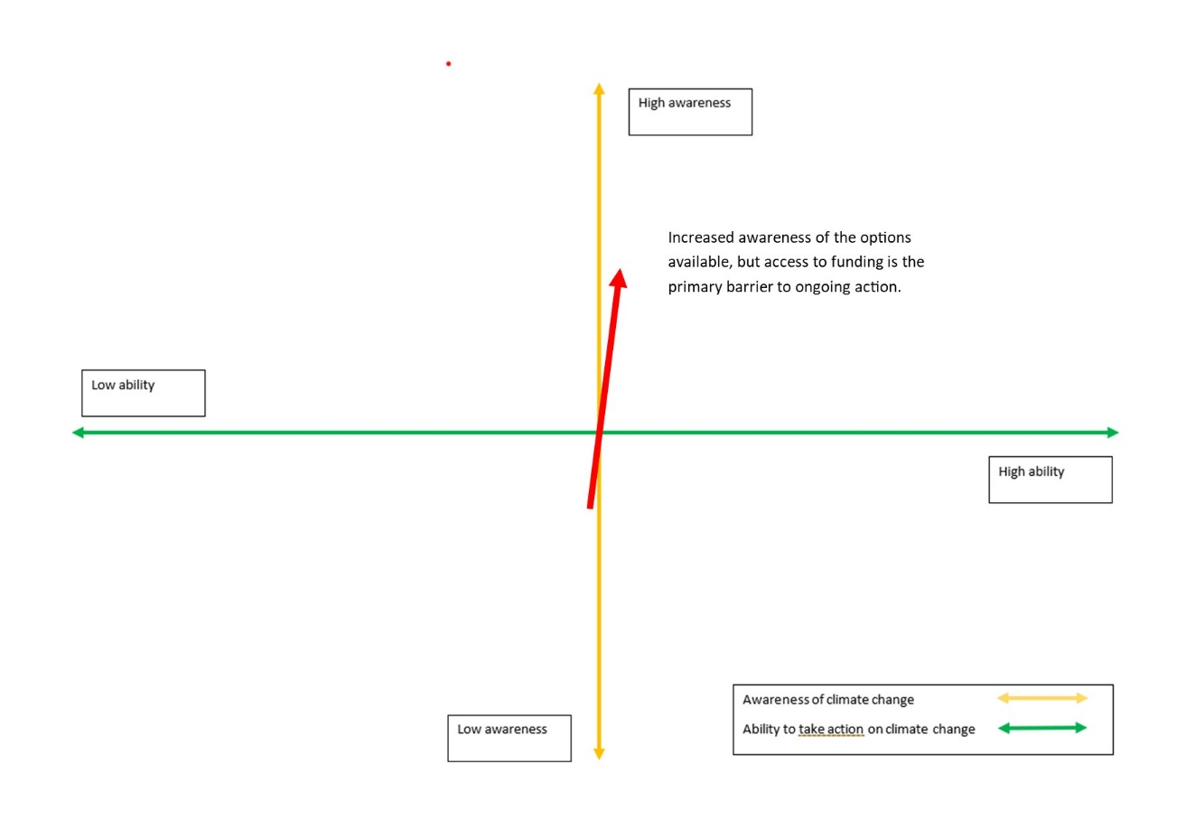

The intervention also appears to have had a limited impact on the group’s networks. Apart from Eco Dyfi with whom the group connected, the only other connection identified as made while receiving Renew Wales support was the Rural Futures programme, which is a National Lottery Community Fund supported project working with the Glantwymyn community. Renew Wales support has potentially strengthened relationships with PAVO, Powys County Council and Glantwymyn Community Council, however, but during the workshop the group was unable to identify ways in which these networks have facilitated future actions, solved problems or created improved opportunities.

Figure 3: Impact of Renew Wales support on Cemmaes Jubilee Hall

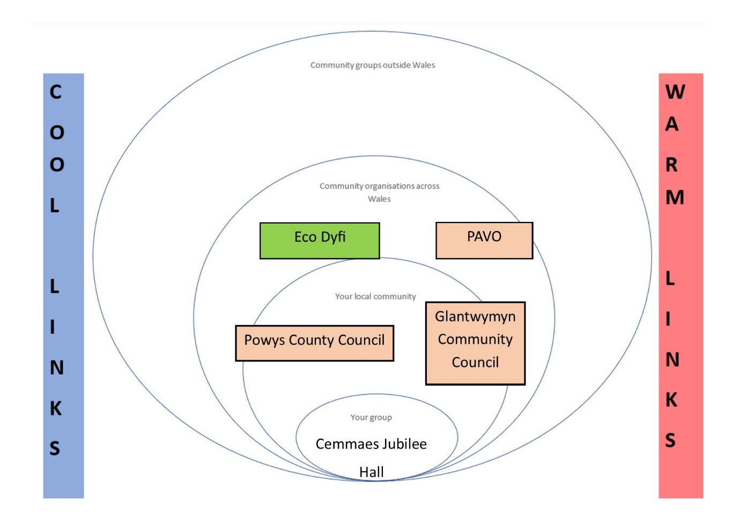

Future plans and ongoing support needs
As when they became involved with Renew Wales, Cemmaes Jubilee Hall’s future plans revolve around ensuring that the space remains usable for the community. The group’s primary concerns continue to be around energy efficiency, in order to make the space warmer and reduce heating costs. While the installation of blinds has gone some way to ensuring that the space is warmer in the winter and reducing insulation costs, there is still considerable work to be done.

Future actions include finding funding to carry out maintenance, replace tiles that are coming off the roof, prevent water-ingress and carry out structural work on the building. The committee also has ambitious aspirations for the space informed by its engagement with Renew Wales, including fitting the building with modern insulation, installing photovoltaic panels on the roof and using a ground-source heat pump to heat the building. There is also work required on the roof to prevent water-ingress. Although the group feels that through Renew Wales and other support available to the sector, the success of these plans will depend on access to funding to make them happen. This was identified as the primary barrier facing the group from making future progress.

Cwm Arian community owned wind turbine
Cwm Arian Renewable Energy (CARE) is a community benefit society run by local residents, which has installed a 700kW wind turbine on Trefawr Farm in Llanfyrnach, Pembrokeshire. The 61m turbine has the capacity to generate over 2,000 MWh every year, sufficient energy to power around 500 homes.

Figure 1: The installation of the Cwm Arian wind turbine

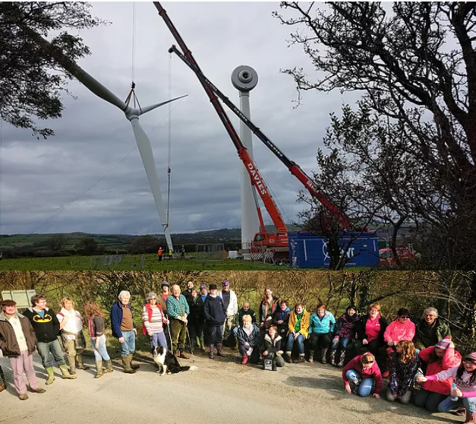

Cwm Arian (Silver Valley) is a rural area located where North Pembrokeshire, South Ceredigion and West Carmarthenshire meet. It comprises the villages of Hermon, Glogue and Llanfyrnach and is characterised by small settlements and a dispersed population with a relatively high percentage of Welsh speakers.

The journey
The origins of the project lie in community development work carried out by PLANED (Pembrokeshire’s local community development organisation), which sought to identify community priorities, including priorities in relation to taking action on climate change. The plan identified that rising energy prices and fuel poverty were a particular challenge facing Cwm Arian, and that the area had particular potential for renewables that was not being tapped into.

In 2006 the community was awarded £8,000 from the Sustainable Development Fund, which Pembrokeshire Coast National Park deliver, for a feasibility study into renewable energy in the area. The study identified a site that had the potential for siting wind turbines on the hills behind Llanfyrnach. These wind turbines could provide income from selling the generated electricity to the National Grid, generating money that could be put back into the community for the benefit of its residents.

In 2010, the Low Carbon Communities Challenge grant was awarded to the Cwm Arian community, based on the findings of the 2008 feasibility study. This funding was expressly to advance community understanding of energy efficiency, and to further the project to erect wind turbines in the community. CARE has also received support from Ynni’r Fro, a Welsh Government and Energy Savings Trust scheme which supports community renewable energy groups in Wales.

With the support of Ynni’r Fro, CARE was officially constituted as a community co-operative in 2011. Since constituting as a community co-operative, CARE has worked towards its long-term goal of installing a wind turbine, as well as other projects such as the EU LEADER funded Supporting Resilient Renewable Communities project, a Growing Better Connections landscape regeneration project focusing on landscape for biodiversity and wellbeing, and a project to develop an old industrial plot as a peaceful, publicly accessible space for creative projects made from recycled and natural materials.

Figure 2: CARE’s Growing Better Connections team

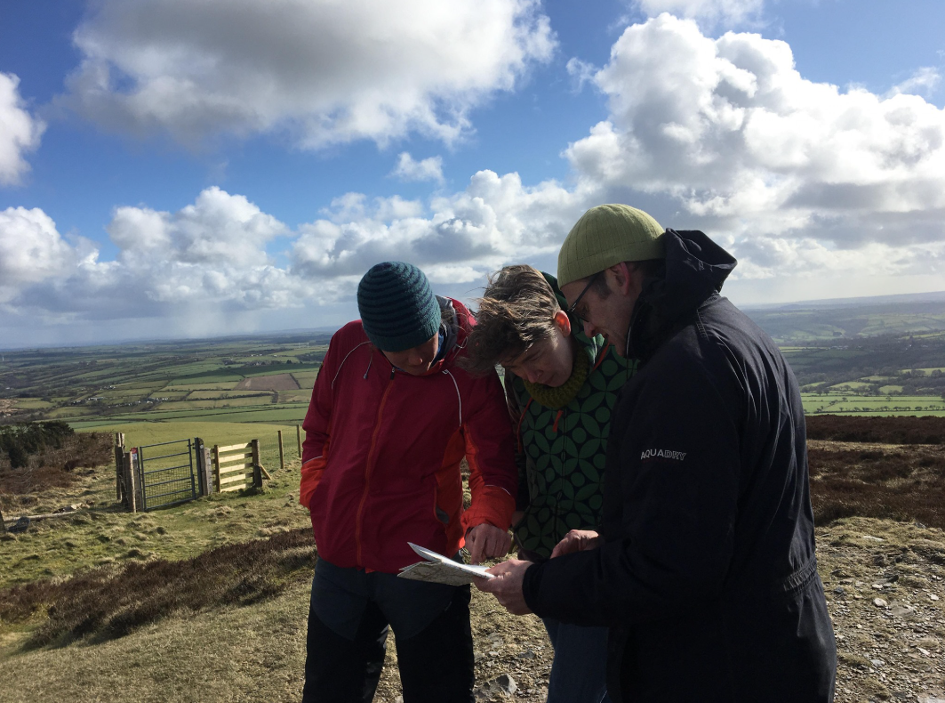

The role of Renew and actions
CARE got involved with Renew Wales as part of their long-term relationship with the development officer provided by Ynni’r Fro. CARE was identified as a group that could benefit from the support available through Renew Wales. Since they initially got involved with Renew Wales, CARE has received support during multiple phases of the project regarding different things. In addition, CARE has hosted a Renew Wales coordinator for just over a year.

The most recent round of support received from Renew Wales has involved putting the group in touch with a Mentor at Sharenergy. The support focused on helping CARE to put together a forecast budget for the turbine, as things was an area that the group felt that it had insufficient experience to handle on its own.

The role of Renew has been important in helping to solve some specific technical problems, but is ultimately “a relatively minor part of the wider mosaic of support [the group has] received.”

Figure 3: The site ahead of the installation

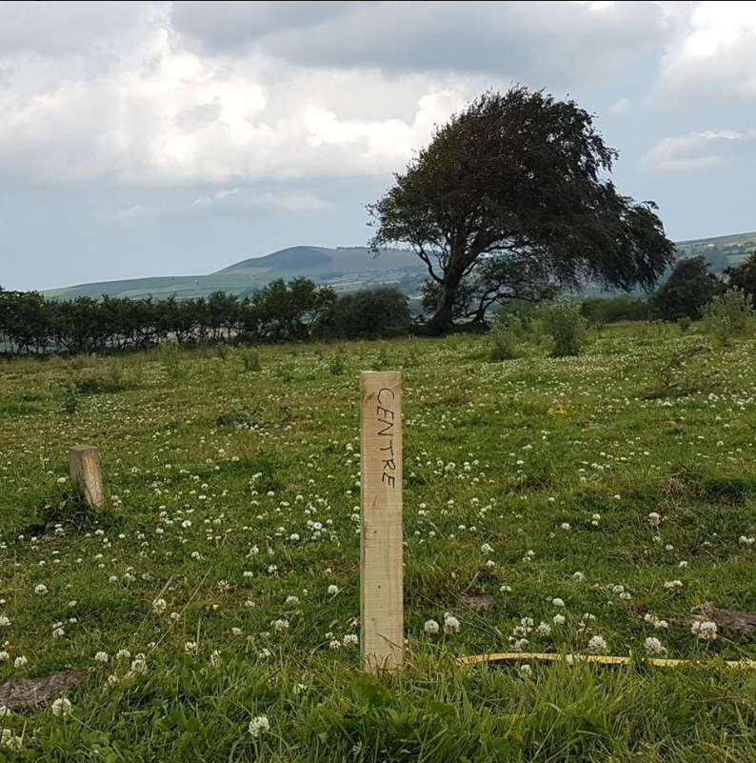

Impacts
Workshop participants were asked to plot the impact of Renew Wales support on the organisation’s awareness of and ability to take action on climate change and sustainability along two axes, one representing awareness of climate change and sustainability, and the other ability to take action on these themes. Discussions have been represented pictorially below.
As figure 4 below, indicates, it was suggested that there has been an impact on the group’s ability to take action on climate change and sustainability, because it solved a particular problem they were facing. There was, however, a strong feeling that the group was already well aware of climate change prior to becoming involved with Renew Wales.

Figure 4: Impact of Renew Wales support on awareness and ability to take action on climate change and sustainability

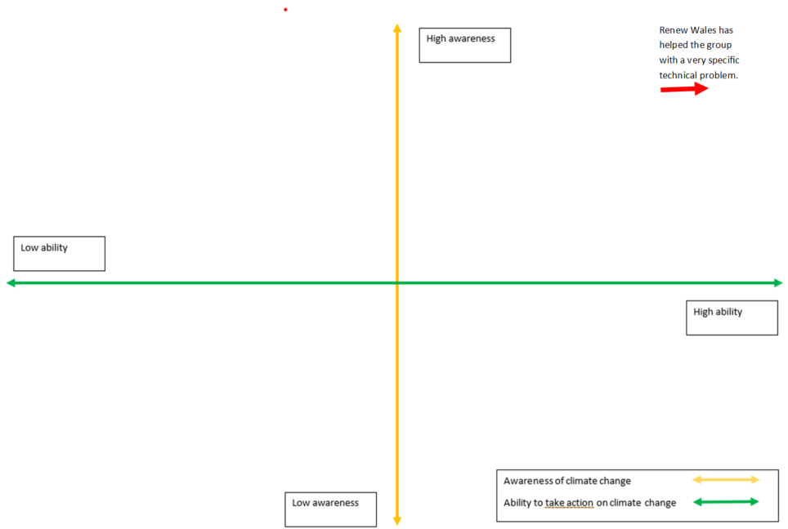

The workshop also explored the legacy of Renew Wales support on CARE’s networks. During the workshop, it was identified that Renew Wales support was something that emerged from the organisation’s networks as much as it had contributed to them. It was identified that the Renew Wales support had strengthened relationships with the organisations they were put in contact with, specifically Sharenergy and Community Energy Wales.

Another important difference that the support made is to improve CARE’s relationship with the local community. The support, being provided by an established external organisation with an existing reputation-built relationship with the community and overcame some residual scepticism within it.

“Bringing in external experts always brings credibility to a project, something that is important for building trust with a community that you’re hoping to convince to invest in the project.”

Figure 5: Lasting legacy of Renew Wales participation on CARE’s Networks

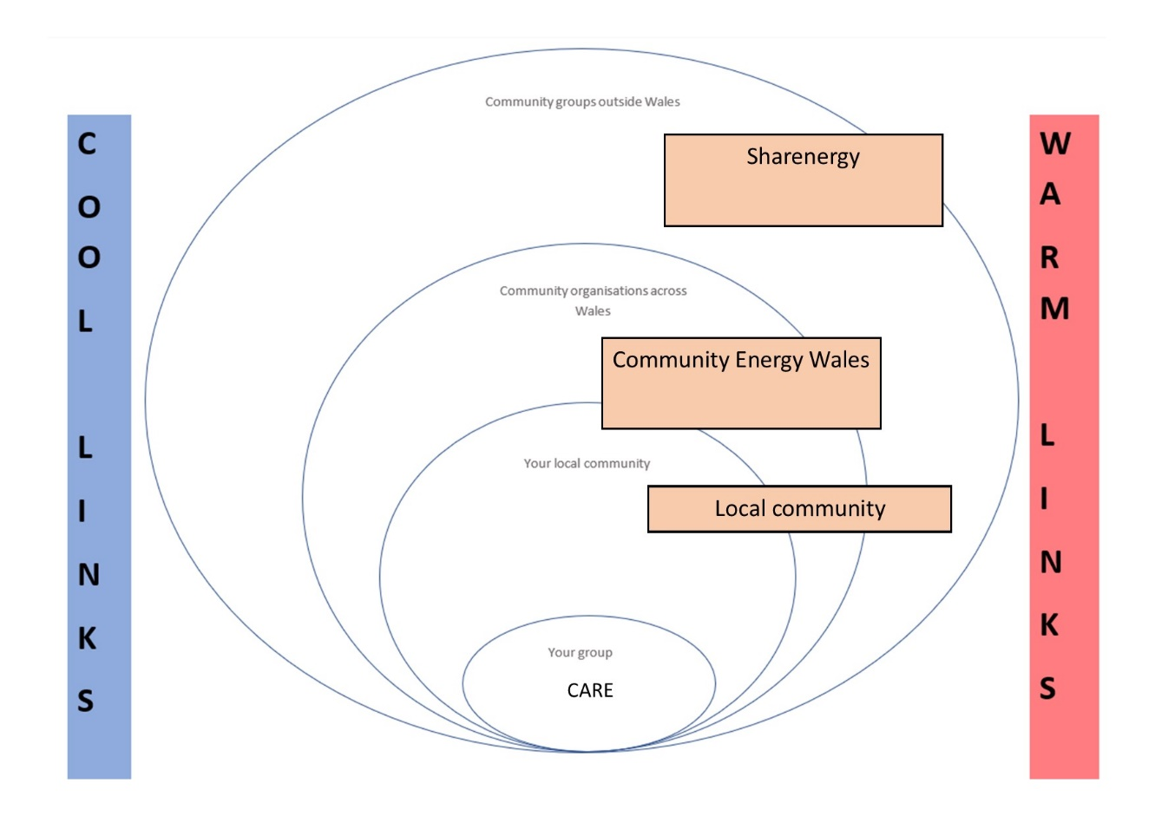

Future direction and legacy of Renew Wales support
The future objectives for CARE are to continue pursuing their existing goals and objectives as they relate to building the resilience of the local area to climate change through promoting community owned energy generation and tackling fuel poverty. The construction of the turbine will be a step change for the organisation, as income from the turbine will be used to support a community fund that will invest in energy efficiency work, potentially including bulk buying insulation and installing it in homes in the area.

The main support needs identified by CARE are around engaging with Welsh Government and other policymakers. Taking action on climate change will require more collaboration between public bodies and communities, but CARE’s perspective is that at present these organisations are poorly geared up to support communities in this area. Ensuring that public bodies and policymakers are as open as possible to communities and can provide relevant help to communities that want to take action, will be essential if communities are to play a big part in Wales moving towards net zero.

01545 571711
wavehill@wavehill.com
wavehill.com

Emmaus South Wales
Emmaus South Wales is a registered charity, based in Bridgend. Working with and for the benefit of homeless people, the charity provides accommodation for up to 24 formerly homeless and jobless people. In return, supported individuals are expected to work 40 hours per week or as much as they are able, in the charity's social enterprise. They are required to sign off all benefits with the exception of housing benefit, which is claimed to help support the Community. The ultimate goal is for each Community to become self-sufficient, supporting itself with the revenue it generates through its businesses. There are currently 29 Emmaus Communities across the UK, In addition to this, there are four emerging groups, working to establish new Communities.

The journey
Founded in 2012, Emmaus South Wales opened its first shop in 2013, and has grown steadily since then. Emmaus South Wales has seven physical shops across South Wales, as well as collection and delivery vans, which have added capacity to the organisation. The most significant milestone for the charity since its foundation was the opening of its house in Bridgend in 2016.

The long-term goals for Emmaus South Wales are for the Community in Bridgend to become financially sustainable, and to help the individuals it supports on a longer-term journey towards stability and employment. The core goals of Emmaus are not directly related to taking action on climate change and sustainability, although the importance of charity stores to its model means that sustainability, re-use are well embedded in the organisation.

The role of Renew and actions
Emmaus’ motivation for getting in touch with Renew was to have a wider conversation about re-use and sustainability within the organisation. As well as a more general desire to start a conversation around sustainability within the organisation, the group’s contact with Renew was driven by a desire to get better at re-using bikes. Initial visioning exercises suggested that this could involve providing bicycle maintenance as a service available through Emmaus stores and/or selling bicycles in store.

The first mentor that Renew worked with was directly related to this initial motivation, receiving mentoring from Cycle Training Wales. In particular, the mentor provided a feasibility study for bicycle maintenance, concluding that it wasn’t feasible to do major bicycle repairs in store (due to space constraints and the requirement of having a workshop to do these repairs), but minor repairs and bike sales were possible. These recommendations have been implemented, and Emmaus now sell bikes and do minor bike repairs in store. While this has not produced significant differences to income, it has improved income slightly, and the service that Emmaus is able to offer to communities.

The second mentor that worked with Emmaus South Wales was brought in to conduct an energy efficiency audit of the charity’s shops. The findings of the report resulted in a bid to secure a loan from the Carbon Trust to change lighting in Emmaus’ superstore and its shop in Porthcawl. While the bid for funding in Porthcawl was rejected by the Carbon Trust, which cited insufficient savings to justify expenditure, Emmaus has undergone a refit of lighting in the superstore, completed in 2018.

Impacts
This refit has had a significant impact on Emmaus in a number of areas. The lighting has improved aesthetics in the shop, through using smaller lights. In theory, the refit has the potential to cut lighting use in half, although in practice, the impact of the refit in this area remains to be seen.

In terms of wider impacts of the support received through Renew Wales, discussion emphasised that Renew’s impact was not a big one, but had influenced a number of small things within the organisation. For example, staff at Emmaus report some behaviour change impacts in terms of making staff and volunteers think more critically about energy use when approaching future problems. There is a perception that through exposing staff to conversations about energy usage and sustainability, Renew has provoked similar conversations about energy usage and sustainability in different contexts in the future.

At the same time, there is a perception that the impact on the organisation as a whole is more limited. Re-use, and preventing things from going into landfill, is a key value for the company. Rather than changing the way that the organisation thinks about sustainability, then, the main contribution of Renew has been to add organisational capacity, helping the organisation to know what to look for and how to look for it regarding environmental impact, particularly in the area of energy efficiency.

Figure 1: Impact of Renew on Emmaus South Wales’ Awareness of and ability to take action on climate change and sustainability

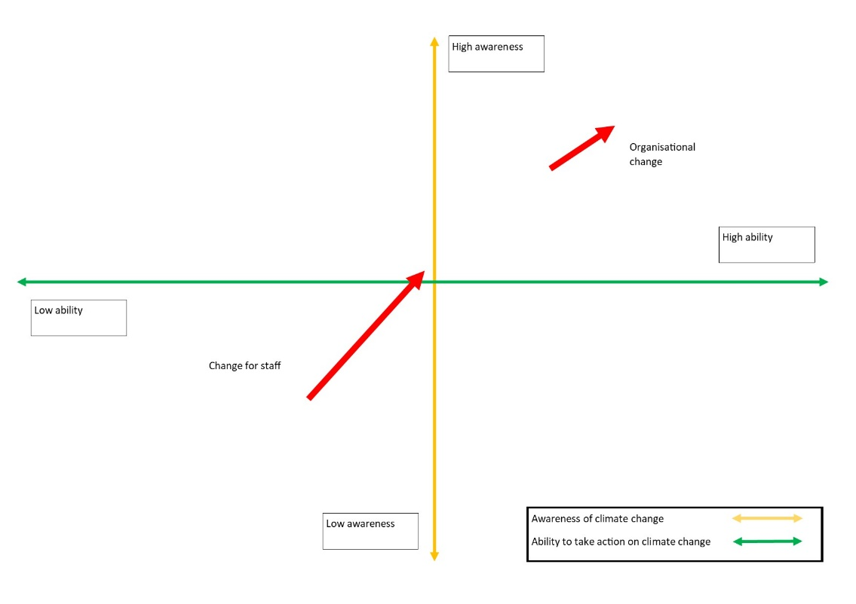

Emmaus South Wales’ contact with Renew has also had a small impact on Emmaus’ networks within the third sector, although the increase in networks has been largely limited to the individual coordinators and mentors they have worked with, as well as their host organisations. This relationship is ongoing, and Emmaus South Wales reports that they plan to collaborate again in the future. A not insignificant secondary impact in this area is a broader knowledge of funding sources for low carbon energy initiatives, which will enhance the organisation’s ability to draw in funding for similar projects in the future.

Figure 2: Lasting legacy of Renew Wales participation on Emmaus South Wales’ networks

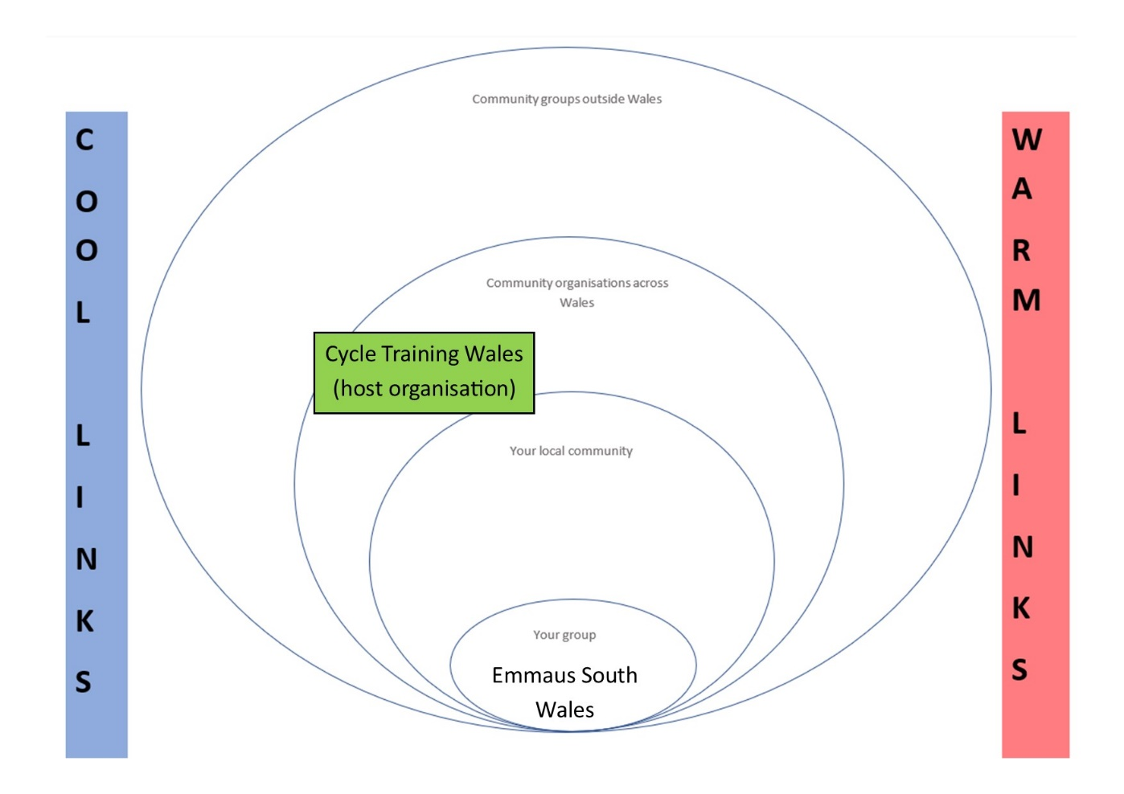

Future direction and the legacy of Renew Wales support
The primary objective for Emmaus South Wales in the future is to achieve financial stability through generating further income through enterprise. Key to this will be identifying and developing business opportunities that allow the charity to expand its operation and generate new income through enterprise. Examples currently being discussed include house clearances, something that is being actively pursued by other community enterprises elsewhere in the UK. There is the potential for more peer-to-peer mentoring in this area, which would help the learning from other community enterprises to be taken on board by Emmaus South Wales.

A big driver for Emmaus South Wales’ future expansion will be cost-effectiveness, and the potential to fit out any buildings owned by the charity with motion sensor lighting, solar panels and other equipment that it learned about through Renew Wales. Conversely, the major barrier to impact in this area is the fact that Emmaus South Wales rents many of the properties it operates out of. In this context, investing in the energy of property is actually quite difficult.

Gilfach Goch Community Gardens
Gilfach Goch is a former coal mining village located in Rhondda Cynon Taf. With 3,436 residents as of the 2011 census, Gilfach Goch is located in Cwm Ogwr Fach, halfway between the Ogmore and Rhondda Valleys.

Set up by community members in 1996, the Community Association is a company limited by guarantee and a registered charity which is managed by a board of trustees. Based in a community centre in the village, the aim of the community association is to 'to promote any charitable purpose for the benefit of the community in Gilfach Goch and in particular the advancement of education, the promotion of good health and the relief of poverty, distress and sickness'. It has a number of programmes running within the centre, including:

- After School clubs, youth clubs and holiday playschemes
- The WCVA-funded Active Inclusion employment programme for 16-24 and 25+ year-olds
- Messy Monsters Creche and play nursery
- A parent & toddler group
- Social enterprises including a community café and hair salon
- A disability group
- Rooms for hire including conference suites and an IT suite

The association primarily works with members of the local community, but its Active Inclusion employment programme activities operate throughout the whole of RCT and its disability clients come from across South East Wales.

Figure 1: Gilfach Goch

The journey
In the last 20 years, the association has grown, including developing a new extension for the centre. The association has continued to work for the benefit of the local community, although the direction of its activities has partly been shaped by the availability of funding to draw in money to support the community. Members of staff at the association have a background in environmental issues, although there is a perception that environmental projects have not been easy to fund in recent years, meaning that the association has done less work on the environment than many would have liked it to have done.

The contact with Renew Wales came as Gilfach Goch Community Association sought to engage with the local community to collectively redevelop the outdoor space around the centre. The aim of doing so was to create a community garden that would be of benefit to the whole community, but particularly the residents of the local Swn-yr-Afon sheltered housing run by Trivallis Housing.

The role of Renew and actions
Contact with Renew Wales was made through the local CVC, Interlink, which hosts a Renew Wales coordinator. The coordinator initially brought the community association together with Swn-yr-Afon, and brought in mentors from Grow For It, a community garden in Llantrisant, Rhondda Cynon Taf, and EggSeeds, a sustainability and outdoor education organisation based in Cardiff.

Figure 2: The Community Garden at Gilfach Goch Community Association

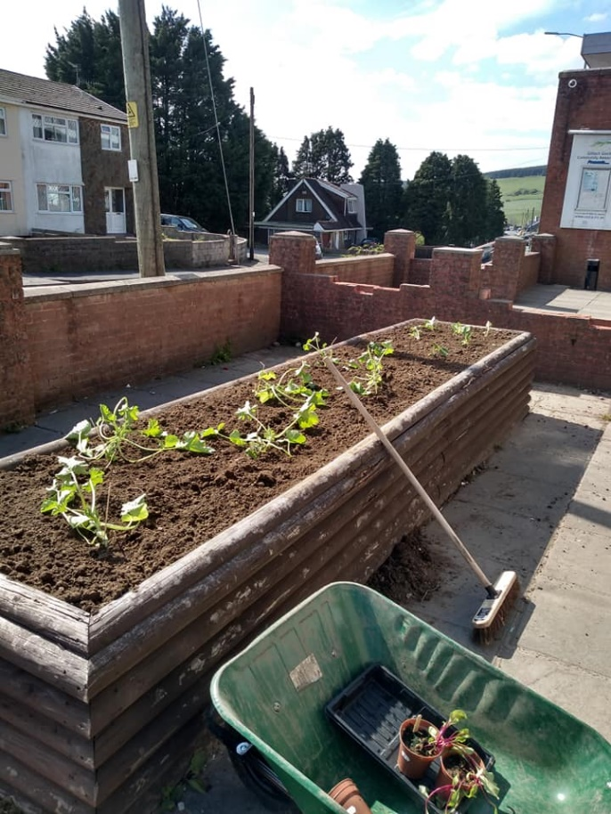

One of the mentors ran workshops with five or six different community groups (e.g. youth group, parent and toddler group and the senior citizen group) within the community association to find out what they wanted in the community centre consulting different community groups about what they wanted from a community garden and to talk about the issue of climate change. These consultation exercises resulted in a workshop and a plan of action to create a community garden space.

Following this action plan, the mentors helped the community association to carry out the work developing the community garden, through fencing off the area, creating raised beds for growing and making some garden furniture all made out of recycled materials.

The first stage of the community garden has been completed, with the garden area now fully marked out and everything planted. A second stage of its development is now planned, due to be completed by the end of 2021, which will include an outdoor shelter and a seating area, done through a woodwork skills club.

Impacts
The main impact of the support on the community association has been the additional expertise provided by Mentors, that has allowed Gilfach Goch to develop its community gardens.

Awareness of and ability to take action on climate change

Gilfach Goch community association were asked to plot the impact of Renew Wales support on the organisation’s awareness of and ability to take action on climate change and sustainability along two axes, one representing awareness of climate change and sustainability, and the other ability to take action on these themes.

As figure 3 below, indicates, it was suggested that there has been an impact on awareness of climate change and the ability of the community association to take action. The impact of the support has been more significant in terms of awareness than it has on the ability to take action. There has been particular impact on individuals’ awareness of the specific actions that they can take to reduce carbon emissions and how the community garden fits into the wider picture of action on climate change and sustainability.

“The workshops explained actions we as individuals could take to combat climate change such as turning off lights, recycling more, not using a car as much. The community growing mentor focused on the impact our garden would have e.g. planting trees would absorb CO2, community growing would reduce food miles.”

It was noted, however, that levels of understanding were quite varied among members of the community association.

“The level of knowledge around climate change varied a great deal with the different groups. The youth group knew a lot about climate change whilst the senior citizen group mostly knew very little. The workshops explained what climate change was and the different ways it could impact e.g. melting the ice caps would result in rising sea levels. The workshops also filled in gaps and misconceptions people had about climate change.”

There is a perception that the intervention did not have a significant impact on Gilfach Goch Community Association’s ability to take action on climate change because it is a relatively small part of the wider action that needs to take place around climate change.

Figure 3: Impact of Renew Wales support on awareness and ability to take action on climate change and sustainability

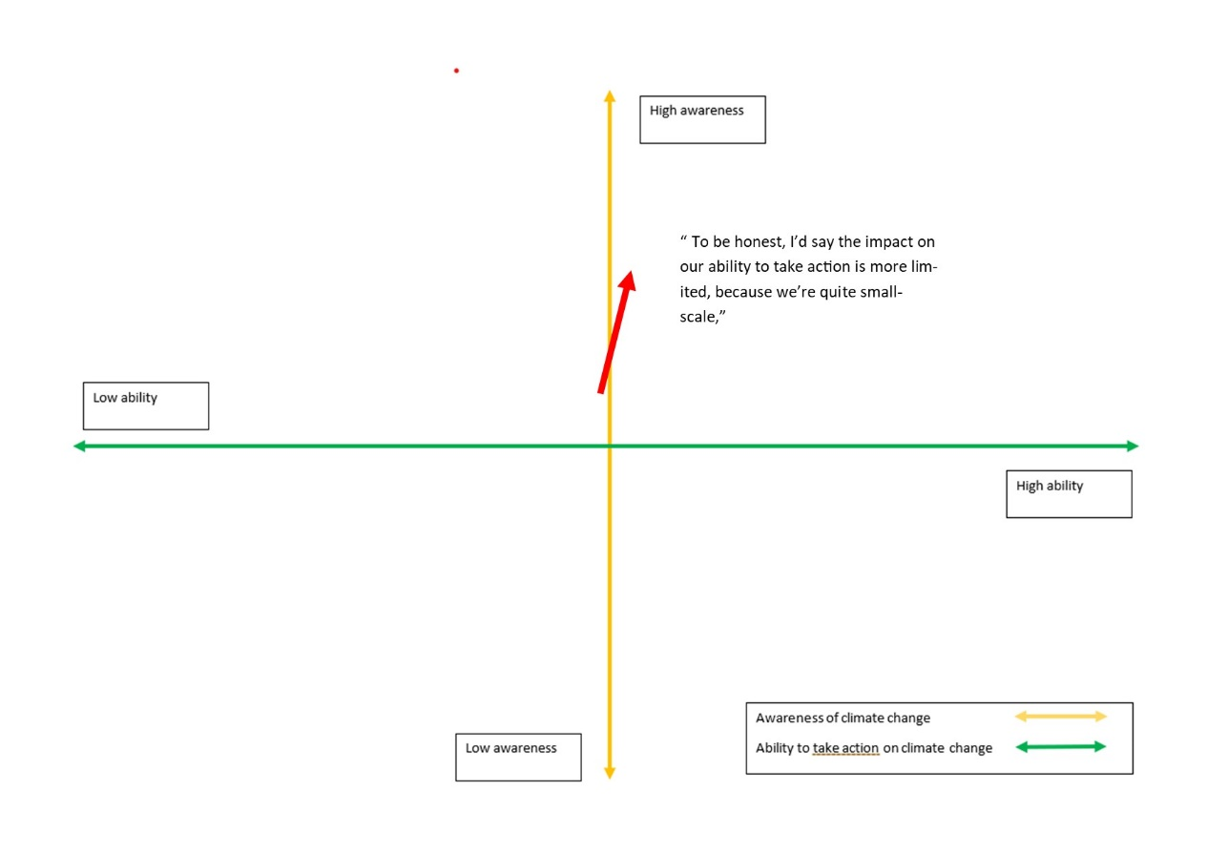

The climate change conversations that Mentors had with the groups were seen as important drivers of this change. It was suggested that bringing in outside expertise to discuss these issues is often more impactful than existing members of the community association trying to engage the community about climate change.

Figure 4: Plants grown at Gilfach Goch community garden

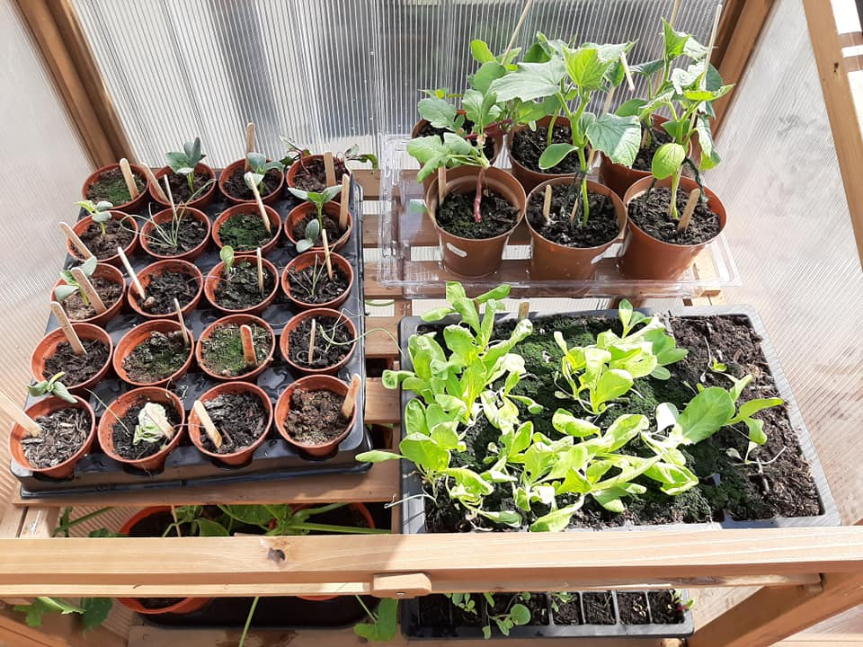

Networks and connections

The workshop also explored the legacy of Renew Wales support on Gilfach Goch’s connections and networks. It was suggested that the impact of the intervention has been relatively minimal. The reason for this is that Gilfach Goch Community Association is already a well-established community organisation that already has very strong relationships with other community groups.

The intervention strengthened relationships with the Swn-yr-Afon sheltered housing and the host organisation of Renew Wales mentors. However, there is a perception that these relationships have dropped off a little bit since the consultation and development of the community garden. Although not working directly with these organisations, including Swn-yr-Afon, Gilfach Goch Community Association feels that these organisations still have their doors open to them, and there is the potential that these relationships could be picked up again if the circumstances dictated that this would make sense.

“The main impact is that we know where would go for advice and support for this kind of project in the future.”

Figure 5: Lasting legacy of Renew Wales participation on Gilfach Goch Community Association’s Networks

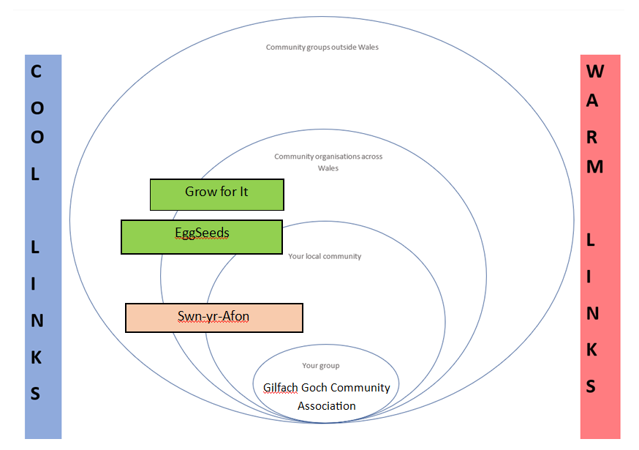

Future direction and legacy of Renew Wales support
Gilfach Goch Community Association’s ongoing vision is to continue to support the local community in the area by giving them the services they need and creating a sense of ownership over the development of the community.

Inevitably, the way that this support is delivered will be influenced by Welsh Government policy and funding priorities. The community will continue to carry out activities with a climate change focus provided that this is supported by Welsh Government policy and the availability of funding to make it happen. The Gilfach Goch Community Association believe that the WFGA establishes a framework for future priorities, including around supporting communities to take more action on climate change and sustainability within their communities.

The community association would strongly consider accessing mentoring support for future initiatives, and they believe that there will always be a need for this kind of mentoring support, as “community development will always need experts to come in and provide specific expertise to support communities”.

Mayhill Washing Lake and Community Food Garden
Mayhill Washing Lake and Community Food Garden is located in the Mayhill district of Swansea. Overlooking the city centre, docklands and Swansea Bay, Mayhill Washing Lake and Community Food Garden is located on Town Hill in the southern part of Mayhill. Taking its name from the Old English words ‘waesse’ and ‘lacu’ meaning wet or swampy stream, Mayhill Washing Lake is a stream arising on the hill. During the medieval period, the stream provided much of Swansea’s water supply, and in the 1700s, was used to feed a large tannery and - by the 1800s - the city’s workhouse, known as Cae Cwm.

Figure 1: View of Swansea from Mayhill Washing Lake

The journey
By the 2000s, the area had largely become disused, with the washing lake no longer significant in the supply of water to the city. Owned by the council, the land was used primarily as a way of getting from one part of Mayhill to another and was known as a site for fly-tipping and other antisocial behavior.

Realising that the area was not being used to its full potential, in 2017, a group - led by a local councilor - decided to come together to do something about the area. As well as taking care of a neglected area of Mayhill, the group were motivated by a desire to get involved in a growing project, leading to the founding of Mayhill Washing Lake and Community Food Garden group.

Recognising how difficult it can be to get access to nature in the middle of a 21st Century town, and wanting to do something to address food poverty, the group came together to cultivate some land beneath the Washing Lake and do general maintenance and work on the site. With between five and eight members regularly attending sessions, the group also does wider outreach involving the wider community in the project. The space is also open to the public, meaning that anyone can use the site whenever they please, and take any of the produce that has been grown.

The role of Renew and actions
Mayhill Washing Lake and Community Food Garden got involved with Renew via connections with the local Renew Wales coordinator in the context of their host organisation, the Swansea Environment Centre. The group’s motivation for seeking help from Renew Wales was that while they had a lot of enthusiasm for the project, they did not have all the technical expertise and experience they needed to bring it to fruition.

Figure 2: Volunteers at Mayhill Washing Lake and Community Food Garden

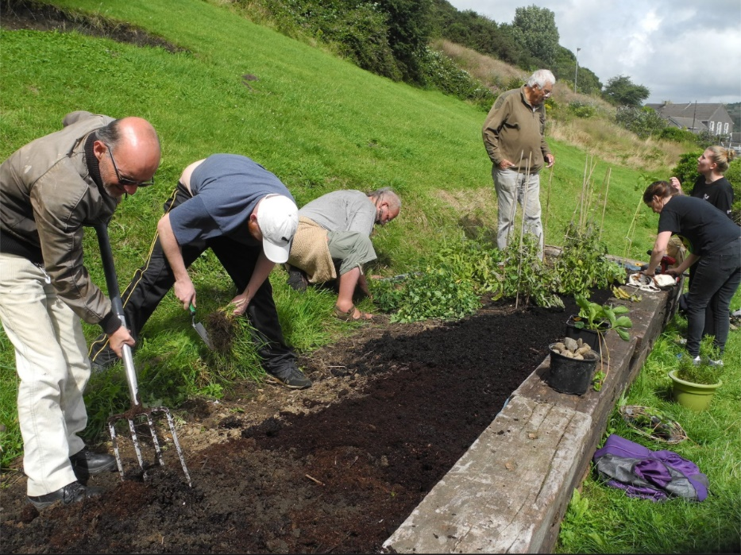

Working with the coordinator, the group developed an action plan, and then was put into contact with a peer mentor from Cae Tan. Cae Tan is a Community Supported Agriculture project based in Ilston on the Gower. Supported primarily through the financial contributions of its members, Cae Tan also carries out outreach with community and school groups.

Cae Tan worked with Mayhill Washing Lake and Community Food Garden by providing advice on a variety of specific issues, including how to build and maintain raised beds, how best to prepare the soil for growing and how to provide a water supply to the food garden. This support was tailored to the specific problems faced by the group and drew from specific experience of similar projects.

Impacts
A number of impacts of Renew Wales support were identified. Most significantly, the support provided by the mentor helped the group to complete practical projects that they previously wouldn’t have had the expertise to complete as effectively. Interestingly, coordinator support throughout the action planning phase was identified as something that had increased the group’s ability to recruit and retain volunteers for the project.

Workshop participants were also asked to plot the impact of Renew Wales support on the group along two axes, the first referring to awareness of climate change and sustainability and the second to groups’ ability to take action on these issues.

As figure 3 indicates, there is a perception that the group’s awareness of and ability to take action on climate change has increased since its involvement with Renew. In part, this is due to the increased capacity of the group to develop local solutions to growing food due to the mentoring.

However, there was also a suggestion that some of these impacts would have happened anyway due to the experience gained by working on the project and finding solutions to practical challenges. Likewise, there a perception emerged that some of the changes in climate change awareness were driven by exogenous factors, including changes to weather, seasons and rainfall, as well as wider social change. In this context, Renew Wales should be understood as a contributor to wider changes rather than a principal driver of them.

Figure 3: Impact of Renew Wales support on awareness and ability to take action on climate change and sustainability

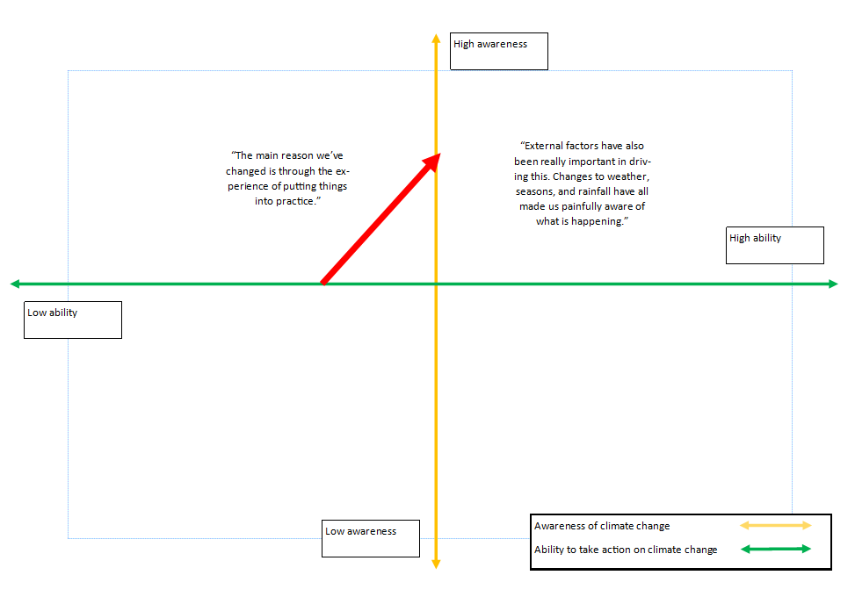

Likewise, the workshop indicated that Renew Wales has only had a relatively limited impact on groups’ networks. While some relations have been strengthened by the intervention, these generally pre-existed the intervention, and Renew Wales should be understood as strengthening existing relationships rather than forming completely new ones. The group has worked more effectively with other community growing spaces, such as Vetch Community Garden and Seaview Allotment space, but these relationships would probably have happened anyway.

Figure 4: Lasting legacy of Renew Wales participation on the group’s networks

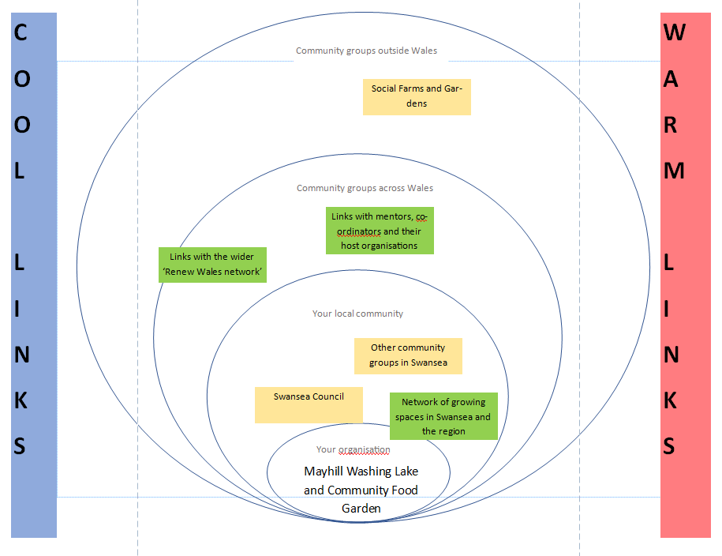

In terms of both the group’s awareness of and ability to take action on climate change and sustainability and its networks, Renew Wales’ impact on Mayhill Washing Lake and Community Food Garden has primarily been catalytic, helping things to happen more quickly and effectively, and strengthening relationships rather than being the primary driver of either.

Future direction and legacy of Renew Wales support
Mayhill Washing Lake and Community Food Garden has plans for the future, including bigger projects throughout the space. While the group has a core group of volunteers, more are needed to achieve ambitious new projects. Increasing the number of people regularly involved in activities would be an enabler of this.

There is also a suggestion that the group could do more to build relations with other stakeholders within the community, including groups who live in the area but are not currently engaging with Mayhill Washing Lake and Community Food Garden. Significantly, the council, as landowners of the site, could become more engaged in the project, something that is of importance in the context of the WFGA and Swansea Council’s recent declaration of climate emergency.

Sketty Eco-Church Project
St. Paul’s Church is located in the Sketty district of Swansea. Built for the Swansea-based Vivian family of industrialists, the church was consecrated in 1850 and became a parish church in 1851. The church is still an important part of the community in Sketty, and for the last year has had an Eco-Church group, which was responsible for making contact with Renew Wales.

Figure 1: St. Paul’s Church in Sketty

The journey
The Sketty Eco-Church group was founded in January 2018, and since then, its journey has been one of setting up and building the capacity of the Eco-Church group. This journey has been structured by the Eco-Church accreditation process, and the steps required to make progress on this scheme. The Eco-Church scheme is run by A Rocha, a Christian charity whose aim is to incorporate environmental aspects of the gospel in their congregational life. The Eco-Church scheme helps churches and communities to deliver local projects through sharing ideas, expertise and encouraging each other. Recently, A Rocha has promoted an eco-diocese scheme, which is an initiative aimed at diocesan-level engagement with Eco-Church within the Anglican church. It was at this point that the Church in Wales gave a presentation on the subject, and a group of people involved with Sketty Church became interested in the scheme.

This came at a time of transition for Sketty Church, as a new ‘generation’ of people were becoming involved in the running of the church as an older group were stepping away and passing on their commitment to the property and the community. Around eight of these people have become active in the Eco-Church group. The new group getting involved in the church were faced with a major challenge in the form of an aging building with high energy bills and unused space. At the outset, stakeholders were originally thinking of a full-on regeneration of the premises, but the Eco-Church scheme encouraged them to take a more gradual, small-scale approach to regeneration.

The role of Renew and actions
Once signed up to the Eco-Church scheme, the group was looking for ways in which to bring in knowledge and expertise to help with the kind of steps taken by the Eco-Church scheme. At this point, the local Renew Wales coordinator and a member of the Eco-Church group started talking about the project, and the group was identified as suitable for Renew Wales support.

Bringing a coordinator in to develop an action plan helped to focus the group on a set of achievable goals, as well as winnowing out the most useful - and feasible - ideas that the group had already come up with. Bringing in a mentor to look at the energy efficiency of the building was also a useful addition to the group’s capacity at this stage: while the ideas the mentor came up with are still being trialled, it has added early impetus to the group’s activities, and the group workshop participants reported that this is a type of support that the group could not easily - or cheaply - have acquired elsewhere.

Impacts
Workshop participants were asked to plot the impact of Renew Wales support on the organisation’s awareness of and ability to take action on climate change and sustainability along two axes. Participants were keen to stress that there has been a different journey for different people within the organisation.

As figure 1 indicates, for members of the Eco-Church group, the impact has been primarily in the area of capacity building, helping the group collectively - and as individuals - to take action on issues about which they were already knowledgeable. A big part of this movement has been in bringing people together around a more coherent set of goals (as defined by the Action Plan) and setting out ways in which to achieve them together.

Meanwhile, the support has had a secondary impact on the wider congregation at Sketty Church, as having coordinators and mentors come to the church has drawn attention to the activities of the group. Workshop participants reported that for this wider group, the intervention has been awareness raising as well as capacity building. The excitement and vision that the support received through Renew has helped to build within the church has contributed to bringing more resistant groups along with the core Eco-Church group.

Figure 2: Impact of Renew Wales support on awareness and ability to take action on climate change and sustainability

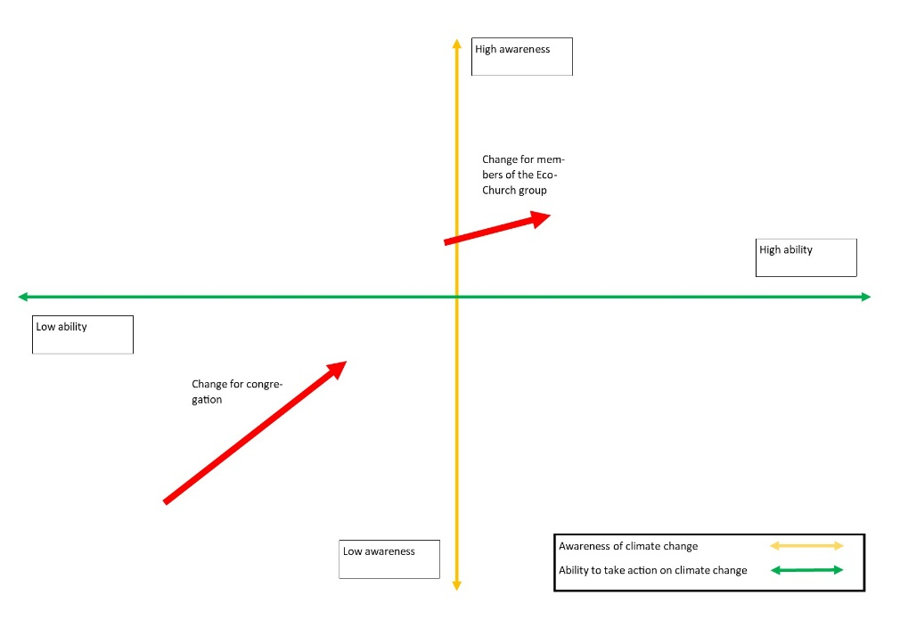

Workshop participants reported that in conjunction with the Eco-Church scheme, which pre-dates the group’s involvement with Renew- the support available through Renew has helped to re-frame aspirations from the church. Prior to the Eco-Church project, there was a recognition that the church needed to look outwards to the community more effectively, and the Eco-Church project, catalysed by the support and mentoring available through Renew, has helped to provide a focus around which the church can engage with other communities.

This role in helping the church to look outwards and engage with communities is mirrored in the lasting legacy of Renew on the church’s networks. As figure 3 indicates, workshop participants reported that the mentoring received through Renew has helped to foster relations in a variety of areas. At the same time, attribution of these connections to Renew is difficult.

As such, figure 3 distinguishes between relationships and networks (represented in green) that have been built primarily through involvement in Renew, and relationships and networks that have been strengthened by the group’s involvement in the programme (represented in yellow). It shows that Renew’s impact on Sketty Eco-Church in this area has primarily been catalytic, helping relationships form more quickly and effectively, rather than being the primary driver of these relationships.

Figure 3: Lasting legacy of Renew Wales participation on Sketty Eco-Church’s networks

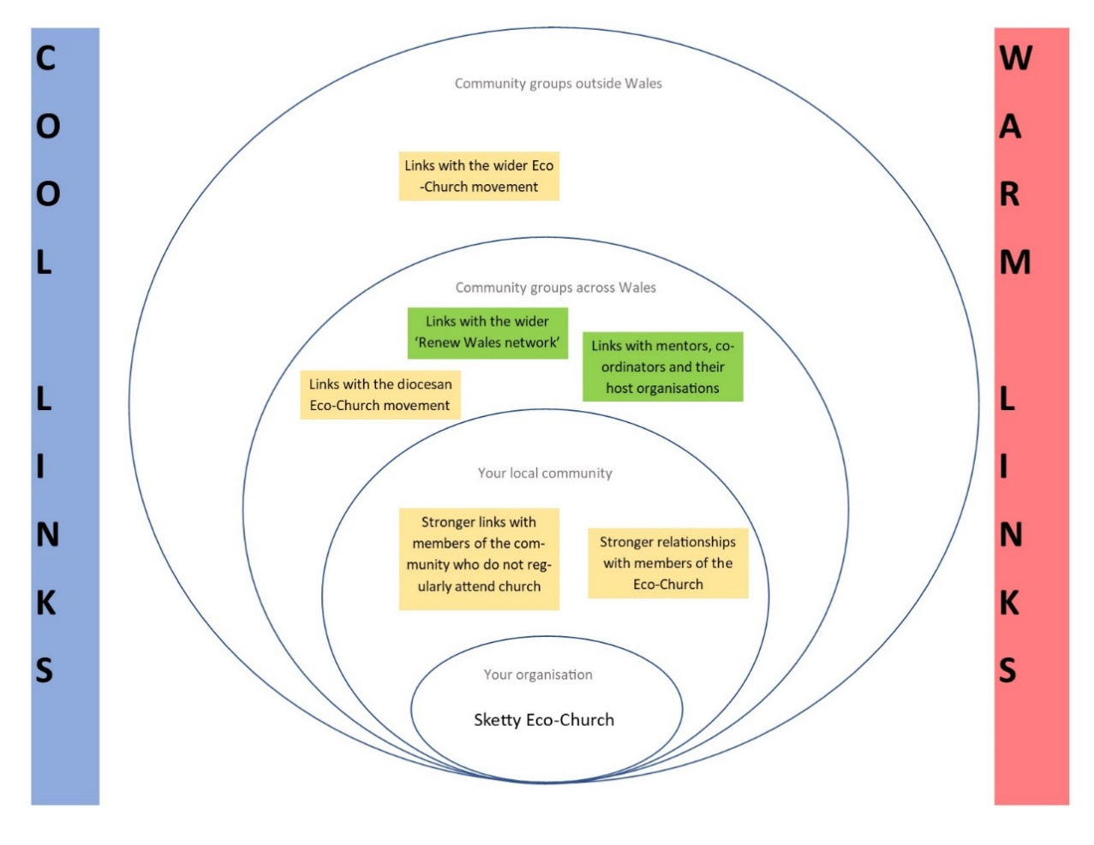

Future direction and legacy of Renew Wales support
The Sketty Eco-Church group’s future plans are largely structured around the Eco-Church scheme and putting measures in place that will allow them to continue working their way through the accreditation. Beyond this, the group’s plans are to engage with the wider community in Sketty more broadly, as well as engaging with the rest of the congregation of Sketty church around the issues the group has been working on.

In addition to communicating more with the congregation at St. Paul’s Church, the group has the chance to work together with other churches engaging with the scheme across the Diocese of Swansea and Brecon. While many of the groups are at an even earlier stage with the project than Sketty Eco-Church, there is the potential for a network of participating Eco-Churches to continue to support each other in the future.

In the future, Sketty Eco-Church has the potential to be the focal point of an asset-based regeneration of the area, turning the church property from a potential liability into an asset for the church community as well as the wider population of Sketty. Workshop participants reported that as part of the long-term vision of the Eco-Church, they would like to start drawing on resources and expertise found locally within Swansea, strengthening community cohesion and fostering links between different groups within the community.

Theatr na nÓg
Theatr na nÓg is a professional theatre company based in Neath. Founded in 1982, the company produces original theatre in English and Welsh. The theatre primarily works with young people. It is a registered charity relying on the support on the Arts Council of Wales, private companies and other funders to make its work possible. In a normal year, more than 16,000 young people and their families attend Theatr na nÓg’s educational performances.

The journey
Theatr na nÓg’s motivation for getting involved with Renew Wales came from two productions that the company was putting on. Both of which had themes relating to environment and sustainability and inspired the company to do more to take action on climate change and sustainability.

Figure 1: The Butterfly Hunter

Photo by Simon Gough

The Butterfly Hunter was a play about Alfred Russel Wallace. Growing up in Llanbadoc, Monmouthshire, Alfred Russel Wallace came up with the theory of evolution at the same time as Charles Darwin after stumbling upon an unusual beetle in the Neath Valley. The play followed Wallace on his journey from Wales to Brazil and the Malay Archipelago, exploring jungles and remote islands to see how his theory came to light.

Eye of the Storm was a play set in a small former mining community in Wales, about Emmie Price, an intelligent and practical teenager who dreams of studying tornadoes at an American University. The play explored themes such as climate change, the effects of austerity, and the role of women in science.

Figure 2: Eye of the Storm

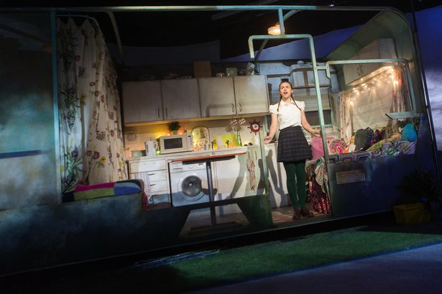

These plays, communicating messages about the importance of taking climate change and biodiversity seriously, encouraged Theatr na nÓg to take their own practice more seriously and look at what it could do to take action on these issues.

The role of Renew and actions
Initial contact with Renew Wales was made through Social Farms and Gardens. Theatr na nÓg wanted to look at the biodiversity of the land around its building, working with local businesses and the local school to develop a community garden. However, after an initial exploration of this idea, it was decided that maintaining the garden would require too much time from company staff to sustain it in the long term and this plan was abandoned.

Instead, the Severn Wye Energy Agency undertook a building audit for Theatr na nÓg. This resulted in options being mapped out, identifying actions that were of no cost, or even cost-saving, and actions that were of low, medium and high cost. A member of staff at Theatr na nÓg reported that “we were surprised by how much could done cheaply, including things like installing insulation under our false ceiling”.

This support has led to some actions, although major changes on the building an aspiration rather than a reality. At present, most of the changes that Theatr na nÓg has made are around behaviour. These include changes to behaviour in and around the office.

“In the office we monitor how much paper we use and have tried to reduce this amount. We have changed to fair trade tea bags that contain no plastic and we recycle our waste wherever possible. We have also introduced homeworking for staff where possible: two of our four members commute from Cardiff so they are now working from home one day each week to help reduce their carbon footprint.”

We have also changed our gas & electricity supplier. such as installing insulation under the building’s false ceiling.

Figure. 3: The Theatr na nÓg building

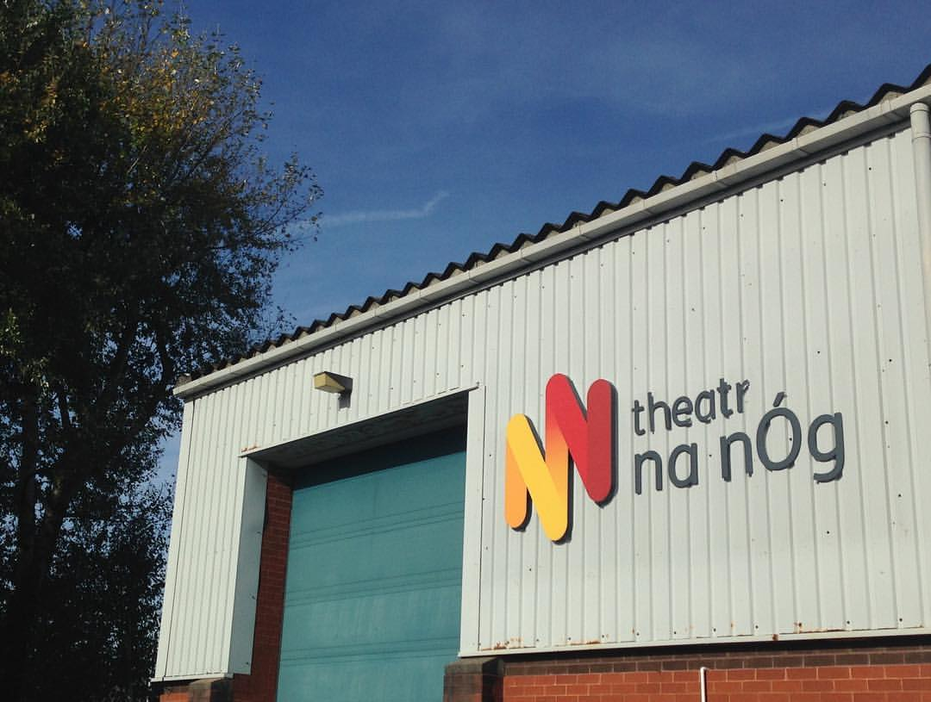

The journey that the theatre has been on has also resulted in changes to the way that the theatre puts on productions.

“We have changed how we build sets, costume props, and we hire more instead of purchasing and re-work our props to use them in different productions more instead of purchasing new ones. We have also reduced the amount of materials we use.”

There have also been changes to the way that the theatre interacts and communicates with audiences.

“During the shows we have changed our food boxes and paper cups to recyclable material and we encourage visitors not to bring in single use plastics. We have also set challenges for our school audiences to create seed bombs and bug hotels and to also reduce their own amount of waste.”

Impacts
The main impact of the support on Theatr na nÓg has been giving it increased knowledge and confidence of what it can do to take action on climate change and sustainability, helping the organisation to form plans for how to take action.

“The main added value of having Renew Wales on board is that their support helped us to pull everything together into a cohesive plan.”

Awareness of and ability to take action on climate change
Theatr na nÓg was asked to plot the impact of Renew Wales support on the organisation’s awareness of and ability to take action on climate change and sustainability along two axes, one representing awareness of climate change and sustainability, and the other ability to take action on these themes.

As figure 4 below, indicates, it was suggested that there has been more of an impact on the organisation’s ability to take action than on its awareness of climate change issues. The reason for this is that the main impact has been showing the theatre what its options are, opening up more opportunities to take action. Awareness was already high within the company prior to the intervention, as the theatre has already been putting on productions to raise awareness of these issues.

Figure 4: Impact of Renew Wales support on awareness and ability to take action on climate change and sustainability

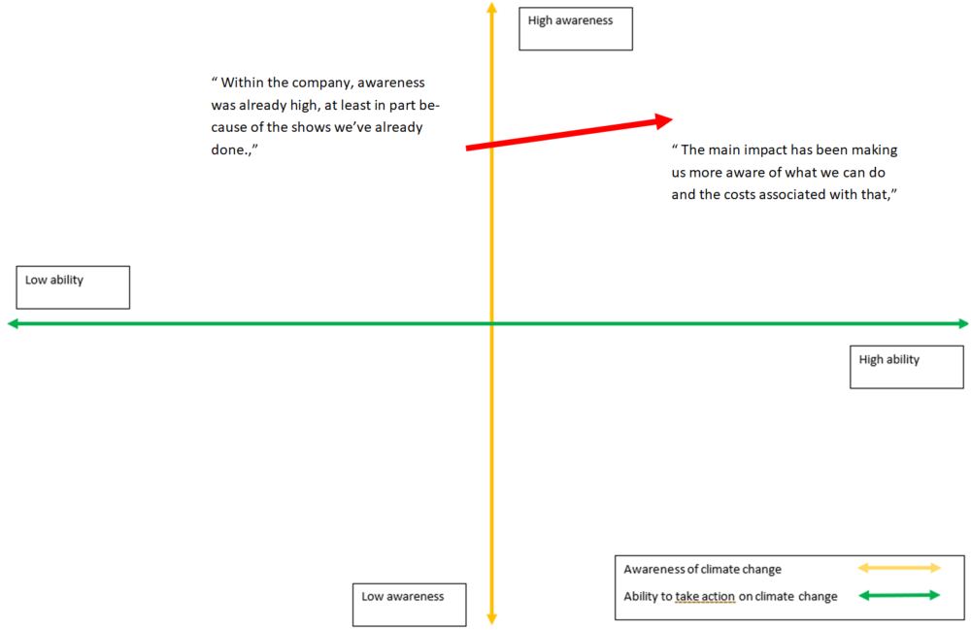

In addition to the impacts resulting from the support, barriers to action were also discussed. Barriers discussed included time and resources within Theatr na nÓg to drive these activities forward. Having staff with the motivation and the time to drive activities forward is essential. While Theatr na nÓg has had passionate staff, these haven’t always had the time to coordinate change. The theatre has found this a challenge in relation to the community garden proposals, as staff do not live locally and would have to be present outside of office hours.

Finally, the cost of taking action is a potential barrier to some of the actions identified by Renew Wales support. Some projects, such as installing solar panels on the property, will require financing. Theatr na nÓg is ineligible for various funding schemes to support organisations to install energy efficiency and energy generating facilities because they go out and perform their plays elsewhere. This renders them ineligible for funding schemes designed to support community buildings.

Networks and connections
The workshop also explored the legacy of Renew Wales support on Theatr na nÓg’s connections and networks. It was suggested that the impact of the intervention has been small, but nonetheless positive. As a result of the mentoring received, new relationships have been formed with the community garden at the National Waterfront Museum in Swansea, the Severn-Wye Energy Agency, and – through the Severn-Wye Energy Agency – Sustainable Communities Wales.

“The main impact is that we know where would go for advice and support for this kind of project in the future.”

Figure 5: Lasting legacy of Renew Wales participation on Theatr na nÓg’s Networks
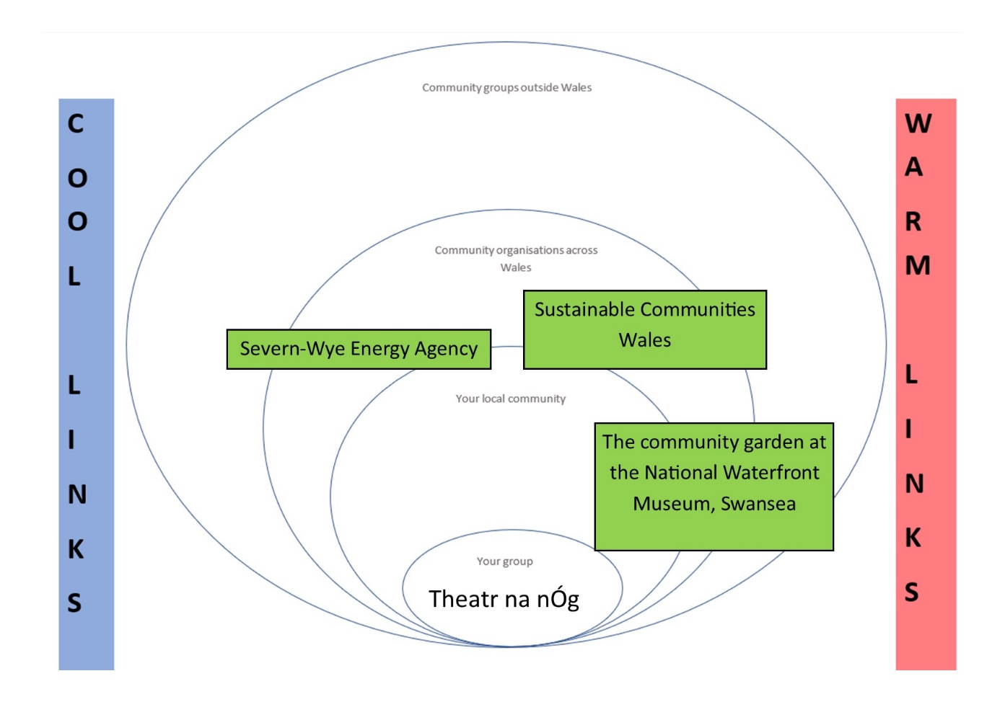

Future direction and legacy of Renew Wales support
Beyond the support received through Renew Wales, Theatr na nÓg plans to continue to act to improve the energy efficiency of its building. It plans to install LED lighting in the building, and engage with SPECIFIC, a project delivered by Swansea University to support organisations with experimental approaches to developing energy efficient buildings. This would include energy usage monitoring to establish a baseline for energy use within the building.

Theatr na nÓg’s other support needs include support with funding applications to install LED lighting and solar panels. Additionally, it would like to receive more information about how to engage with schools and young people around the themes of climate change and sustainability. Additional resources, potentially including peer-to-peer sharing of resources that have already been used to communicate climate change and sustainability themes to young people.

Ysgol Pen Barras
Ysgol Pen Barras is a co-educational bilingual primary school in Ruthin, Denbigshire. With more than 270 pupils between the ages of 3 and 11, the school serves the town of Ruthin and the surrounding area. The school moved to its current site on the edge of the Glasdir Estate in April 2018, moving from its previous site on the South East of the town centre.

Figure. 1: Ysgol Pen Barras, Ruthin

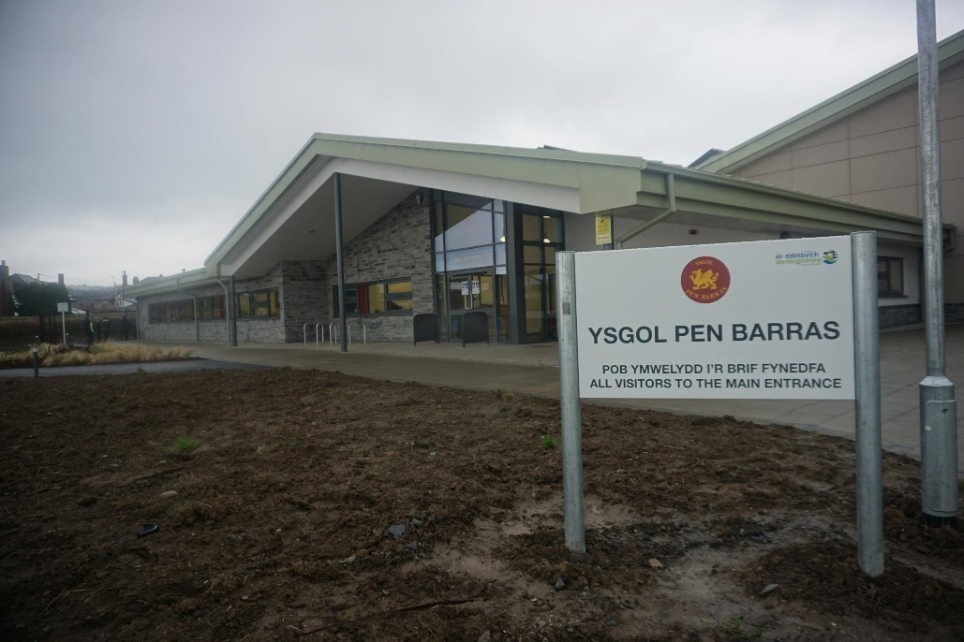

The journey
Ysgol Pen Barras has been running an Eco Council at the school for several years. Comprised of 11 key stage 2 pupils sitting alongside the School Council, its aim is to give pupils ownership over and a voice in the way that the school and its grounds are run, as well as to educate the children about the importance of the environment and sustainability and how they can take action on it.

The role of Renew and actions
The Ysgol Pen Barras Eco Council got involved with Renew Wales through existing links between the local Renew Wales coordinator and the school. The coordinator had already been involved with the school through their role with their host organisation ‘Size of Wales’, and the outreach work they had previously done at the school.

The teacher responsible for coordinating the Eco Council, Miss Parry, was looking for new ideas for how to teach pupils about climate change and sustainability and help with concrete actions that the Eco Council group could take around the school and its grounds.

After initial contact was made, the coordinator worked with the school to identify priorities and a set of actions that could be taken. Priorities identified at this stage included plans to grow vegetables in the school grounds, improve the amount of recycling that the school does, and work out more effective ways of teaching pupils about climate change and sustainability.
The action planning aspect of the intervention was identified as crucial, helping to focus priorities as well as helping the school to understand what would be possible for the Eco Council group to achieve.

After the initial planning stage, the school received some support from the coordinator, who worked with the children around the topic of climate change and sustainability.

Figure 2: A climate change conversation taking place at Ysgol Pen Barras

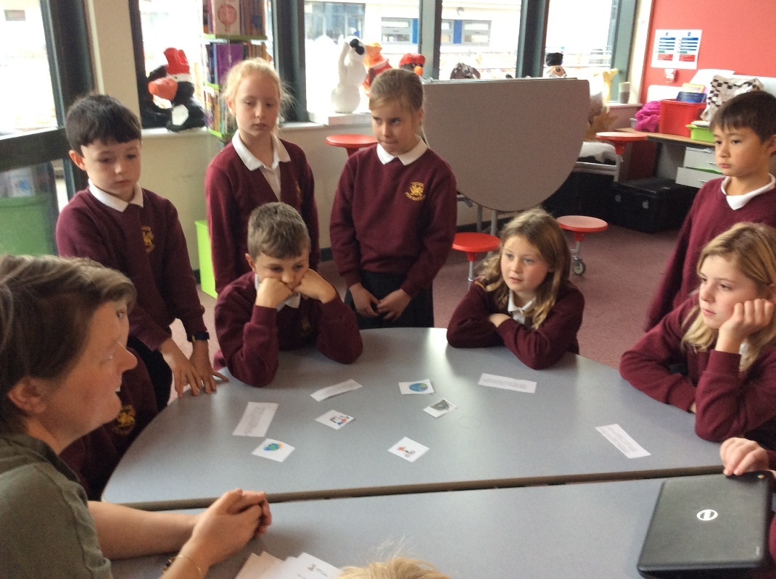

The school was also put in touch with a mentor from North Wales Wildlife Trust, who came in and advised the school on how to set-up a tree nursery. This has resulted in concrete actions, with the garden now producing some food that is being used in the school kitchen and the school participated in Natural Resources Wales’ Acorn Antics, a campaign to highlight the importance of seed collection and help grow trees from locally collected seeds. Other actions include a crisp packet recycling initiative and a campaign to get students walking to school.

Figure 3: The Garden at Ysgol Pen Barras

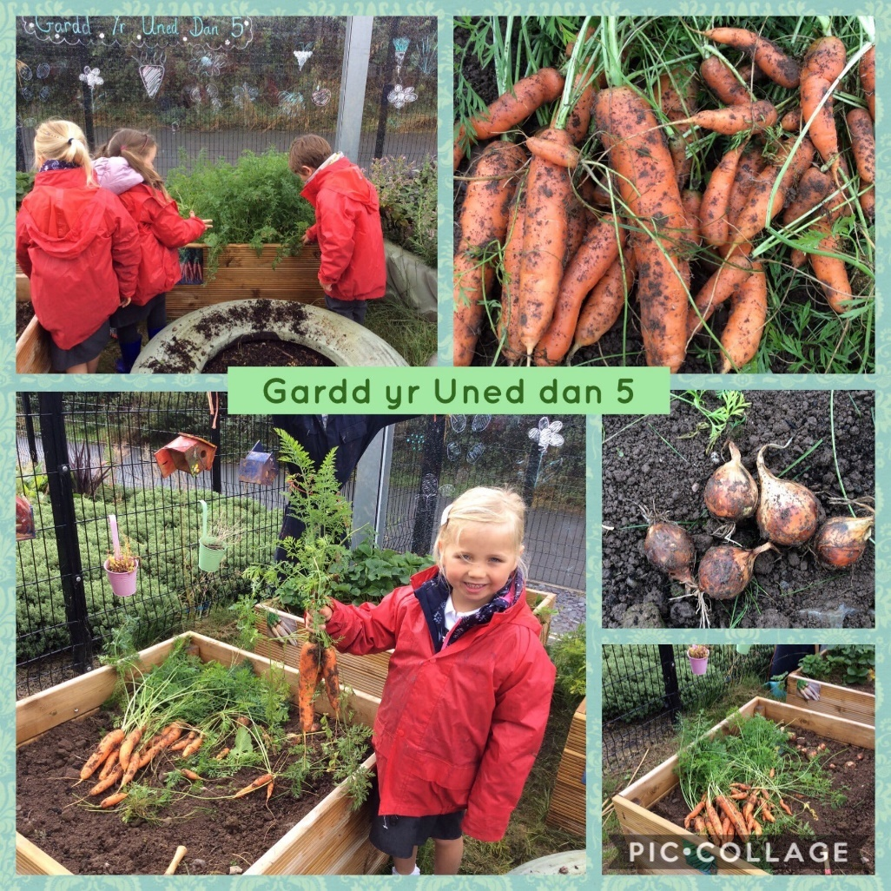

Impacts
Workshop participants were asked to plot the impact of Renew Wales support on the organisation’s awareness of and ability to take action on climate change and sustainability along two axes, one representing awareness of climate change and sustainability, and the other ability to take action on these themes. Discussions have been represented pictorially below.

As figure 4 below, indicates, it was suggested that the impact of the support has been more significant in terms of awareness than it has on the ability to take action. When probed as to why the school’s ability to take action on climate change was less pronounced, it was suggested that the size and scale of climate change means that it’s much harder to take meaningful action on climate change at a local level than it is on sustainability, an area in which local actions appear to have more of an impact.

As a result, two lines have been plotted, one representing awareness of and ability to take action on climate change, and the other focusing on sustainability.

Figure 4: Impact of Renew Wales support on awareness and ability to take action on climate change and sustainability

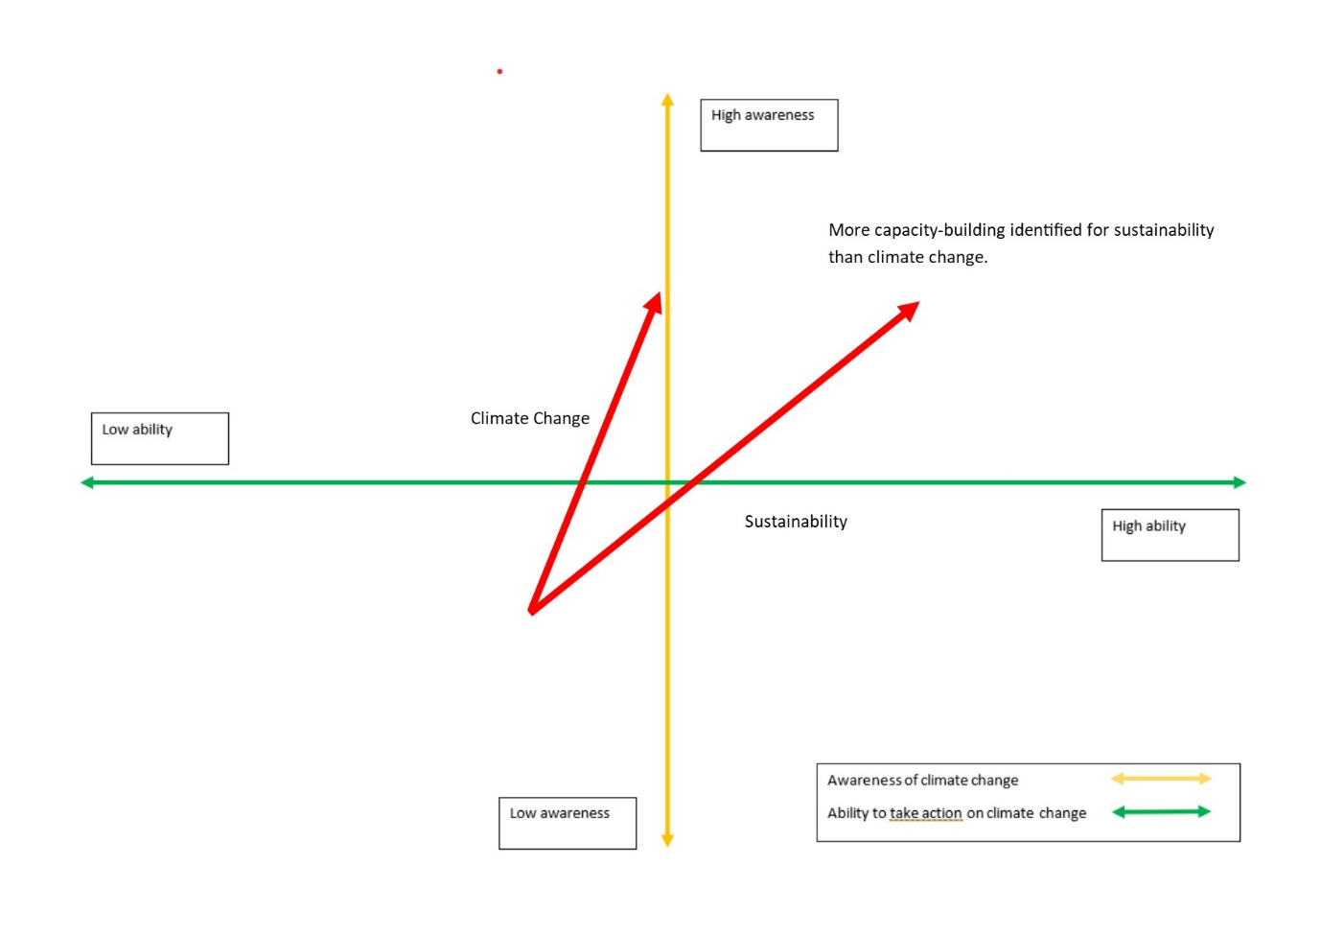

For teachers at the school, there has been learning around how to communicate with the children around climate change and sustainability, and children participated in a climate change strike. Children report being more environmentally aware as a result of the engagement with Renew Wales and have taken action.

“We try to turn off the lights when we leave the classroom and cycle or walk to school now.”

Students have also got involved in climate strikes, something that was facilitated by the school.

Figure 5: Pupils on Climate Strike at Ysgol Pen Barras

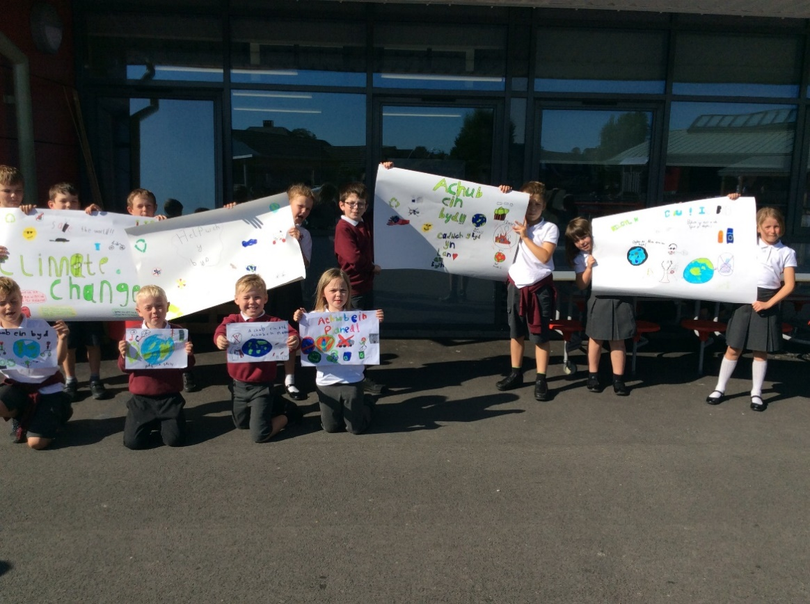

The workshop also explored the legacy of Renew Wales support on Ysgol Pen Barras’ networks. First and foremost, the programme has strengthened relationships between the school and the coordinator and mentor’s host organisations. Activities carried out with the Eco Council have also strengthened relationships with the local council and parents at the school, some of whom have become more involved in school activities such as the garden.

Most significantly, involvement in Renew Wales has strengthened the school’s relationships with other schools in the local area, with the potential to learn from other schools running similar initiatives and provide support to schools in the future.

Figure 6: Lasting legacy of Renew Wales participation on Ysgol Pen Barras’ Networks

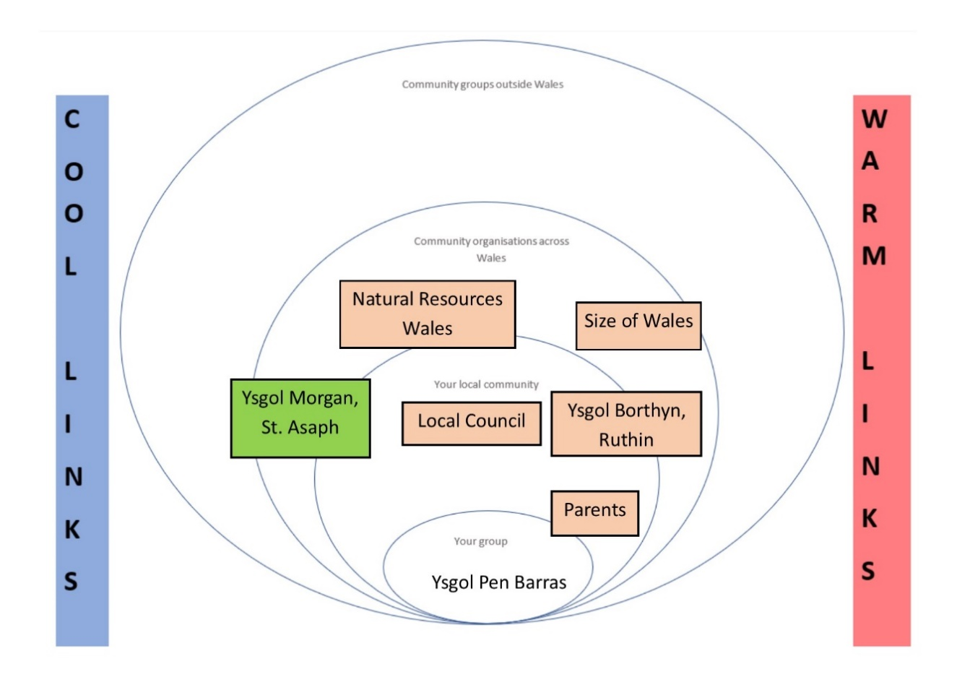

In this area, as with the other areas discussed, it is difficult to determine how much these networks would be different without the support through Renew Wales. Many of these actions and outcomes could have taken place without Renew Wales support being in place, and successful outcomes cannot be solely attributed to the programme. At the same time, Renew Wales has had a successful catalytic effect, bringing about and intensifying connections that were already in place, or allowing Ysgol Pen Barras to contribute more, and in different ways, to local networks.

Future direction and legacy of Renew Wales support
Ysgol Pen Barras has a number of plans to continue the work done with the Eco Council. The school wants to develop the gardening club further, perhaps getting more parents involved in the activities. There are also plans to link local actions to a more global context, teaching pupils about global responsibility by - for example - sponsoring part of a rainforest. Finally, the school plans to meet with local primary schools to work collaboratively to teach climate change in primary schools.

There are, however, barriers to achieving these goals. A significant barrier facing Ysgol Pen Barras in its attempts to do more to take action on climate change and sustainability and build on current programme activities is the competing priorities the school and staff face. With other priorities competing with the Eco Council, there is a danger that time and resource pressure will ‘crowd out’ the Eco Council and sustainability actions.
The context of the new curriculum due to be introduced by Welsh Government, and the Wellbeing of Future Generations Act require work across the environmental and education sectors to ensure that there is an understanding and positive connection with the role that natural resources and the environment play in everyone’s lives. This new context should help to ensure that initiatives like the Eco Council become more central to the way that schools operate.

In this context, there may be considerable benefits for Ysgol Pen Barras (and other schools) from trying to scale Eco Council efforts. Supporting schools to come together to develop materials to teach children about climate change and sustainability, as well as sharing expertise about how to take action at a local scale.

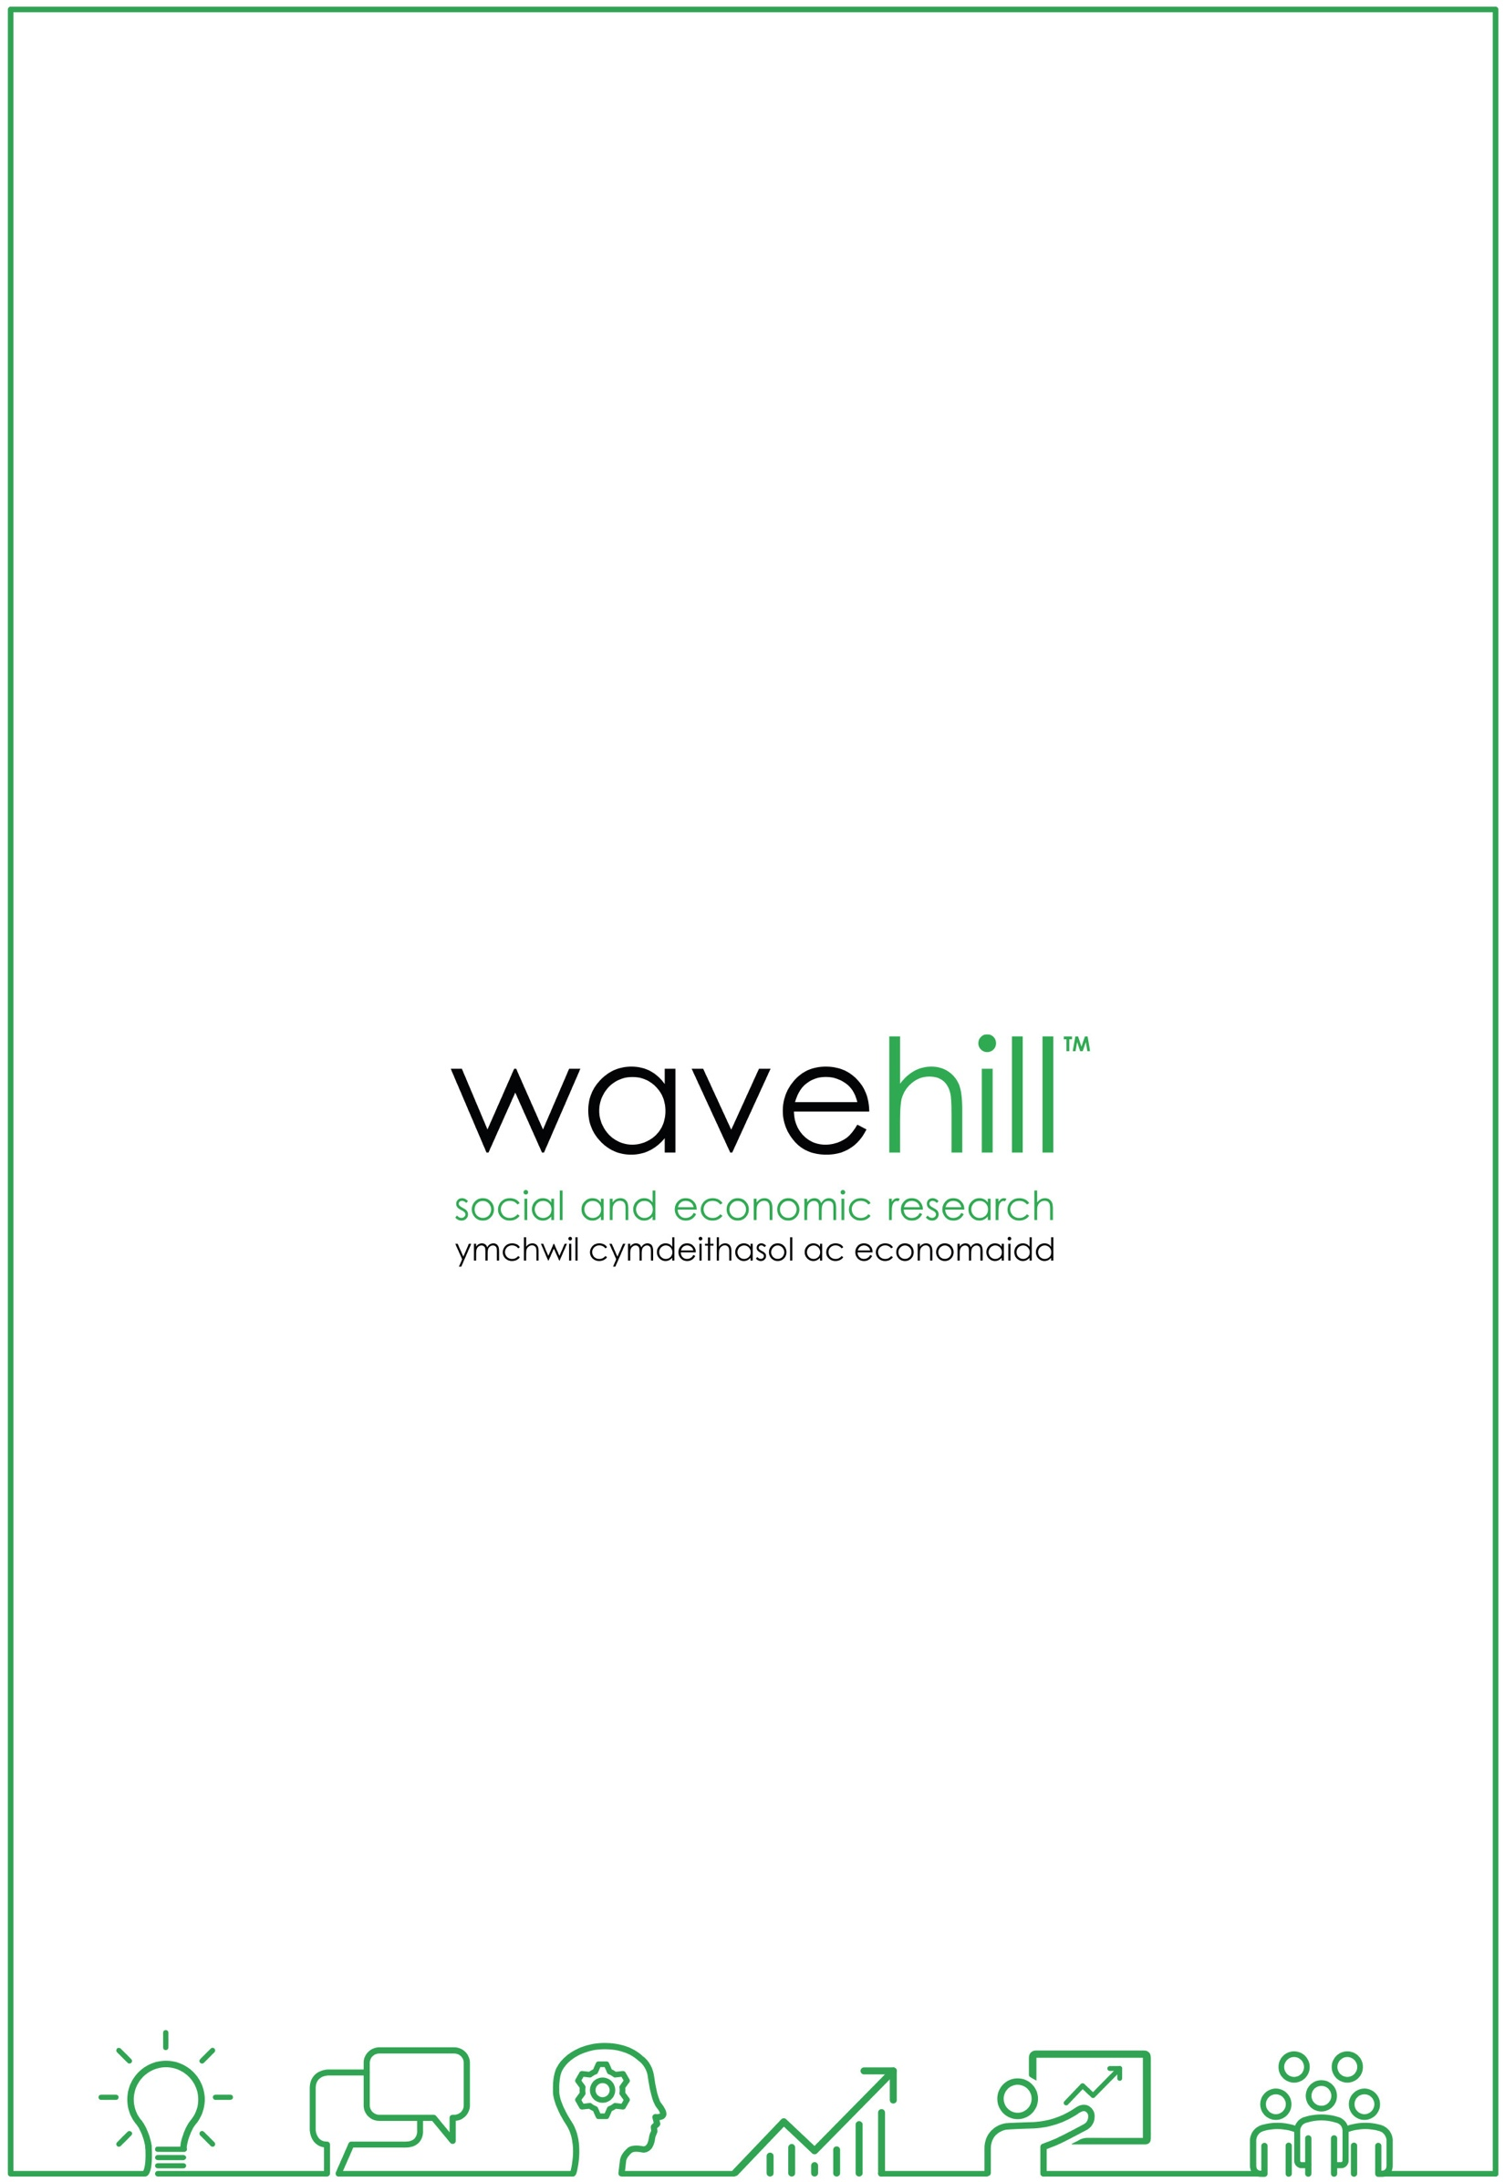

https://renewwales.org.uk/
Additionality is “the extent to which activity takes place at all, on a larger scale, earlier or within a specific designated area or target group as a result of the intervention”. https://assets.publishing.service.gov.uk/government/uploads/system/uploads/attachment_data/file/191511/Additionality_Guide_0.pdf
Action Learning Sets are a structured method enabling small groups to address complicated issues by meeting regularly and working collectively. For more on Action Learning Sets, please see: http://www.fao.org/elearning/course/FK/en/pdf/trainerresources/PG_ALSets.pdf
https://renewwales.org.uk/
https://dtawales.org.uk/
The extent to which activity takes place at all, earlier or within a specific area or target group as a result of the intervention and/or an impact or outcome that would not have occurred in the absence of the intervention.
https://assets.publishing.service.gov.uk/government/uploads/system/uploads/attachment_data/file/191511/Additionality_Guide_0.pdf
http://www.socialvalueuk.org/app/uploads/2016/03/SROI_Guide-Stage4.pdf
https://www.betterevaluation.org/en/resources/guides/contribution_analysis/ilac_brief
“Mentoring is a process where people are able to share their professional and personal experiences in order to support their development and growth in all spheres of life. Generally mentoring is a one-to-one relationship where a person with more experience in an area or organisation is paired with someone who wishes to develop their skills and abilities in order to perform at a higher level.” Walker, W. O., Kelly, P., & Hume, R. F. (2002). Mentoring for the new millennium. Med Educ Online, 7(15). Retrieved from https://www.betterevaluation.org/en/evaluation-options/mentoring
https://basecamp.com/how-it-works
Lave, J. & Wenger, E., (1991), Situated Learning: Legitimate Peripheral Participation, Cambridge: Cambridge University Press.
https://wenger-trayner.com/resources/what-is-a-community-of-practice/#:~:text=A%20community%20of%20practice%20is,It%20is%20very%20broad.
Wenger, E., (2007), ‘Communities of Practice: A Brief Introduction’, information accessed from: https://infed.org/mobi/jean-lave-etienne-wenger-and-communities-of-practice/
https://seneddresearch.blog/2016/03/22/the-well-being-of-future-generations-wales-act-2015-what-is-it-and-what-does-it-mean-for-wales/
https://futuregenerations.wales/wp-content/uploads/2017/02/150623-guide-to-the-fg-act-en.pdf
https://futuregenerations.wales/wp-content/uploads/2017/02/150623-guide-to-the-fg-act-en.pdf
Action Learning Sets are a structured method enabling small groups to address complicated issues by meeting regularly and working collectively. For more on Action Learning Sets, please see: http://www.fao.org/elearning/course/FK/en/pdf/trainerresources/PG_ALSets.pdf
https://www.arloesigwyneddwledig.cymru/en/

