Somerset Nature Connections:
A Somerset Wildlife Trust and Somerset National Landscapes Project
Final evaluation report
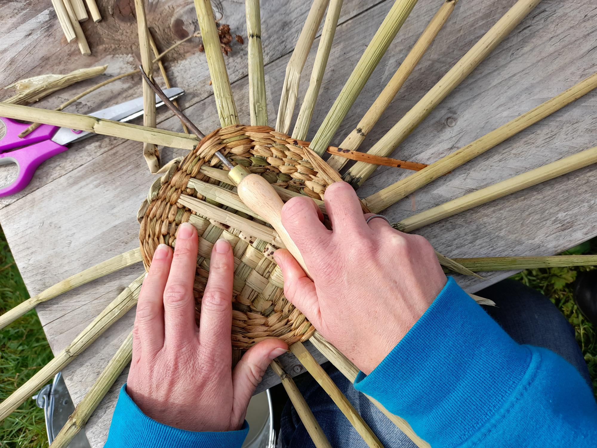

Dr Helen Seers, Abby Sabey, Dr Marie Polley
Meaningful Measures Ltd
October 2023

Meaningful Measures Ltd
Meaningful Measures Ltd is a company that provides innovative person-centred evaluation, audit and research solutions. Our mission is to enable people’s own voices to shape the understanding and improvement of health and wellbeing services around the world.

Acknowledgements
We would like to thank all the participants who took part in Somerset Nature Connections. We would also like to thank Somerset Wildlife Trust and their National Landscape Partners (Mendip, Quantock and Blackdown Hills)* for commissioning this evaluation and in particular Kristen Lambert for their input and teamwork.

Disclaimer:
The views in this report reflect those of the authors and do not necessarily reflect those of Somerset Wildlife Trust or Mendip, Blackdown and Quantock National Landscapes.

How to cite this report:
Seers H, Sabey A, and Polley M (2023). Somerset Nature Connections. A Somerset Wildlife Trust Project. Final evaluation report. Meaningful Measures Ltd, England, UK.

Main contact:
Dr Helen Seers, Co-Director, Meaningful Measures Ltd
Helen@meaningfulmeasures.co.uk

*The National Landscapes were formally Area’s of Outstanding Natural Beauty. A national rebranding took place in November 2023.
Executive Summary
Both contact with nature and connection to nature have a positive impact on health and wellbeing,. Visiting nature once a week is associated with better health and wellbeing and pro-environment and pro-conservation behaviour¹. The Somerset Nature Connection’s (SNC) programme of work builds on the wider research literature which shows the benefits of nature for health and wellbeing. SNC is a project funded by the National Lottery Community Fund (2020-2024), Hinkley Point C Community Fund, Somerset Council and the Somerset Community Foundation Discovery Fund, aimed to tackle some of the barriers that prevent people experiencing the health and wellbeing benefits of Somerset’s spectacular natural environment.
The project aimed to help people to access natural spaces, by enabling people to feel more connected to the natural world, developing a more reciprocal relationship with nature (taking action for it) accompanied by a focus on supporting mental wellbeing and physical activity. This was achieved by delivering weekly support activity and by supporting community groups to deliver nature-based interventions.
Quantitative Holistic Health and Nature Scale (H-HAN) data showed that people reported feeling more connection to nature after attending SNC. The majority of people had a positive increase on the scales of the H-HAN for all domains. The most changes were seen in self-esteem (88%), mood (84%) community (84%) and motivation (81%). 65% of respondents reported positive increases in their connection to nature. All H-HAN also domains reported a statistically significantly improvement in scores comparing week 1 to week 6 of the SNC course. Scores on the and Nature Connection Index (NCI) increased after attending the courses. There was a smaller subset of 17 people’s data for the NCI tool, showing that people felt more connected to nature 6 weeks after starting the SNC course.
The reception of the weekly SNC course from the 30 people who completed exit questionnaires were reviewed was very positive, some people saying it was “life-changing” or “lifesaving”. Many people were very sad when the SNC sessions ended and did not want them to stop, however, many people became volunteers after attending the courses. SNC was also viewed as supportive in terms of participants neurodiversity needs.
Qualitative focus groups and follow-up phone calls have shown that people taking part in SNC had a positive and beneficial experiences of their sessions. People attending for 18 weeks reported positive benefits in improved social connections, confidence, leaning new skills, improved mental health and appreciation of nature. In addition, people reported taking action for nature more, with one person stating they had set up a forest school on the back of attending the course, and another starting a community garden project.
Delivery targets for the project were achieved 110 people attended the weekly SNC sessions across the three years of delivery (target 108). Also 30 community groups (target 20) were supported with providing SNC advice and interventions with participants from these wider projects. Community work consisted of 99 Sessions, 309 Participants, 84 External Staff or Partners. There were also wider cascading impacts of this work. Lastly, a higher number of volunteers/peer support buddies than the original target of 20 were recruited – in fact there were more offers of people wanting to become volunteers than it was possible to take up.
Community groups were explored in focus groups with members of staff leading the projects and learning from the SNC approach. Qualitative data reported that: there were positive benefits for their groups. There was some learning from those taking part with positive and constructive developments for future working practice described. Furthermore, staff and volunteer experience for the project was captured to guide roll out of similar interventions such as SNC in the future.
Learning points for future development of SNC:
Weekly group participants suggested:
- Weekly groups should not send new people on taster sessions with the end sessions of old groups, as this may create confusion with group members.
- People should be supported via a buddy scheme to prevent people leaving without having further support, should they require it.
- Other more suburban places with easy public transport links for people to meet after their 18-week course ends.
Community groups suggested:
- Improving transport access for participants to get to sessions or locating services within accessible town settings.
- Improving timely communication between SNC and community group staff to enable ease of setting up sessions and administration.
Overall, SNC represents an intervention that is well run, sensitive, creative, and enables people to connect more with nature to enable the cumulative benefits of nature for human and environmental health. Future work building on the success of green interventions such as SNC should be sustained. Connections into the green social prescribing funding streams should be sought.
“From the very first session I knew this was the sort of therapy I need to help me through my depression” (Exit questionnaire respondent)
“It feels like the best treatment for me, I’ve tried counselling, but it hasn’t improved how I feel. This course did.” (Exit questionnaire respondent)
“It keeps me sane and gives me peace.” (Exit questionnaire respondent)
“I have found this course a real lifesaver at a particularly distressing time in my life.” (Exit questionnaire respondent)
Contents
1.0 Introduction 6
1.1 Nature and health 6
1.2 Somerset Nature Connections 7
2.0 Method 11
2.1 Data collection: 11
2.1.1 Quantitative data capture: 11
2.1.2. Qualitative data capture: 12
2.2 Ethical Considerations 13
2.3 Data analysis 13
3.0 Results 14
3.1 Quantitative Results: Participants’ H-HAN and NCI data 14
3.2. Participants’ experiences of weekly Somerset Nature Connections 17
3.2.1 How people got started with Somerset Nature Connections and activities undertaken 17
3.2.2 Impact of Somerset Nature Connections on the participants 18
3.2.3 Suggestions for developing Somerset Nature Connections in the future 22
3.2.4 Experience of course participants who became volunteers: 25
3.3 Experiences of community groups working with Somerset Nature Connections 26
3.3.1 Overall experience of Somerset Nature Connections for Community Groups 27
3.3.2 Perceived benefits to the Community Group attendees 27
3.3.3 Wider challenges associated with taking part in SNC 28
3.3.4 Ideas for improvements and future developments for Community Group links 28
3.4 Staff views of SNC: 29
4.0 Conclusions 34
Appendix A Description of the Somerset Nature Connections Course 36
Appendix B: Quantitative outcome measures used 40
Appendix C: Participant Information Sheet and Consent Form for the focus groups 42
Appendix D: Questions used in focus groups, exit survey and phone follow-ups 44
Appendix E: Community Groups worked with 47

1.0 Introduction

1.1 Nature and health
There is a current and expanding strong international evidence base showing that both contact with nature and connection to nature have a positive impact on health and wellbeing^{1,2,,}. Connection to nature is linked to higher mental wellbeing and lower levels of anxiety¹. Evidence shows that there is greater nature connectedness reported following visits to rural and coastal locations, compared with urban green space¹. Also, visiting nature once a week is associated with better health and pro-environmental and pro-conservation behaviour¹. Other research has shown that people require a minimum of 120 minutes a week in nature for optimum health. In addition to the above, there is a large body of evidence highlighting the benefits of nature to our mental health³. Living near natural environments is associated with lower stress and faster recovery from mental health issues and ‘Green’ interventions for mental health can deliver positive outcomes¹.
Furthermore, there is evidence to suggest that nature connection may enable people to be more active in terms of pro-environmental and pro-conservation behaviours¹. A triple positive reaction, therefore, occurs when people become more connected to nature - they receive health wellbeing benefits, which may reduce health demand on overstretched health systems, and also people play and active role in positive climate change activities and protection and conservation of nature thereby responding to the biodiversity crisis too. Nature connection overall is a very powerful thing to enable in groups of people.
Due to increasing urbanisation some people are spending less time in nature and feeling less connection to nature¹. Mental health problems are on the increase in the UK, however, nature-based interventions may play a role in improving the health and wellbeing for these populations. Nature connection should be open to all people and barriers including availability and access to public parks or other natural spaces need to be addressed¹. Some groups – including people on low incomes – are more likely to face barriers to accessing nature¹. Green interventions to support health and wellbeing are developing at pace, evidence is beginning to show that nature based social prescribing interventions can positively impact on happiness and wellbeing through reducing social isolation and improving wellbeing. Whilst additional research is needed to further explore the benefits of both contact and connection to nature, and the impact on health in context of Green Social Prescribing and other nature and health interventions, the current research already provides a compelling picture.
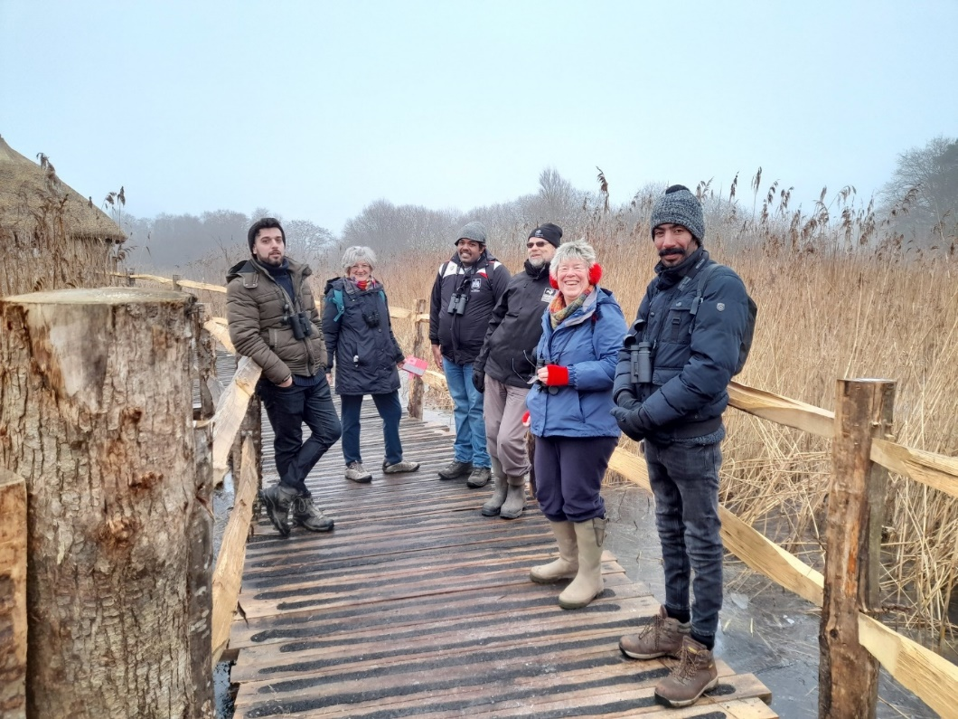

1.2 Somerset Nature Connections
Between Autumn 2020 and Spring 2024 Somerset Wildlife Trust (SWT) delivered Somerset Nature Connections (SNC). SNC was funded by the National Lottery Community Fund, Hinkley Point C Community Fund and Somerset Community Foundation Discovery Fund (as well as other local funders too) and aimed to tackle some of the barriers that prevent people experiencing the health and wellbeing benefits of Somerset’s spectacular natural environment. The project was developed from previous learning and approaches taken by The Wildlife Trusts over many years and was developed by a collaboration between Somerset Wildlife Trust and the National Landscapes in Somerset, who piloted some initial projects. This was, at the time a move away from the more traditional nature-based engagement work of National Landscapes and SWT – with previous offers being more educational in focus or practical conservation volunteering. The SNC project aims to help people to access natural spaces, by enabling people to feel more connected to nature with a focus on supporting mental wellbeing and physical activity.

Partners involved:
SNC is a partnership between the Somerset Wildlife Trust, Mendip Hills, Quantock Hills and Blackdown Hills National Landscapes SNC aimed to support local communities and individuals most vulnerable to mental health issues. Support is via providing better access to nature spaces to encourage and increase self-management for individuals and develop a network of skilled volunteers who can support communities for the longer term. Part of the model of the SNC project has also been inspired by previous developmental work with the Natural Academy (www.naturalacademy.org). The project has been working closely with mental health charities MIND and Chard WATCH. For example, MIND in Somerset provided mental health training to Somerset Wildlife Trust project officers delivering the support. Significant funding was also received from Hinkley Point C Community Fund and Somerset County Council. Specific aims and objectives are set out in Table 1 below as well as other smaller grants from SPARK, Natural England, Devon County Council and the National Landscapes
Three delivery-focused project officers ran a group programme in outdoor locations to build people’s capacity to more effectively self-manage their mental health. Sessions built on the Five Pathways to Nature Connectedness: contact, beauty, emotion, compassion and meaning.
Table 1 – Aims and objectives of Somerset Nature Connections
Aim | Objective
To support people experiencing mental health problems to access the natural environment to improve wellbeing. | To enable 108 people experiencing mental health problems such as depression and anxiety who live in deprived or isolated communities to access local natural environments to help them more effectively self- manage their mental health.
To reduce demand on statutory mental health provision by providing people experiencing mental health problems the tools and environment to help self-manage their mental wellbeing.
To support community groups working with people already experiencing or at higher risk of developing mental health problems to use natural environments to improve people’s mental wellbeing. | To support 20 community groups to access the natural environment and provide support and training to enable them to continue accessing the natural environment beyond the life of the project.  8 groups that we work with (40 beneficiaries) will be from groups supporting adults with Learning Disabilities and/or Autism through approximately 36 sessions
To recruit and train 30 volunteers as peer supporters to support local groups and individuals over the longer term.

To train and upskill 20 staff and volunteers from both health and social care and conservation sector to remove barriers and build understanding and confidence leading to more opportunities for people with learning difficulties and /or autism to access and engage in the natural world.

There were two main models of delivery for SNC:
- Weekly group delivery model (see appendix for more details):
An 18-week programme, delivered in three blocks of six weeks with a maximum of six people per programme. This model supported 110 people over three years.
The course was aimed to support people who may be experiencing mild to moderate mental ill health. Sessions were available to both those who have a mental health diagnosis, and those who did not. People experiencing mental health issues were referred by health and wellbeing partners or people were able to self-refer (via a Facebook group). People attended for half a day each week, and sessions involved wellbeing interventions such as groundings, sit spots and reflections/check-ins, as well as practical, outdoor activities adapted to the needs of each group.
Activities included wildlife walks, conservation tasks, and natural crafts (see appendix for more details). People were encouraged to work together in small groups, for mutual support and to enable longer-term relationships to develop. Upskilling volunteers was part of this model.

- Somerset Nature Connection services run via a local community group engagement model (see appendix for details of groups worked with).
Thirty local community groups over three years, who were supporting people with, or at higher risk of developing mental health problems were able to work with the staff team at SNC. Community groups included those working with adults with learning disabilities, those with long term health conditions, carers and isolated older people.

For the community group engagement model, SNC Project Officers worked alongside community group leaders to provide a structured, purposeful outdoor programme of sessions. These sessions aimed to improve people’s ability to self-manage their mental health and were adapted to participants’ needs. Sessions covered the health and wellbeing benefits of local natural environments and health and safety practicalities, as well as outdoor activities. Sessions were designed to support the mental health of participants and to increase group leaders’ knowledge and skills to deliver outdoor wellbeing-enhancing activities in the future years, thereby widening their service offer.
In 2022, Meaningful Measures Ltd were recruited as an independent evaluator of the three-year SNC project to support data collection and deliver an evaluation report. In this final evaluation report, the experience of the participants of the weekly SNC sessions and the views of the people running the community groups in partnership with the project have been analysed. In addition, quantitative data from the full three years of the project will be presented which corroborates the impact highlighted in the qualitative data.

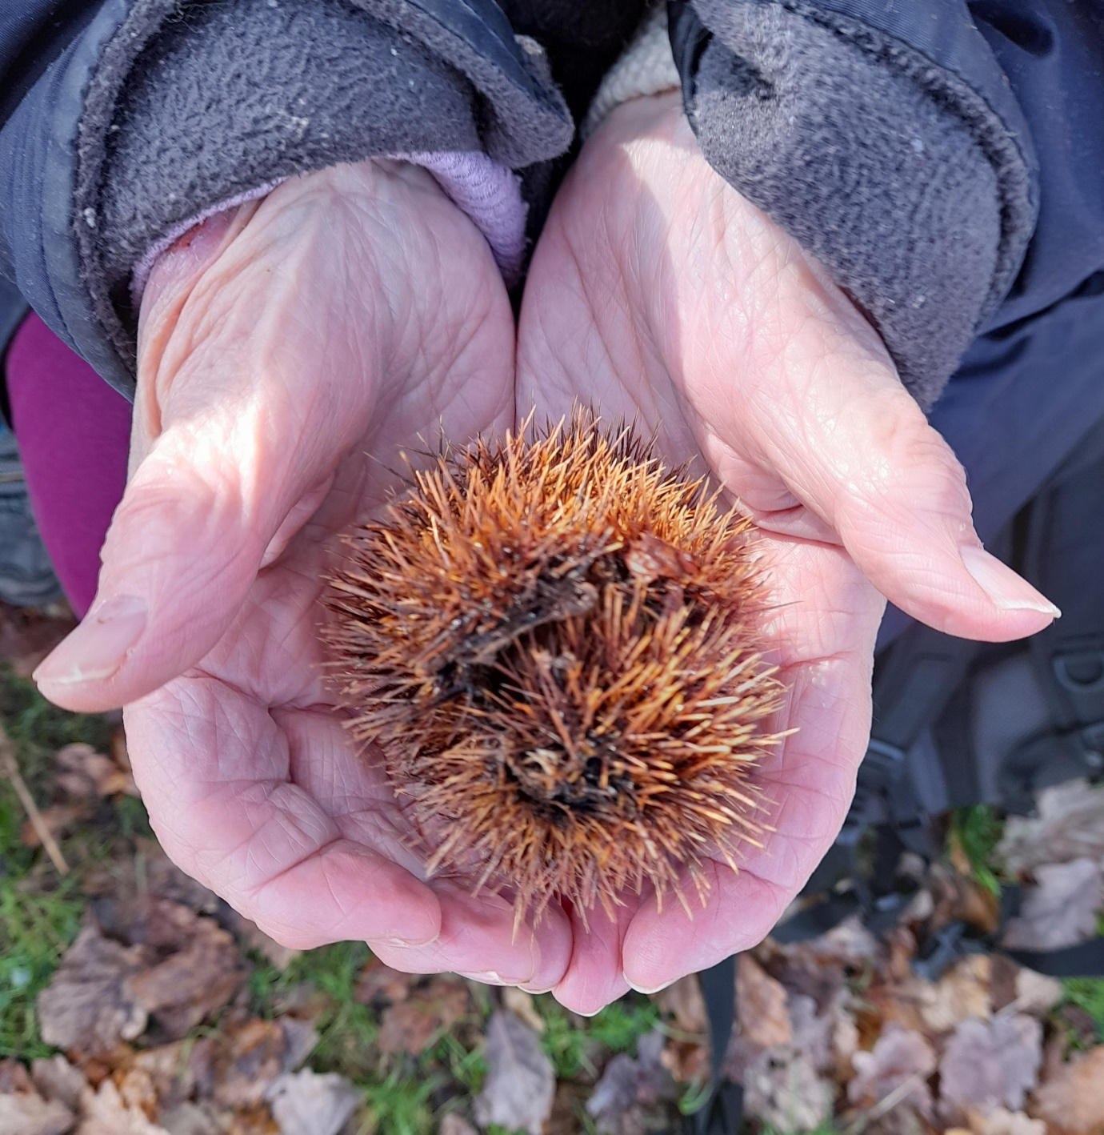

Method

2.1 Data collection:
A pre-post course (baseline, weeks 6, 12 and 18) data collection for the SNC weekly groups participants was carried out along with focus groups to get more in-depth feedback about people’s experiences of the SNC course including staff who rolled out the community services.

2.1.1 Quantitative data capture:
Two qualitative measures of nature connectedness were used: Holistic Health and Nature Scale (H-HAN) to measure participants’ wellbeing and connectivity to nature between August 2020 to August 2023. A subset of people provided responses to the Nature Connection Index (NCI) scale between October 2022 and June 2023.
The Holistic Health and Nature Scale (H-HAN) – this was developed in collaboration with Natural Academy, Avon Wildlife Trust and The Care Forum in April 2017 to capture feedback from participants attending weekly self-care course. (See Appendix for the full tool and Figure 1 for an image.)
Figure 1. Holistic Health and Nature Scale (H-HAN)
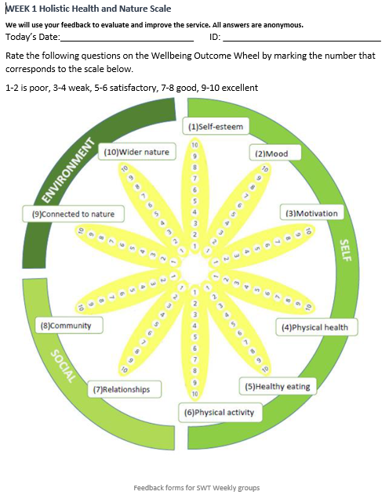
The H-HAN scale was developed to capture baseline data and show any distance travelled and any ongoing impact across 10 different domains: Self-esteem, mood, motivation, physical health, healthy eating, physical activity, relationships, community, connected to nature, and wider nature. It was administered at week 1, 6, 12 and 18 of the SNC course to monitor peoples’ progress against each of the domains.

Nature Connection Index (NCI) is a validated tool used nationally by the UK Government in the Natural England MENE surveys to measure of nature connectedness for both children and adults. NCI consists of six questions, which have weighted scored answers and can produce a total score out of 100 to indicate the level to which a person is connected to nature. The higher the score, the more connected to nature somebody is. (See Appendix for the full tool and Figure 2 below for an image.)
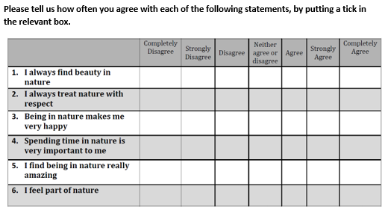
Figure 2. The Nature Connection Index (NCI) questions

2.1.2. Qualitative data capture:
Focus groups
People attending the weekly SNC Project sessions of the (Spring/Summer 2022) were invited to take part in a focus group carried out by Meaningful Measures Ltd, to explore experiences of the course and understand the ways in which the SNC course impacted individuals. Focus groups were also used to explore the experiences of staff members of community groups who had worked with SNC.
Potential volunteers for this group were identified by staff at Somerset Wildlife Trust and provided with an information sheet about the focus group and a consent form to sign (see Appendix B). Informed consent was received from all participants prior to taking part in the focus groups.
The two focus groups with a total of 5 attendees were held online and were led by the researchers (HS & AS). Attendees were a mix of people who had attended the SNC. An additional focus group was held in October 2022 with the staff members from community groups supported by SNC Each focus group lasted one hour. All questions used in the focus group are in the Appendix C. All focus groups were recorded using ‘Google Meet’ and a transcript was generated automatically. In addition to the above several impact testimonials were obtained from the SNC staff and views of the SNC project officers and manger were sought.
Exit survey and follow-up phone call data:
In addition to the focus group data capture, an exit survey was offered to all participants at the end of their sessions (this may have been at the end of 18 weeks, or at the end of the first or second block of six weeks if people left early). Also, there were follow-up phone calls to people 3 to 6 months after SNC ended, carried out by SNC project officers (see Appendix c for questions used).

2.2 Ethical Considerations
All data collected by Meaningful Measures Ltd was stored in password protected, encrypted files in an agreed, secure, GDPR compliant cloud-based storage location. No data files were stored on individuals’ laptops, instead, all data is stored on cloud-based storage. Meaningful Measures Ltd staff are also trained in GDPR compliant data processing procedures. Informed consent was gained for everyone who took part in a focus group.

2.3 Data analysis
Where quantitative data was collected, the frequency of responses were analysed and where applicable, the average difference before and after the courses was calculated and any relevant statistical tests carried out. Where open questions were asked and short amounts of qualitative data were provided, this was analysed by content analysis to identify the main themes. Transcripts from the focus groups were cleaned and anonymised to ensure no participants were identifiable prior to analysis. Researchers thoroughly familiarised themselves with the data before analysing it based on an adapted qualitative framework approach set out by Gale et al. (2013), to identify main themes and findings.

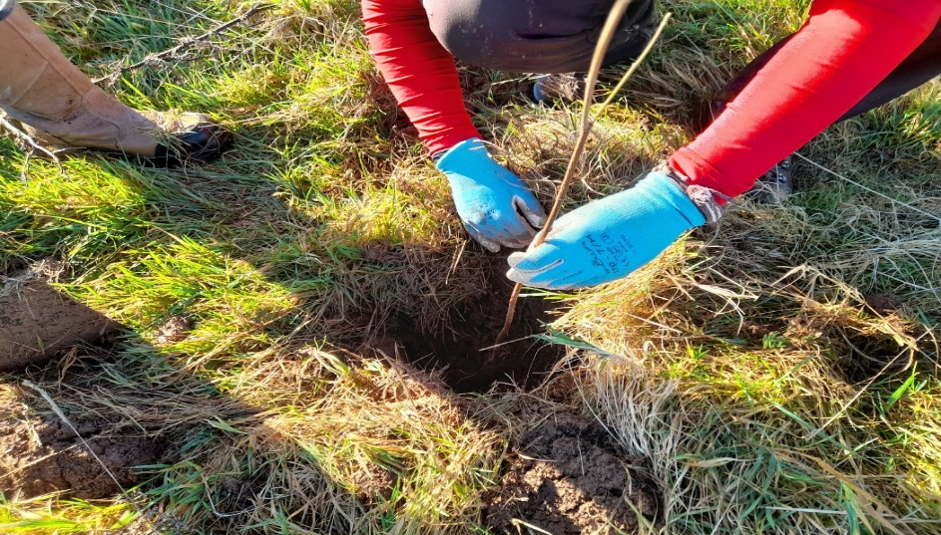

3.0 Results
In this section results from quantitative and qualitative data will be presented to show the impact of SNC.
Quantitative results will be presented from the H-HAN scale and the NCI scale. Note, some quantitative data was collected for the community groups, however it was not consistently collected or collected in large enough volume to do any analysis for this report.
Qualitative data will be presented from focus groups (held in October 2022) and, also exit interview questionnaires and follow-up phone call interviews will be presented from:
- Weekly participants of the SNC programme
- Community group providers

3.1 Quantitative Results: Participants’ H-HAN and NCI data
Of 110 people attending weekly sessions so far, 92 attended for 6 weeks or more (between 6-18 weeks). Reasons given for not attending for the full 6 weeks were provided to the project officers informally and consisted of: “health/mental health, family/personal stuff, not the right group for them” (anecdotal data from Kristen Lambert).
The Holistic Health and Nature Scale (H-HAN). Data was received from 78 participants at week 1, this represents 71% of the total possible 110 sample. 76 responses were gained at week 6 (69%), 40 at week 12 (36%) and 24 at week 18 (22%). Therefore, only participants’ data between week 1 and 6 can be compared reliably with any statistical test.
Figure 3 below shows the percentage of participants making a 1 point or more improvement, or no change, or one point or more decrease in the score on the wheel comparing week 1 and week 6 data.

Figure 3. Bar chart to show percentage of people making improvements, staying the same, or deteriorating on the H-HAN Wheel between baseline and 6 week follow up (n=76).
Figure 3 shows that the vast majority of participants improve their scores at six weeks, and this indicates that the improvements are impressive. The biggest improvements are in self-esteem (88%) , mood (84%) community (84%) and motivation (81%). Only a small percentage of participants deteriorated (the most being in the domains of physical health, eating and community. The most maintenance scores come from the Nature and Wider Nature connection domains where it could be argued that people coming on the course are already interested in nature to some extent.
The H-HAN data can also be plotted in terms of mean scores over time. While there were low numbers of people in the follow-up groups providing their data, this figure can show the trends in the scores.

Figure 4. Mean scores over time for the H-HAN Wheel comparing baseline and follow-up timepoints (n= baseline 76; 6 weeks 76; 12 weeks 40; 18 weeks 24).
Figure 4 shows an improvement in mean scores between baseline and the follow-up weeks. At 6 weeks follow up, a statically significant positive improvement was seen for all domains (p<0.001) and the largest mean improvement was seen in the self-esteem (+2.4), Mood (+2.33) and Community (+2.33) and motivation (+2.23) domains. Due to lower follow-up numbers, statistical analysis was not carried out on means score change data for 12 and 18 weeks.
Overall, these H-HAN results show that taking part in the SNC weekly groups improved people’s connection to nature and that level of connection increased, the longer a person attended the SNC course. As there is no control group to compare to other people not attending the SNC, it is impossible to determine how much of the increase in nature connection can be attributed to the SNC course attendance. Further data collection and analysis is needed to confirm the H-HAN trends shown.
NCI data was collected from 17 people at baseline and 6 weeks between September 2022 to June 2023. The NCI tool was introduced late into the evaluation as a test to see if this other measure would corroborate the H-HAN data. H-HAN is not validated, and NCI is validated, therefore it was a useful measure to introduce for a small sub-set of the group. The NCI data was coded and translated into a score out of 100 (with 100 being the most connected to nature).
The mean NCI baseline score was 71.9 which increased to 88.4 after 6 weeks, hence a mean score increase of 21.5 score points. This level of score change also indicates that people became more connected to nature after 6 weeks on the SNC course. As with the H-HAN data, results from 17 participants can only provide an indication of what is happening and therefore more data collection is needed to confirm this trend of increased connection to nature.
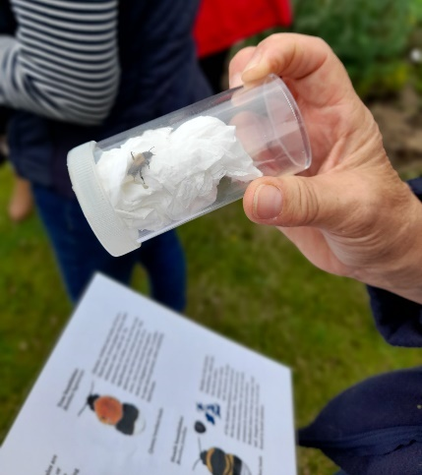

3.2. Participants’ experiences of weekly Somerset Nature Connections
Data was analysed from the focus group of 5 participants who attended the weekly SNC programmes in 2022 and from 30 people completed the SNC exit questionnaire. 16 people who completed the exit questionnaire were also phoned 3 to 6 months after finishing the SNC course. Demographics were not available for any of these participants for this report
Three main themes emerged from the qualitative analysis, and these were:
  - How people got started with Somerset Nature Connections, and activities undertaken
  - The impacts of the Somerset Nature Connections course on participants
  - Suggestions for developing Somerset Nature Connections in the future.

3.2.1 How people got started with Somerset Nature Connections and activities undertaken
Several participants had been prompted to join the group due to the impact of Covid19 and recent life events. At least 10 people stated learned about SNC from a SWT Facebook post; six hard heard about it from their GP; five had learned about it via word-of-mouth; three people were signposted to SNC via a mental health charity (Somerset Mind and Rethink mental illness); four had heard from various sources including a support worker and a therapist.
All the participants spoke very warmly about their first session with SNC. Some had experienced anxiety and were unsure if they could manage to go, but the positive and caring welcome they received reassured them that this was the right thing to be doing:
"I was really anxious about going, about what it was going to entail. But once I’d met X, who is such a wonderful person, I was so glad that I did go. And I just loved everything about it." (Focus-group participant)
"…the whole atmosphere was very, sort of, caring, and you really felt held in the group, even though you were new. Everybody was really welcoming. It just almost felt like home straightaway" (Focus-group participant)
There was clear appreciation of the role of the facilitators in creating the welcoming atmosphere who were described as "absolutely brilliant, just so human, lovely and empathetic" and "just amazing”. Participants felt boosted and uplifted by the combination of meeting new people and being out in nature, especially after the pandemic:
"For me, just coming out of the COVID stuff, and just finding my feet after my own personal issues and mental health stuff, it was just such a boost to be with a group of people and out in nature at the same time. Those two things together were just huge. It was a really, really uplifting combination.” (Focus-group participant)
"It’s just a wonderful experience… It's the whole slowing down, disconnecting from electronics, everything is around you in everyday life, and just pure escapism, isn't it, really, and going back to basics, sitting around a campfire, and it's just amazing, just magic." (Focus-group Participant)
“The leader was perfect at the role. Very natural, at ease, and never in a position where anyone felt condescended. She was an equal and I thought that was a nice aspect of the course.” (Exit questionnaire respondent)
In the exit questionnaires the favourite elements of the SNC activities included (in no particular order): Craft, guest speaker nature talks (butterfly count), bumblebee session, chutney making, Beetle Bank making, Seashore trip to Kilve beach (good for fossils), moth identification, whittling, campfire making, rush weaving, peg weaving, wool dying, pottery.
“All of the sessions were engaging and interesting. I particularly loved the whittling session.” (Exit questionnaire respondent)
“I enjoyed all the sessions, but the handloom weaving stands out for me – lovely to create those together and have them to remember the course.” (Exit questionnaire respondent)

3.2.2 Impact of Somerset Nature Connections on the participants
Three key types of impact were noticed in the qualitative data, for participants – i) increasing their social connections and confidence to improving their mental health and appreciation of nature; ii) improved mental health, iii) improved connection to and appreciation of nature.
- Improving social connections and confidence
Participating in SNC had helped all the participants to reconnect with other people and feel more confident around others after the impact of the pandemic. It also helped the participants to reengage with community and realise that there was life after covid.
Participants felt that certain activities had really helped bring people together to work as a team, such as making bird houses and feeders and a stool from hazel twigs which also involved acquiring new skills such as using a drill. This group work helped them get to know new people, extend their social connections and also increased their confidence in themselves:
"…we had to saw the wood and use an electric drill, which is all completely new. But we did it in pairs and, like you say, it was teamwork, and you got to know the other people that you were with." (Focus-group participant)
“It built my confidence with people as well. The social element, that had sort of waned a little bit” (Focus-group participant)
“Somerset Nature Connections has been a wonderful discovery. A safe, welcoming place with friendly people where I can be myself and learn interesting new in skills. It is so good for me. I always come away feeling better about myself.” (Exit questionnaire respondent)
“Talking to people in a group and individually made me more confident. As a carer, life can be so lonely and being able to sit in a safe friendly group once a week really helped.” (Follow-up phone call)
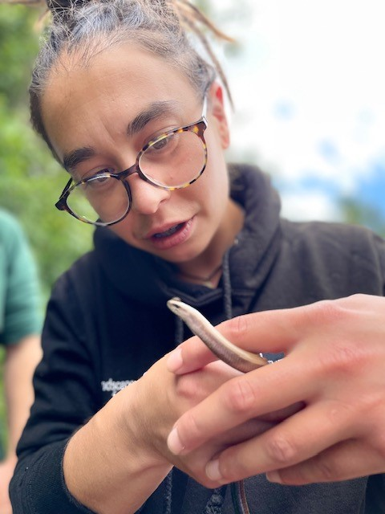
Picture credit – Carolynsavageartist.co.uk

- Improving mental health
A clear area of impact of attending the SNC group was around participants’ mental health. Participants from the exit questionnaires reported lots of examples of the ways that the course had given tools to support wellbeing such as mindfulness, grounding and Qigong:
“Resetting me back on the path of mindfulness and reflection – I will practice daily meditation and spend time in nature and recall (at the end of the day) 3 things I am grateful for.” (Exit questionnaire respondent)
All the participants in the focus groups linked their attendance at SNC with improved mental health. Specifically, participants described how when their social confidence returned, their anxiety and depression became more manageable. This meant they were able to manage other parts of their life as well:
“I started to get that bit of resilience again…so yes, just lots of different strands of my life started to weave back together again." (Focus-group participant)
Two people identified the group setting as helping them to feel safe in outdoor spaces, knowing they were with others and the space was not open to the public. This and the focus on things to look for when out in open spaces, alleviated their feelings of anxiety:
“It’s given me the tools to be able to go out on my own in nature which is something I wouldn’t do before…It gave me things to focus on and things to look for that took my mind from my anxieties.” (Focus-group participant)
“When you do go out into the woods, when you're asked to go out and take a moment to look for something or think about something, you know you're totally safe. I think that's just the icing on the cake really.” (Focus-group participant)

Some people expressed strongly that attending the weekly courses had made a major difference to their mental health and had been a significant positive change for them.
“From the very first session I knew this was the sort of therapy I need to help me through my depression. It gives me space to be myself and interact with like-minded people. Tuesday is the highlight of my week!” (Exit questionnaire respondent)
“It feels like the best treatment for me, I’ve tried counselling but it hasn’t improved how I feel. This course did.” (Exit questionnaire respondent)
“It keeps me sane and gives me peace.” (Exit questionnaire respondent)
“I feel ready to take on big life changes that will further help me to grow in confidence. The support of the group, trying new things and having a safe place to reflect on things that have been troubling me has been truly life changing.” (Exit questionnaire respondent)
Beyond just enjoying the session, it was clear the activities out in nature led to an important and lasting change enabling some participants to get out into nature more when not attending SNC and find positive benefits from this:
"I found myself in a clearing, I couldn't see anybody else, and I felt like I was in the woods on my own. It was so moving that I just burst into tears, because it was something that I hadn't ever really done. So although I felt on my own, I knew there were people around, but it was just that profound moment, which then has led to me being able to go off on my own since." (Focus-group participant)
Above all it was clear the experience of attending SNC was uplifting for everyone involved and there was a sense of joy conveyed when talking about the activities:
"We melted pewter and made little acorns. We got an acorn, and we pressed it in some clay, melted pewter and made a little acorn…it's just absolutely amazing…You go back to your childhood sort of, in a way.” (Focus-group participant)
There was also comment from one person that the activities were supportive of their neurodiversity, leading to them perceiving the SNC course as inclusive and therapeutic:
“While the NC course isn’t autism focussed it is definitely autism informed and I found the pathway provided a great structure and cohesion, and I found the staff to be knowledgeable on autism and neurodiversity. The nature connects course helped me with managing melt-downs and it gave me tools to deal with underlying reasons for them. It gave me a routine and nature really helped with sensory overload. I think it could help a lot of people with autism.” (Exit questionnaire respondent)
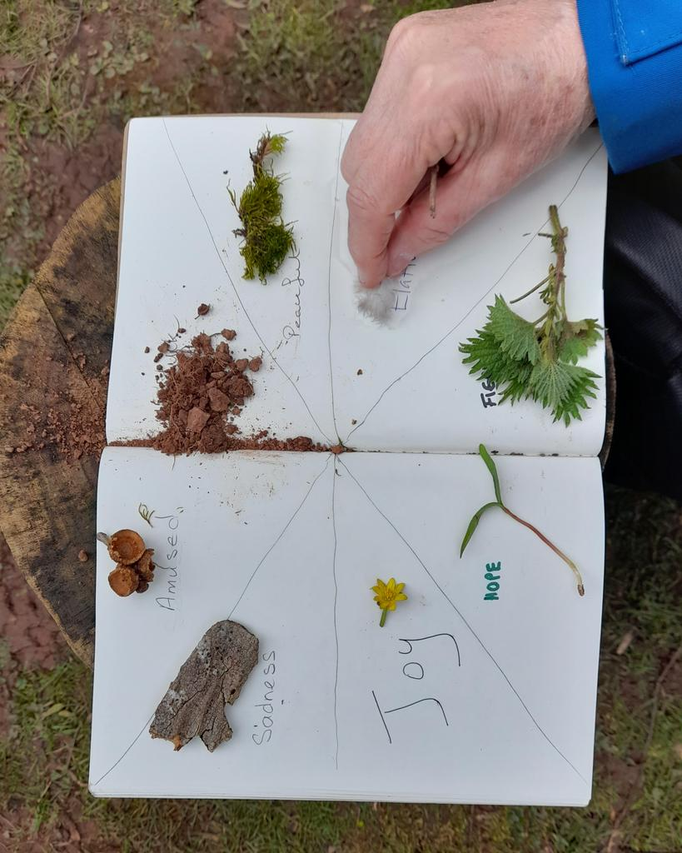

- Improving their connection to and appreciation of nature
Participants also described how attending the SNC group had led them to have a new appreciation of nature. Going out into nature was now a favourite activity for some, paying attention to things you wouldn't have noticed before and importantly, feeling confident to do this. It was evident how enriching and significant this was for one of the participants:

"I saw a deer in the field across from me...I actually stopped for about 45 minutes and just watched it. It was having breakfast. It was enjoying all the hedges and having all the berries, so it was so nice to watch.” (Focus-group participant)
“When I first started these courses, I had a very different idea of what to expect and wasn’t sure if it would be for me. But my whole experience has been amazing. I have found a new love of nature and enjoyed the calming and relaxing effect. It has helped so much.” (Focus-group participant)
“Taking time to use senses to connect with nature rather than just walking through a site.“ (Exit questionnaire respondent)
“I go out and really observe my garden instead of just looking at it.” (Exit questionnaire respondent)
“I feel very connected since attending the project. I loved the mindfulness activities and regularly take a sit spot in the woods.” (Follow-up phone call)
As well as using things they had made such as the birdboxes and feeders in their gardens, the participants also participated in 'no mow May' and planted wildflower seeds to attract bees and butterflies. One participant opened her garden as a wildlife space in her local open gardens event.
Greater awareness of related issues such as sustainability was also talked about; one participant has used her craft skills to be more sustainable, by crocheting a shower body puffs from cotton instead of buying plastic ones and another person referred to taking more care with recycling. For one participant, the greater awareness and understanding of nature had changed their behaviour towards supporting natural spaces and protecting the environment:
“There’s a stream nearby, and the way I engage with that is really different now. I sort of keep an eye on it, if there's any litter around, I'll clear it up, and I keep an eye on the vegetation around the stream." (Focus-group participant)
Lastly, exit questionnaire respondents were able to mention specific things they were doing to take action for nature as a result of their attendance on the course. Examples included pro-environmental behaviour: “More Recycling”, membership of organisations/volunteering:
“I will continue to be a member and supporter of Somerset Wildlife Trust, RSPB and Woodlands Trust.” (Exit questionnaire respondent)
“I will volunteer at the ANOB and hopefully return to these sessions (SNC) to help.” (Exit questionnaire respondent)
Gardening or working an allotment with nature in mind:
“We have astroturf in the garden and I want to change that. I also have plans to put up trellis and plants seeds for flowers for the bees and butterflies.” (Exit questionnaire respondent)
One participant has started a community project in an old school to create a garden and community area and another is even running their own forest school as a result of attending the SNC:
“I'm running my own forest school called Forest Catkins encompassing many of the lessons and techniques you showed us in my sessions.” (Follow-up phone call)

3.2.3 Suggestions for developing Somerset Nature Connections in the future
15/30 people on the exit questionnaire said the course was not in need of improvement e.g., “It was all pretty perfect.” Early suggestions for improvement were incorporated into course development – e.g., a suggestion for singing was included later. One person found the campfire smoke poor for their breathing health. Other suggestions included having more time for activities, more handouts, more access to water facilities, and more detailed instructions for the crafts. Also, others wanted less time on rules and contracts:
“Too many rules weren’t conducive to feeling relaxed. Life is messy, and even with rules I don’t think we can protect ourselves from getting offended by someone.“ (Exit questionnaire respondent)
Two areas emerged from the focus-groups as potential improvements to the programme - managing the beginning and the end of the engagement with the programme.
Taster sessions had been attended by two people but they didn’t feel this was ideal as they met new people who wouldn't be there at the start of the next block as they would be leaving. For two people it also hadn't been clear to them at the start, that the programme was more than just the first six weeks, although they were pleased to subsequently learn that it was an 18-week programme.
Many people were very sad when their course was coming to an end and there was agreement among all participants that they found dealing with the end of the 18 weeks was difficult:
"I was absolutely bereft...because suddenly I didn't have it in my life anymore." (Focus-group participant)
"I was desperately upset, even at the beginning I was upset at the thought of the finish, because it meant such a lot." (Focus-group participant)
“You’re kicking me out! I have found this course a real lifesaver at a particularly distressing time in my life. I am so relieved you have asked me back to support others who I know will benefit.” (Exit questionnaire respondent)
In this regard, the buddy scheme and volunteering played an important part for some participants. Lack of capacity for buddies and volunteers, however, had been a problem for one participant who was disappointed not to be able to get involved in this way:
"I was very fortunate to be invited back, quite early, as a volunteer. But if I hadn't had that, I think somebody used the word bereft…I absolutely feel that would have been the situation with me as well." (Focus-group participant)
Unfortunately, at the point of the follow-up phone calls (3 to 6 months after the course had ended), one person had lost connection with the approach taken on the course, and felt back to where they were before they came on the course, suggesting that they needed more tools to access further Nature Connection opportunities.
In the focus groups suggestions were made for ways to help fill the gap left after the programme. One idea was to have monthly 'nature reconnection' sessions in local areas to help with the sense of a sudden end to the activities and support. It was acknowledged, however, that maybe not everyone would be wanting to continue, depending on work and other reasons. As one participant highlighted, in her group only one person was happy to come back to reunion get-together that had been arranged. There was also discussion about groups establishing their own connections after the 18 weeks had ended. Two participants had forged a friendship with one or two people from their SNC group but it was recognised that living near to other participants or having their own transport made meet-ups easier. The geographical spread of participants in some groups was raised a potential barrier to forming independent groups after the 18 weeks:
"If everybody's spread out, like we are, like Taunton and Bridgwater, and all round the Quantocks… I mean, X and I are fortunate because we've got our own car, but everybody else comes in a taxi. So that's the problem there, isn't it? That's a difficulty there." (Focus-group participant)
A useful suggestion was made to meet up locally such as in a park rather than having to travel, as parks could also offer opportunities to take part in nature-based activities in more urban areas:
"It doesn't have to be out in a wood or somewhere, does it? There are wooded spaces around urban areas as well, to do it. I know, from conversations we had around the campfire, that people had done their connections in their locality, without having to travel into the depths of the countryside to do it. But also, it's just seeing it around you, even in your garden or outside in the street." (Focus-group participant)
It should be noted that, as a result of realising this potential gap, the project team did provide extra follow-up activities for people who had left Nature Connections. This is documented as follows: Project Officers worked hard to try and manage the end of the project transition gently, talking about elements of the course they might continue to bring into their day to day life as well as supporting and signposting people to other opportunities within their communities where possible including; practical conservation volunteering groups with the National Landscapes, ‘Working Well’ on the Quantock Hills, Volunteer opportunities at other sites such as Earthlight Herbs, Walking Groups and other Nature Connection Projects such as Osprey Outdoors. Some weekly course cohorts also set up their own WhatsApp groups and now meet outside of the sessions for walks, nature-based art activities and trips to sites across and outside of Somerset. On the Mendip Hills, annual nature connection celebration events were also offered to previous attendees as a way to continue those connections, as well as monthly wellbeing walks sessions that were again, open to all and in years 2 and 3 of the project, helped to ease the transition at the end of the project for some of those leaving (Evidence provided by Somerset Nature Connections Project Manager, Kristen Lambert).
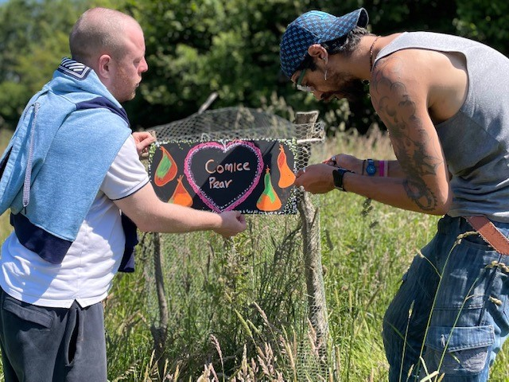
Picture credit Carolynsavageartist.co.uk

3.2.4 Experience of course participants who became volunteers:
Several participants on the weekly SNC course became volunteers after their blocks ended, this represented a nice way for participants to continue to practice their nature-based mental health skills and help others. Here are testimonials from two of the volunteers.

Example 1: SNC Participant who became a volunteer:
“I went on to become a buddy and then a trained volunteer after I was a participant for 18 weeks. Being a buddy and volunteer gave me immense confidence. Carrying on the course was so impactful and I wanted to give back to new participants what I had gained myself. I wanted to share my passion for the course with other people. It’s definitely a good sign when most of the participants who attend want to carry on as a buddy or a volunteer. No one wants to leave. Being knowledgeable about the course after having attended it as a participant was a really important part of volunteering. My mental health and wellbeing was in a good place to be able to do this and that’s because of attending 18 weeks as a participant. Being a buddy and volunteer gave me a great sense of belonging.”

Example 2: SNC Participant who became a volunteer:
“Now I am a volunteer I get to experience the project from a different angle. I help with the practical aspects of running camp, such as tending to the fire, setting up and clearing down, as well as helping support the participants with the tasks and exercises. It is such a privilege to see the progression of people’s journeys throughout the course. Watching the engagement and enthusiasm they have for each session and their growing passion for nature is amazing to see, and the vulnerability and openness they give to the exercises is in many cases incredibly brave and awe inspiring. The setting and construct of the course gives many the space and security to open up. Some of the emotion exercises can be quite challenging, but whenever we do them, they seem to open up some really important conversations, and personally have inspired some emotional revelations I may not have experienced in a different setting. I continue to benefit from the course as a volunteer, and am always learning something new, about myself as well as nature. Being a volunteer, I get to see the commitment the facilitators have for the project, as seeing all the preparation they put into delivering the sessions highlights their passion further.”
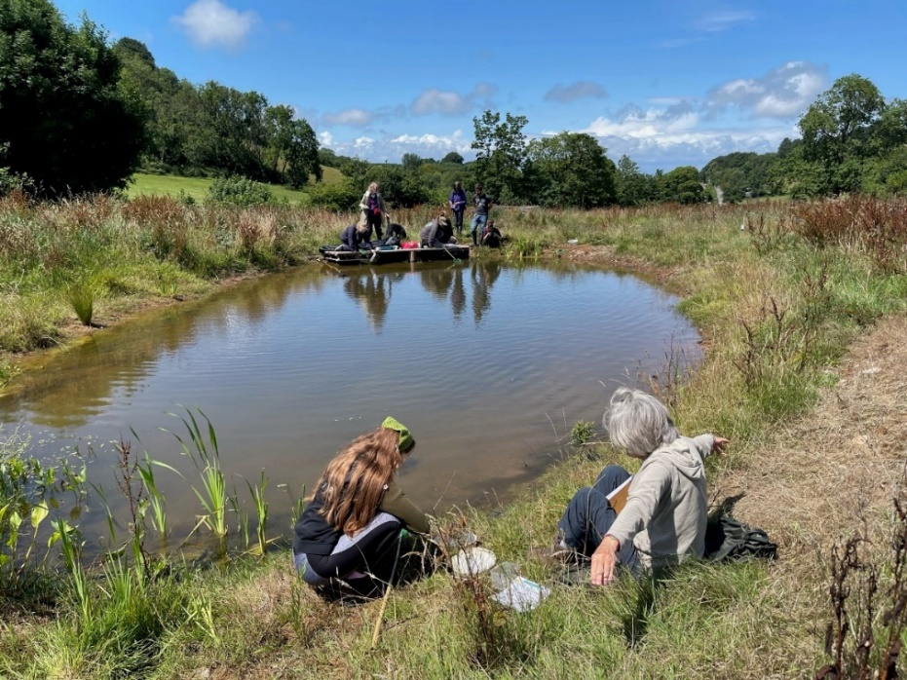

3.3 Experiences of community groups working with Somerset Nature Connections
In total 30 Community groups collaborated with SNC activity across three years of the project. This consisted of 99 sessions, 309 participants, 84 external staff or partners (See Appendix E for list of all three years’ project activities). The impact of collaborating with SNC for the community groups is detailed in a previous report.
For this evaluation, researchers carried out a focus group with three out of nine community groups from year 2 and talked about their involvement with SNC. Each organisation represented a different group and spanned both adults and children These three organisations illustrate the range of different people and ages that SNC has worked with:

- A children's charity running groups and activities for 6–14-year-olds. SNC had run 'green connectors' sessions for the youth club and had also been involved in a project in the summer holiday period. There was a current project with the children at an allotment which was helping bring children together to learn about wildlife and connect with each other.

- An established art group run by Mind, for adults with mental health difficulties or learning disabilities, who had taken part in SNC.

- An organisation running a day centre for adults with special needs and learning difficulties and had connected people using their services with SNC.
Throughout the discussions, there were four main themes that emerged from this focus group, which were:
- Overall experience for the community groups
- Perceived benefits to the community group attendees
- Perceived challenges for those taking part
- Ideas for improvements and future developments

3.3.1 Overall experience of Somerset Nature Connections for Community Groups
All three organisations were very positive about working with SNC. They all talked highly of the staff who ran sessions, who were described as enthusiastic, well prepared and knowledgeable. The sensitivity of the SNC staff in how to work with the different groups was also valued. The art group leader pointed out how this meant she could 'step back' herself and offer 1-1 support if someone was finding a task more difficult.
"It’s built well for mixed ability groups and all of the wildlife leaders as such, they really do know how to communicate with the guys and they understand…their needs and their other ways of working." (Organisation 3)
"They’re very quick to spot if maybe a child or young person is struggling." (Organisation 1)

3.3.2 Perceived benefits to the Community Group attendees
Two of the organisations had evaluated their work with SNC and both reported that their participants had found it really fun. All three organisations talked of enjoyment in being out with others. Supporting loneliness and the importance of social connections both new and established, were mentioned by all three organisations:
"One of the issues that perhaps happens with some children during the school holidays is that they can be quite lonely, but actually what was quite nice is that a lot of them said that they’d met new friends…overwhelmingly, I think it’s for the fact that they are connecting with others that shines through". (Organisation 1)

Even just being out somewhere different had been beneficial for some of the adults:
"I think they were just very stimulated and had new things to talk about, and it’s sort of shared memories, isn’t it? It was different." (Organisation 2)
The activities themselves were also a particular highlight, helping the participants learn new skills and do things like use tools for the first time but also produce something at the end of it. One activity of making flower presses was an example of how the activities had left a lasting impression:
"…a lot of the guys still, every time we go on a walk, will pick some flowers off the floor and take them home because they’ve still got the flower presses that we did there." (Organisation 3)
The Somerset Nature Connection sessions were evidently stimulating, and some change was noticed in individuals: one normally quiet member of the art group got more involved and was encouraged by the people taking the session to produce a painting which was unusual for them. In another example of change, an adult who had been an elective mute for several weeks before the sessions, started speaking again within a few sessions. One of the groups working with adults also reported a new appreciation of nature:
"I think the guys have a lot better understanding of nature and everything like that. I mean, a lot of the guys used to just pull flowers off of hedges like there was no tomorrow, but since being with the Wildlife Trust and the nature, the guys, yes, they understand that nature’s important and it should stay on the trees really." (Organisation 3)

3.3.3 Wider challenges associated with taking part in SNC
Although no challenges were perceived for those taking part in the activities by any of the focus group participants, wider challenges were identified. The organisation working with young people explained that parents can find it challenging if they are keen to help their children attend but mental health problems or attachment issues make this difficult. It was suggested that information could be shared beforehand with the activity organisers they could further support the child with their individual challenges. Another challenge identified by some of the focus group participants was the lack of transport. This was perceived to be a barrier for many people participating in nature-based activities on their own.

3.3.4 Ideas for improvements and future developments for Community Group links
Several suggestions were made for how things could be done differently in future. One suggestion was around communication by SNC with the community group in advance of sessions. One organisation had experienced some delay in receiving details about a session:

"….you can’t fault the actual sessions that they’re involved in...but it’s quite an important one because if you’re a small organisation and, you know, someone’s picking up this work, it’s usually on top of everything else that they’re doing. So timely communication, I think it’s really important, and from my aspect, it would be really appreciated." (Organisation 1)

Another suggestion was made for providing signposting to other similar activities, perhaps at the final session, providing"…ideas for other places that people could go or things they could do in nature locally."
In terms of new ideas for the future, it was suggested that developing something for young people in the 14–17-year age range who don't currently engage with the activities offered by the charity, might attract this group into SNC.
In general, expanding the opportunities to work with SNC would be welcome so that more community groups could be included. To overcome the transport difficulties which were acknowledged, a suggestion was made to have a more locally based group to look for wildlife that exists even in a town setting, or in an ideal world, to have free transport for a weekly trip out into the countryside:
“Ideally, you’d just be having some free transport to actually get people to go out to lovely places, like the Quantocks or Westhay, or any of these beautiful places, but if you don’t have the transport then you’re not going to get there. So that would be my magic wand, to just have a weekly trip out that people could sign up to and come along to with support. You know, they need the support, they need the people there, but they love it." (Organisation 2)

3.4 Staff views of SNC:
It is useful to get the views of the skilled and dedicated members of staff who created and carried out the SNC project. Their learning and understanding should also be captured so that others wishing to emulate this approach in the future can be aware of the work behind the project. The following section has a testimonial from the manager of the project and one of the project officers delivering weekly SNC sessions.
Reflections from Somerset Nature Connections Project Manager, Kristen Lambert
What have been the major milestones and achievements, and what are you professionally most proud of?
“Most major achievement has to be the impact engagement in the weekly courses has had on the lives of many of those attending. Some have told us this has been ‘life changing’, even ‘life saving’, giving them a more ‘positive outlook’ and ‘offering inspiration’. The individual stories have been so positive and powerful in terms their own health outcomes but also what they have been inspired to do in their own communities as a result, for example doing more to support nature and wildlife to thrive withing community groups or their own garden. A few people have gone on further education in related fields or even employment in related fields and I am certain that involvement in this project has played a part in this. Some cohorts continue to be in touch, meeting up for walks in nature together and visiting different spots in Somerset. Long-term friendships and support networks have most certainly been established through this project too – which will no doubt continue to have health and wellbeing benefits for individuals long into the future.
“Success of the participant-buddy-volunteer pathways. Approx 15 people have gone on to become formal volunteers on the SNC project at different points in time. The feedback from their experience has been positive with one even going on to become a paid member of SWT staff. Lots of these volunteers now meet up without SNC staffs involvement – walking together or leading sessions for others around nature-based crafting etc.
“Working with a diverse range of community groups to share our passion for the importance of Nature Connection for people and planet. Organising now bringing it in to day-to-day work – for example Day Care Providers being more aware of taking time to take notice and consider what they have seen in nature when walking with groups to partners setting up their own Nature Connections Groups (Paddington Farm following training funded as part of this project and Bishops Palace’s groups).
“Organisational impacts on Somerset’s National Landscape and SWT regarding importance of this work for engaging previously underrepresented groups. Still a way to go here but there a recognition that change is needed in terms of how we reach out to communities and what tools/approaches we use to do this. (How nature makes us feel/Nature Connection rather than just education or practical volunteering).
“Networks established and strengthened between delivery partners and different sectors – for example Health. referrals from Open Mental Health Teams across different mental health organisations, NHS mental health teams etc. This hasn’t been an easy one to crack and has taking a lot of time but think we have certainly been able to move this forward during the 3-year project.
“Skill sharing sessions have been a real hit and we hope to do more of this in the final months of the project. A good way to reach larger audiences with this work.”
Kristen’s reflections on leading Somerset Nature Connections
“Really enjoyed being a part Nature Connection work that is going on across Somerset. Loads of amazing organisation now doing incredible things for people and planet in terms of offering new and inspiring ways for people to connect with nature and wildlife locally to them.
“Been incredible to work with such an inspiring and experience team of Project Officers and volunteers. People with such a range of amazing skills – I have learnt so much and it has been an absolute joy to work alongside these awesome people.
“Grateful for the support offered by Somerset Wildlife Trust and AONBs – especially towards the end of the project when discussing legacy and next steps. Feeling really positive about the future of this work and opportunities for people of Somerset in terms of nature connection and the impact this could have of action for nature with more people being inspired by the relationship we have with nature and wildlife and it’s great importance.”

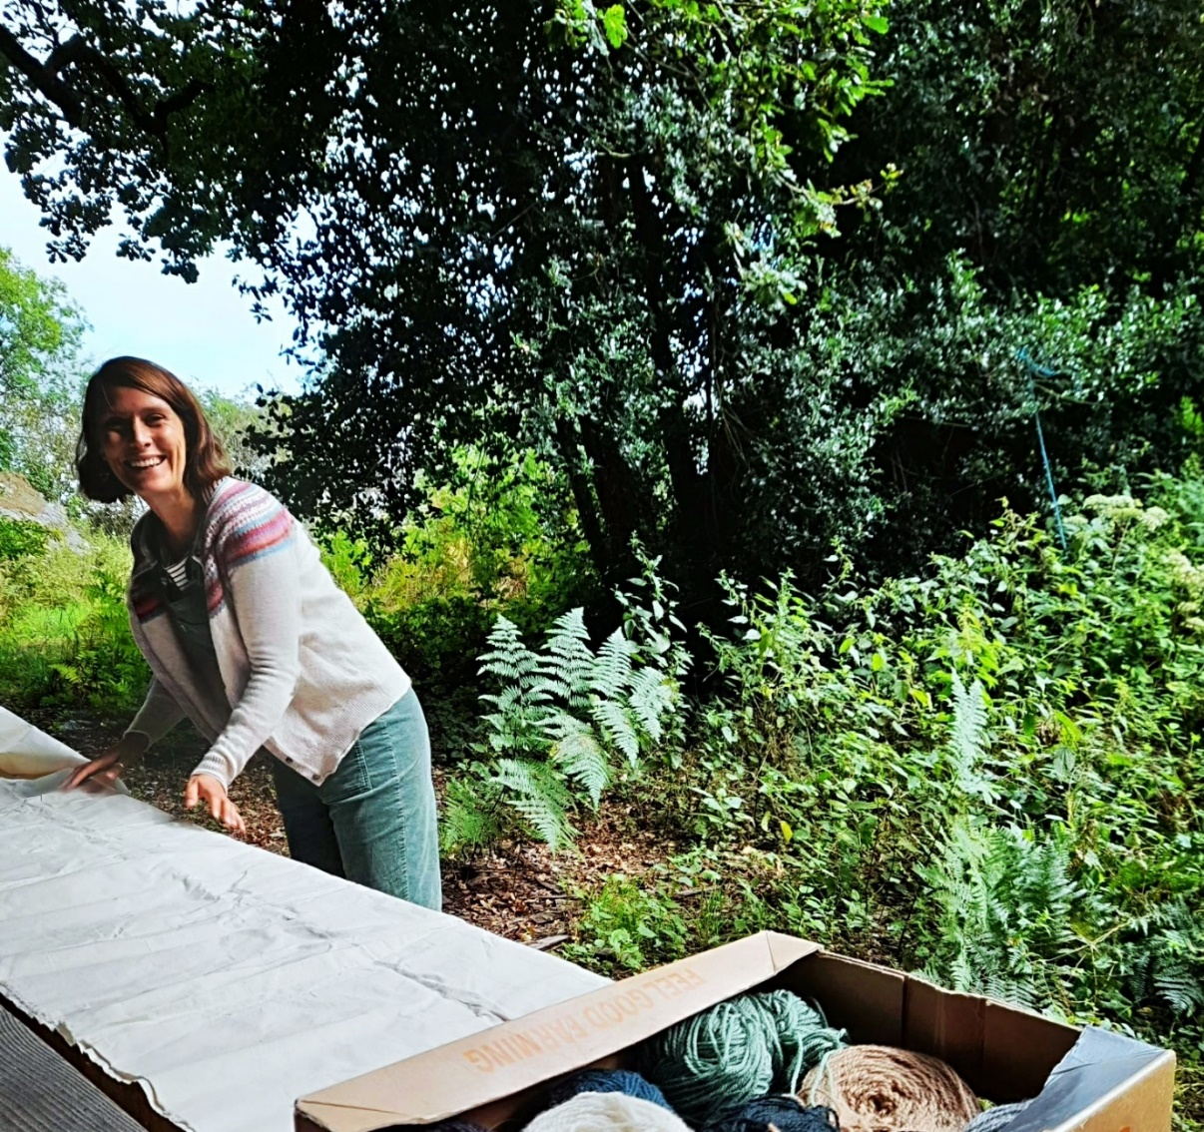
(Picture of Kristen Lambert, SNC Project Manager)

Experience of a Somerset Nature Connections Project Officer:
“The role of an SNC Project Officer is exciting, fulfilling, challenging, varied, and never dull! Every day throws up a new adventure or challenge: trying to fit 8 bags of kit and 6 scythes in the back of a 3-door ford fiesta, a wasp’s nest in the compost loo, a storm blown tree fallen on top of the compost loo, further gales or freezing temperatures forecast, and taxi drivers unable to find their way to a field gate. We have all enjoyed developing rich partnerships with the AONB’s, site owners and wonderful guest facilitators. We have also enjoyed deepening our own nature connectedness and our relationships with the sites we have worked at, being part of those places and seeing them change over time and throughout the seasons – and, we’re eternally grateful for all of the wonderful wildlife that comes out during the sessions to hold us in awe and wonder: an adder basking in the January sunshine, a roe deer fawn hidden in the grass, a ginormous oil better walking over the session plan.

“It has at times been difficult witnessing and attempting to support participants when they are struggling, especially when we have limited capacity to support them as we would like and have to observe the limitations of an overstretched social care system. However, it has also been an incredible privilege to observe some of those participants transform, increasing in confidence and living rich and full lives where nature plays a fundamental role. We have been regularly inspired by the amazingly talented, creative and courageous people we have worked with. Many of them have gone on to do incredible things and to take action for wildlife: transformed their gardens into wildlife habitats; found meaningful nature-based work after long term health problems, homelessness or unemployment; influenced their work places to change practices and policy around the environment and mental health; volunteered with other charities; redirected their career path towards nature recovery; been employed by the project after participating and volunteering, and setting up their own projects! We all feel very fortunate and proud to be part of this amazing project that we wholeheartedly believe in – the power of the reciprocal relationship between people and wider nature to support and transform.”

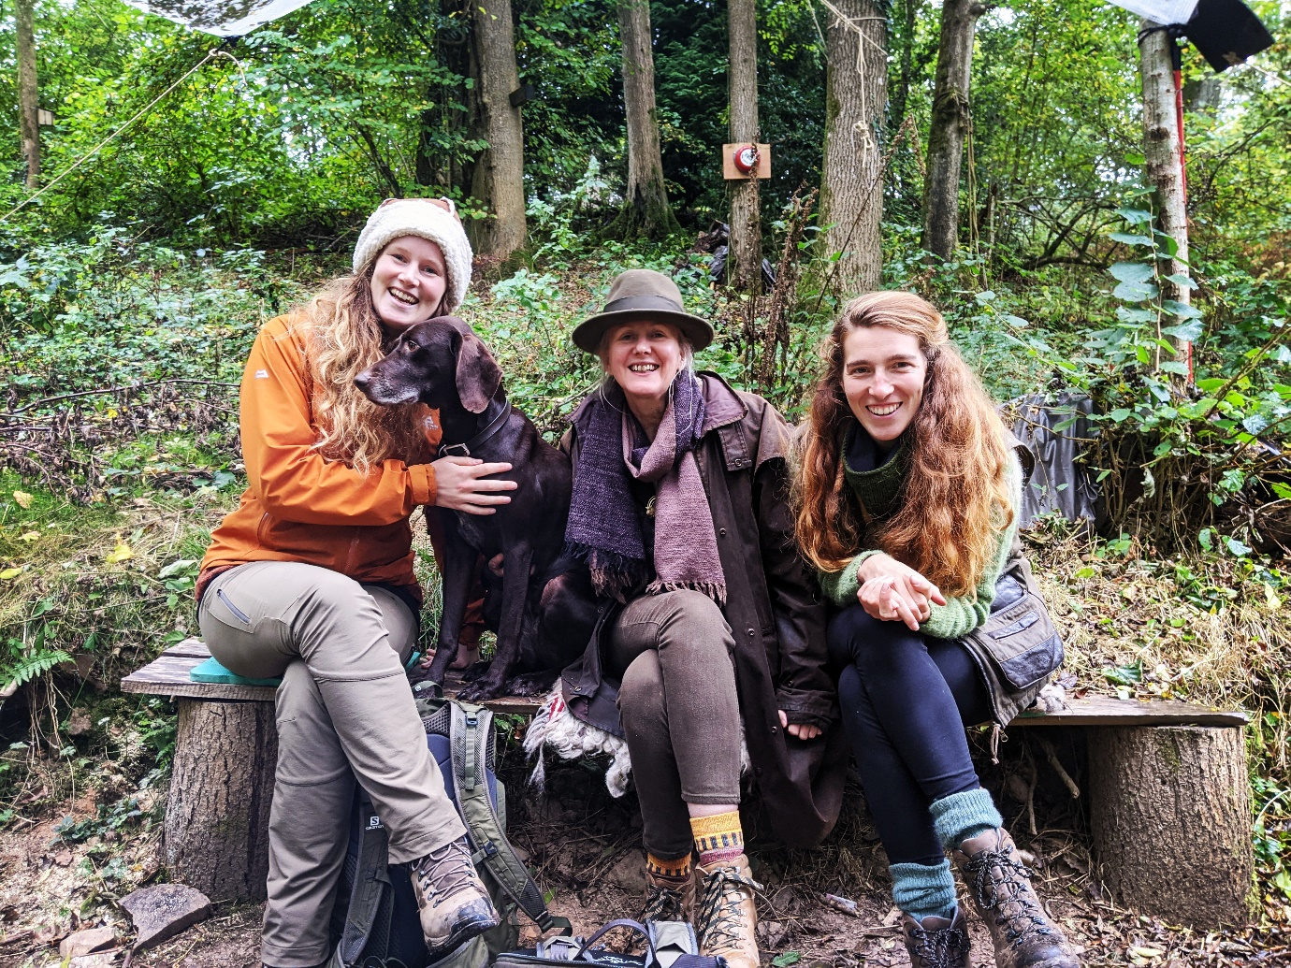
(Project officers on the SNC- Hermione, Jo and Mhari)
Reflections from a National Landscape Partner
“In the Mendip Hills National Landscape (formerly AONB), we’ve been delighted with the number of people and groups that the project team has engaged with over the last 3 years, and the quality of this engagement. The project officer for the Mendip Hills National Landscape has delivered really impactful courses and one-off sessions and has developed strong links with local groups and care providers. We’ve seen how the project has benefitted the wellbeing of participants and the really rewarding outcomes that have been achieved.
“The natural beauty of National Landscapes should be a source of enjoyment, health, and wellbeing for everyone in society; this project has been one of the most important and impactful ways that we, as a National Landscape Team and Partnership, have been able to make this possible through action on the ground. The delivery of the project and opportunities it has provided for people has been very timely, when people have needed nature and the landscape more than ever, and when nature recovery has become a stronger element of our work. Project activities have also helped deliver community engagement and nature connectedness linked to the objectives in the Mendip Hills National Landscape’s Nature Recovery Plan.
“We’re keen to secure funding to continue and build on the successes of the project in the Mendip Hills. Whilst it’s a shame that the formal partnership and hosting arrangement with Somerset Wildlife Trust will come to an end, we still plan to work together through the Local Nature Partnership and by delivering sessions on Wildlife Trust land, particularly within the new Mendip ‘super’ National Nature Reserve. Bringing delivery into the National Landscape Team will also mean greater control of our comms, strengthen our links to funders, partners, and green social prescribing initiatives, and enable delivery in a variety of settings outside of the county of Somerset. We’ve really enjoyed being a partner on the project and working with, and learning from, the incredibly skilled and dedicated project team who have managed the project brilliantly. We’re also grateful to all the stakeholders, participants, and funders that made the project possible.”

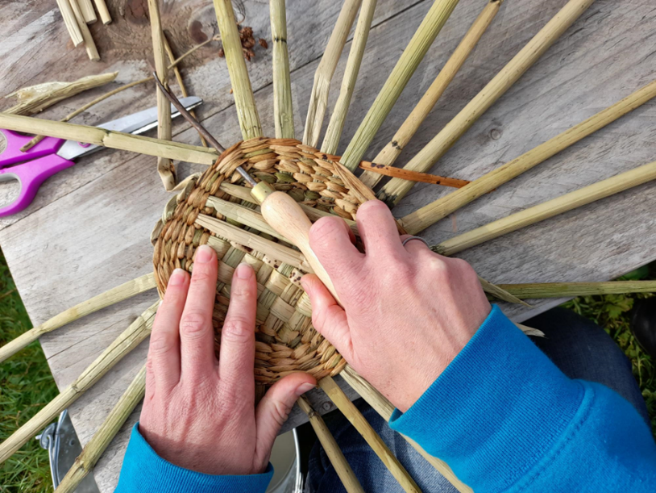

4.0 Conclusions
A key aim of Somerset Nature Connections was to support people experiencing mental health problems to access the natural environment to improve wellbeing and provide the tools and environment to help self-manage their mental wellbeing. Furthermore SNC aimed to support community groups to enable their participants who already have mental health issues to access the benefits of nature. Several types of data gathered from this evaluation corroborated each other and demonstrated that people reported an improvement in mental health, increased their social connections and confidence, become more independent, improved their connection to nature and were able to independently take positive action for nature after attending SNC courses. The peer reviewed literature reports that connection to nature is linked to higher mental wellbeing and lower levels of anxiety¹⁻⁴. Also, visiting nature one a week associated with better health and pro-environment and pro-conservation behaviour¹. SNC programme of work, therefore, corroborates with the wider research literature which shows the benefits of nature for health and wellbeing.
There appears to be a story unfolding of how people who are lonely, anxious and experiencing low mood and other mental health issues have been compassionately welcomed onto the SNC courses and taught to appreciate all that nature can offer. Through the caring and kind approach, the participants have felt safe and nurtured, enough to be able to speak to each other, overcome their social anxiety, try new activities and discover new things about themselves and nature. As confidence and self-esteem has increased, so has their ability to make social connections, which has led to improvements in mental health. Some of these improvements have been quite profound with some people saying it was “life-changing” or “life-saving”.
As well as having personal improvements to their health and wellbeing, many participants reported going home and making positive changes to support nature’s recovery, informed by their experiencing and teaching at SNC. One person for example set up a forest school on the back of attending the course, and another started a community garden project. This is a key aspect of the course, to embed knowledge for people to act independently for nature and to influence people around them in their community.
30 community groups partnered with SNC (well above the aim of reaching 20), also reporting a favourable experience for their participants. Participants from the community groups were seen to connect more with nature, become more confident and improve social interaction. Please see appendix and SWT report for further information on the impact of SNC on the community groups.
Improvements that were suggested predominantly related to the approach to supporting people when the SNC came to an end. Many people were very sad when the SNC sessions ended and did not want them to stop. One person at long term follow-up felt they had missed the sessions so much they were back to where they started before attending. Several ideas were suggested on ways to support people to meet up outside of SNC. It should be noted that the project team did provide reconnection days, and enabled participants to informally connect after the sessions ended.

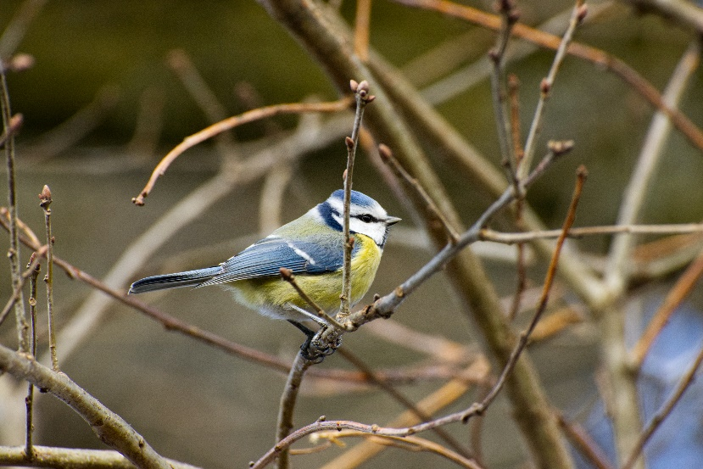

A limitation to the confidence that can be placed in the quantitative conclusions is due to low sample sizes and the fact that statistical test could only be carried out on score changes up to the 6 week follow up time period. It is likely that these findings will be repeated if more data were to be collected, as the H-HAN and NCI data, which showed increased connection to nature, were echoed by the deeper -dive qualitative focus group feedback, the exit questionnaire and the perspectives of the community group partners who witnessed the changes in the people attending their organisations and the project officers who also noticed the same types of changes.
Another limitation is that respondents to the exit survey, follow-up phone calls and focus groups may have agreed to take part as they had positive experience of the intervention. Also, it could be argued that since the project officers gave out the questionnaires, and asked the questions on the follow-up calls, then the data may be biased to be positive. It was noted however that the qualitative data did capture where experiences could be improved, so a range of responses were captured.
Overall, however, the data in this evaluation demonstrates that SNC has met its key aims and that there are demonstrable benefits to people’s mental health, their ability to manage it. Furthermore, people came away and independently took action to support nature’s recovery and community groups were able to support their own participants access the benefits of nature.

Appendix A Description of the Somerset Nature Connections Course

From: Somerset Nature Connections National Lottery Community Fund Year 2 Report, Period Covered: Year 2, July 2021-June 2022, Kristen Lambert

“Our weekly self-care/wellbeing courses (taking place in each of the 3 AONB’s each week), supporting people experiencing mental issues have continued to run in six-week blocks with up to 18 weeks of engagement for people who require longer term support. Participants are encouraged to complete all three courses to promote sustained positive behaviour change and lasting benefits to their wellbeing. Participants can then become buddies to support others and share their experiences on the course and some have also now gone on to register as Somerset Wildlife Trust Volunteers too. As before The Five Pathways to Nature Connectedness have continued to shape each session and participant’s journey contact/sense, beauty, emotion, compassion and meaning). This connectedness is fundamental to our health and wellbeing and our ability to adopt positive environmental and conservation behaviours.

Delivered weekly, each day runs from 10.00am-2.30pm, includes a morning ‘check-in’ and end of the day reflection to provide a safe space for people to share their experiences and thoughts. This allows people to learn from each other and over time empowers them to take charge of their own wellbeing.

The structure of the day includes:
• Grounding (nature-based mindfulness)
• Check-in
• Wellbeing intervention
• Practical activities
• Reflection and group discussion

Our wellbeing interventions encourage individuals to explore their interactions with the natural environment providing the time and space to allow them to develop their understanding around:
• Personal; reflect on the Five Pathways to Nature Connectedness.
• Social; share and work with others through group-based tasks.
• Environment; learn how to make a positive difference to the environment.

We have continued to invite expert tutors to provide sessions sharing their skills and experience, and we also provide ‘take home’ activities encouraging further connection to nature outside of sessions.

Following pages contain examples of activities undertaken at each AONB (Blackdown, Mendip and Quantock Hills).

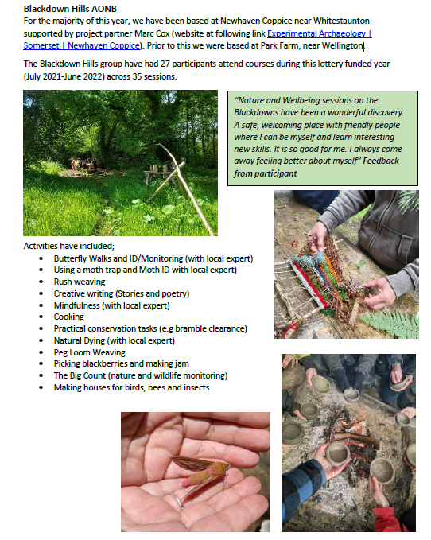

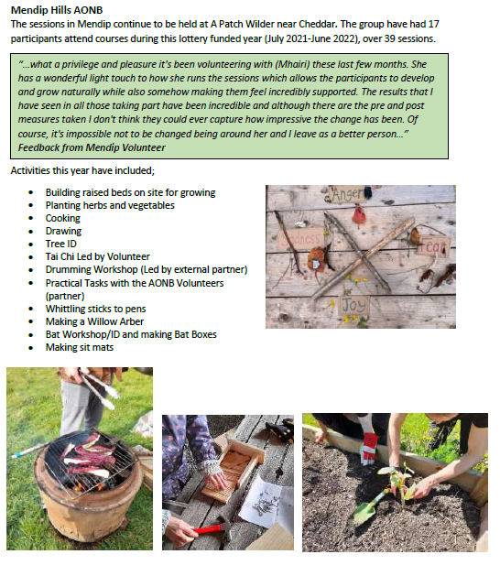

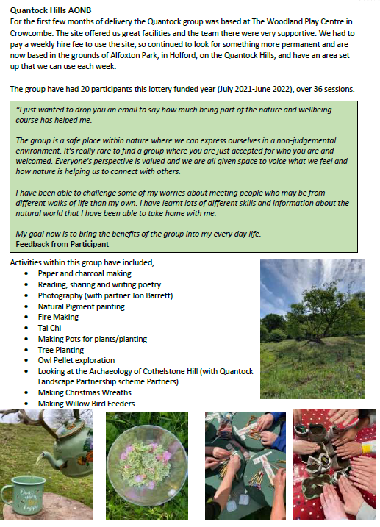

Appendix B: Quantitative outcome measures used

The H-HAN Scale
WEEK 1 Holistic Health and Nature Scale
We will use your feedback to evaluate and improve the service. All answers are anonymous.
Today’s Date:___________________________ ID: ________________________________
Rate the following questions on the Wellbeing Outcome Wheel by marking the number that corresponds to the scale below.
1-2 is poor, 3-4 weak, 5-6 satisfactory, 7-8 good, 9-10 excellent

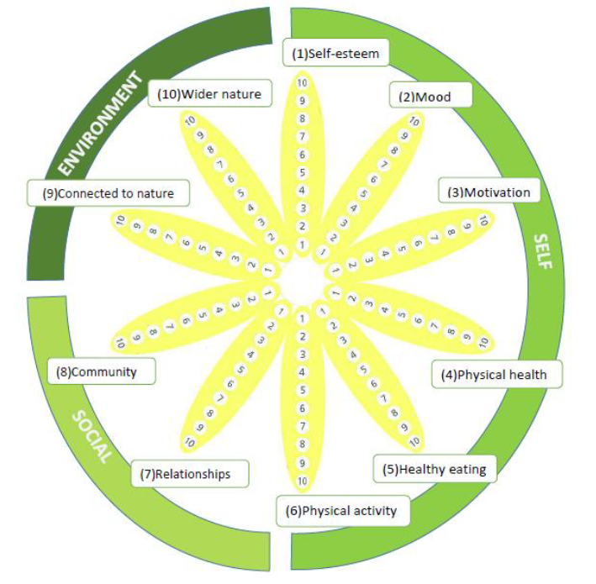

The Nature Connection Index (NCI)

The following questions are about you and nature. By nature we mean all types of natural environment and all the plants and animals living in them. Nature can be close to where you live in towns; the countryside or wilderness areas further away.

Please tell us how often you agree with each of the following statements, by putting a tick in the relevant box. 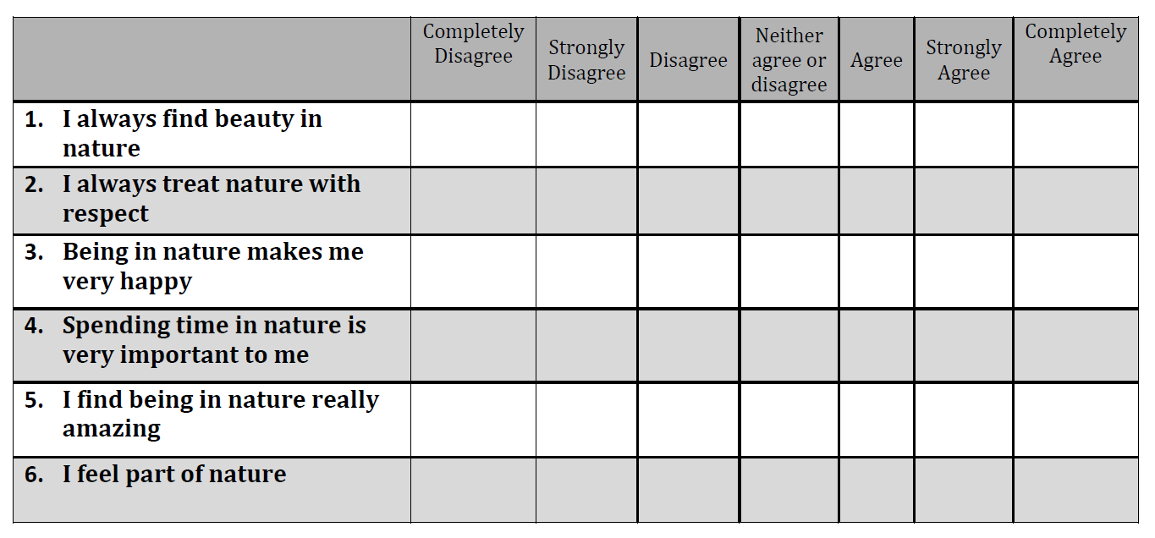

Appendix C: Participant Information Sheet and Consent Form for the focus groups
PARTICIPATION INFORMATION SHEET
Evaluation Somerset Nature Connections for of the Somerset Wildlife Trust
Researcher: Dr Helen Seers, Meaningful Measures Ltd.
You are being invited to take part in an evaluation to explore your experience of the Somerset Wildlife Trust’s Somerset Nature Connections project.
This is an evaluation which is being carried out for the funders of the course (The National Lottery) by Meaningful Measures Ltd. This evaluation will explore your experiences of the course to enable the development and improvement of this work.
The evaluation will involve you:
Being offered the chance of taking part in a small focus group over Google meet. This is optional and will last no longer than one hour and will be recorded and transcribed and then anonymised.
Please note:
- Your participation in this research is entirely voluntary.
- You have the right to withdraw at any time without giving a reason.
- Withdrawal from the research will not affect any involvement or relationship you have with Meaningful Measures Ltd.
- You have the right to ask for your data to be withdrawn, as long as this is practical and for personal information to be destroyed.
- You do not have to answer particular questions if you do not wish to do so.
- Your responses will be made anonymous and will be kept confidential unless you provide explicit consent to do otherwise. No individuals should be identifiable from any collated data, written report of the evaluation, or any publications arising from it.
- All computer data files will be password protected. The researcher will keep files in a secure place and will comply with the requirements of the UK GDPR regulations tailored by the Data Protection Act (2018).
- Any hard copy documents, e.g., consent forms, will be scanned and kept securely in a digital form in a password protected file. The hard copies will then be destroyed.
- If you wish, can receive information on the results of this evaluation. Please indicate on the consent form if you would like to receive this information.
The researchers can be contacted during and after participation using the following contact details,
Dr Helen Seers Helen@meaningfulmeasures.co.uk

Consent Form
Evaluation Somerset Nature Connections for of the Somerset Wildlife Trust (delete yes or no as applicable on your document and send back via email or print it out and fill it in and take a picture) email to Kristen.lambert@somersetwildlife.org
I have been given the Participation Information Sheet and/or had its contents explained to me. | Yes ❒ | No ❒
I have had an opportunity to ask any questions and I am satisfied with the answers given. | Yes ❒ | No ❒
I understand I have a right to withdraw from the research at any time and I do not have to provide a reason. | Yes ❒ | No ❒
I understand that if I withdraw from the research any data included in the results will be removed if that is practicable (I understand that once anonymised data has been collated into other datasets it may not be possible to remove that data). | Yes ❒ | No ❒
I would like to receive information relating to the results from this study. | Yes ❒ | No ❒
I wish to receive a copy of this Consent form. | Yes ❒ | No ❒
I confirm I am willing to be a participant in the above evaluation. | Yes ❒ | No ❒
I note the data collected may be retained in an archive and I am happy for my data to be reused as part of future research activities. I note my data will be fully anonymised (if applicable). | Yes ❒ | No ❒
Participant’s Name: ____________________________
Signature: ____________________________ Date: _______________
This consent form will be stored separately from any data you provide so that your responses remain anonymous.
Admin use only I confirm I have provided a copy of the Participant Information Sheet and have given the participant an opportunity to ask questions, which have been answered.
Researcher’s Name: ____________________________
Signature: ____________________________ Date: _______________

Appendix D: Questions used in focus groups, exit survey and phone follow-ups

Somerset Wildlife Trust – Focus Group Questions 3.10.22
General questions
- When did you join the Somerset Nature Connections Project as a weekly visitor?
Have they become a volunteer?
- How did you find out about the Project?
Referral route?
Experience of service
3. What was it like for you when you attended your first Session and then how was it after that?
Nervous, did think you would join in, low confidence, stressed
Impact of service
4. Can you explain how the nature connection sessions have helped you?
Calming, connecting, expressing your feelings, harmonising with people, escapism, uplifting
5. Going forward what skills have you learned that may support your wellbeing?
Strategies/ ideas – are you a volunteer now?
6. Have you done anything to support nature because of your experience with the course?
Were there any things you took away from the sessions?
Suggestions for improvement
7. Anything you think that could be done differently or any ideas for future sessions?
Anything practical or ideas
8. Anything else you want to tell us about your experience.

Somerset Wildlife Trust – Focus Group for professionals working with Community groups dropping in to Nature Connections 17.10.22
General questions
- Background – intros – Name, professional background
Your answer:
- How did you get involved in the Somerset Nature Connections Project?
Your answer:

Experience of service
- Who are the groups of people you most work with that access the nature Somerset Connections project?

- From your professional perspective what has it been like for you? Challenges, good things…

Impact of service
- From the perspective of the communities you represent what has their involvement with Nature Connections been like (if you could represent them here)?
Have there been any unexpected benefits from being involved?
Any challenges for them in taking part?

- What impact have you seen on people engaged with the Nature Connections project?
Wellbeing?
Nature actions? Anything?
Other?
Suggestions for improvement
- Anything you think that could be done differently or any ideas for future sessions?
Anything practical or ideas
- If you had a magic wand, what would you do with Nature Connections? – in your area or nationally?

- Anything else you want to tell us about your/ the attendees’ experience.

Questions on the exit survey included:
- Please describe your overall experience of the course. What impact has it had on you?
- How were the sessions? Was there one that you particularly enjoyed?
- Was there anything you think we could have done better?
- Will you continue to use anything that you have learnt from the course to help your wellbeing?
- Will you do anything to continue to look after nature?
- Why are you leaving?
- If self-referred, how did you hear about the course?
- Can we contact you in 3 to 6 months to see how you are getting on?

Questions on the follow-up phone calls included:
- Since leaving the SNC Project, how connected do you feel to nature?
- Do you think that the SNC Project had an impact on your wellbeing? For example, do you feel more active, sociable or content?
- Are you currently taking action for nature? This could include in your own garden, within your community, or volunteering with other organisations. Please tell us about this.
- Is there anything else you may want to share with us about your experience of Somerset Nature Connections?

Appendix E: Community Groups worked with
Year 1 (7 Groups)
Group | No. of sessions | No. of Participants | No. External Staff/Partners
Orchard Vale Trust – Online Group | 3 | 20 | 10
Orchard Vale Trust Group 1 – 5 | 3 | 5 | 3
Orchard Vale Trust Group 2 – 2 | 3 | 2 | 1
Orchard Vale Trust Group 3 – 5 | 3 | 5 | 2
Orchard Vale Trust Group 4- 3 | 3 | 3 | 2
Community Garden | 4 | 4 | 0
Somerset Recovery College | 4 | 5 | 1
Totals | 23 | 44 | 19

Year 2 (8 Groups)
Group | No. of sessions | No. of Participants | No. External Staff/Partners
Somerset Sight, Taunton | 3 | 6 | 2
Bishops Palace Winter Wellbeing Group, Wells | 3 | 6 | 1
Thriving Communities – Somerset Art Works and Mind, Wellington | 10 | 14 | 3
Mind in Somerset, Bridgwater Art Group | 3 | 7 | 2
Osprey Outdoors, Burnham/Highbridge | 6 | 7 | 2
Sweet Surprise, Ilminster | 3 | 5 | 4
My Days, Chilton Trinity | 6 | 6 | 3
Earthlight Herbs, Somerset Levels | 3 | 14 | 2
ArcInspire (not direct delivery) | 2 | 2 | 2
Totals | 39 | 67 | 21

Year 3 (15 Groups)
Group | No. of sessions | No. of Participants | No. External Staff/Partners
CHARIS Welcome Hub Art Group | 3 | 14 | 3
Ups and Downs | 3 | 6 | 2
CHARIS Bridgwater Group | 2 | 18 | 2
Homes and Horizons (TRAINING) | 1 | 5 | 1
Taunton and Bridgwater College (wellbeing group) | 3 | 2 | 2
Greendays Day Care | 3 | 5 | 2
Wellbeing Walks – Mendip | 1 | 6 | 1
WATCH Project – Community Conservation Action Groups (Yeovil, Taunton, Chard | 6 | 26 | 2
Wellbeing Walks – Quantock | 1 | 8
Discovery Training/Wellbeing Day (TRAINING) | 1 | 19 | 19
Mendip Farmers Group Training | 1 | 20 | 1
The Space Allotment Summer sessions | 4 | 27 | 3
Ark at Egwood and Yeovil for families | 2 | 22 | 4
Sessions with Displaced Communities – Mendip | 3 | 11 | 1
My Days Conquest Group | 3 | 9 | 1
Totals | 37 | 198 | 44

REPORT END

Natural England (2022) Connection to Nature Evidence Information Note EIN068 Available at: http://nepubprod.appspot.com/publication/5777215462834176
Mughal R., Seers H., Polley M., Sabey A. & Chatterjee H.J. (2022) How the natural environment can support health and wellbeing through social prescribing. NASP. Available at https://socialprescribingacademy.org.uk/media/zakn0rng/how-the-natural-environment-can-support-health-and-wellbeing-through-social-prescribing_.pdf
Natural England (2022) Links between natural environments and mental health Evidence Information Note EIN065 Available at: http://nepubprod.appspot.com/publication/4973580642418688
Natural England (2022) Links between natural environments and physical health Evidence Information Note EIN066 Available at http://nepubprod.appspot.com/publication/6416203718590464
White MP, Alcock I, Grellier J, et al. Spending at least 120 minutes a week in nature is associated with good health and wellbeing. Scientific Reports. 2019;9(1):7730. doi:10.1038/s41598-019-44097-3
UK Government. https://www.gov.uk/government/collections/tackling-obesities-future-choices.
https://socialprescribingacademy.org.uk/what-is-social-prescribing/natural-environment-and-social-prescribing/green-toolkit/
Howarth M, Brettle A, Hardman M, Maden M. What is the evidence for the impact of gardens and gardening on health and well-being: a scoping review and evidence-based logic model to guide healthcare strategy decision making on the use of gardening approaches as a social prescription. BMJ Open. 2020 Jul 19;10(7):e036923. doi: 10.1136/bmjopen-2020-036923. PMID: 32690529; PMCID: PMC7371129.
See online video showcasing the SNC https://www.youtube.com/watch?v=OmIN1wzhTkc
https://findingnature.org.uk/2017/05/10/beyond-knowing-nature/
https://www.naturalacademy.org
Avon Wildlife Trust. Wellbeing with Nature: Improving People’s Health and Wellbeing, Whilst Caring for the Natural Environment and Deepening Their Connection to Nature, Avon Wildlife Trust.; 2021.
Richardson, M. et al., Measure of Nature Connectedness for Children and Adults: Validation, Performance, and Insights. Sustainability 2019, 11, 3250. https://doi.org/10.3390/su11123250
https://www.gov.uk/government/collections/monitor-of-engagement-with-the-natural-environment-survey-purpose-and-results
Note: the researchers think that this issue may have subsequently been addressed by the Nature Connections Team.
Somerset Nature Connections National Lottery Community Fund Year 2 Report Period Covered: Year 2, July 2021-June 2022
Somerset Nature Connections National Lottery Community Fund Year 2 Report, Period Covered: Year 2, July 2021-June 2022, Kristen Lambert

